
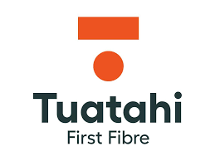


Capgemini response to
Programme Horizon 2026:
System Integrator

Technical Response

June 2026
Part D – RFP Response

1 Cover Letter 6
2 Executive Summary 7
2.1 Overview 7
2.2 Why select Capgemini 8
2.3 Our commercial approach 9
2.4 Our Values 10
2.5 Environmental Sustainability 11
2.6 Our love for Rugby 11
3 Proposed Solution & High-Level Design 12
3.1 Overview of Solution Architecture 12
3.1.1 Scalability of the solution 15
3.1.2 Enterprise integration for monitoring, observability and operational telemetry 16
4 Programme Plan and Delivery Methodology 17
4.1 Integrated Programme Plan on a Page 17
4.2 Proposed Delivery Approach and Methodology 18
Discovery & Design Phase 19
4.2.1 Initiation (Month 1 – Weeks 1–2) 19
4.2.2 Discovery & High-Level Design (Month 1–2) 19
4.2.3 Detailed Design (Month 3–4) 20
4.2.4 Team Structure 20
4.2.5 Iterative Build and Configuration and Testing (execute) 25
4.2.6 Convergence into Integrated Testing and Go-Live 25
4.2.7 Proposed Cut over and Go-Live/ Release Plan 26
4.2.8 Hypercare and Post Go-Live Support 28
4.2.9 Post-Hypercare Support Model 30
4.2.10 Archival and Decommissioning 30
4.3 Use of AI 32
4.4 Key Assumptions 33
4.5 Pre-requisites and Dependencies 33
4.5.1 Pre-requisites 34
4.5.2 Dependencies 34
4.6 TFF Responsibilities 35
4.7 Out of Scope 36
5 Governance and Programme Control 38
5.1 Programme Control Office – the delivery engine for Programme Horizon 42
5.2 Governance Model 44
5.2.1 Decisions and Turnaround assumptions 46
5.2.2 Escalation Framework 47
5.2.3 Programme Challenges and Risk Considerations 48
5.3 RACI Matrix 51
6 Detailed Workstream & Work Package Response 54
6.1 Workstream A: Portal & Customer 55
6.1.1 Work Package 1: Centralised Catalogues and Party Manager 56
6.1.2 Work Package 2: Fibre Ordering Automation and Fulfilment 59
6.1.3 Work Package 3: RSP Billing Automation 62
6.1.4 Work Package 4: New RSP Portal 64
6.1.5 Work Package 5: Order pre-qualification 69
6.2 Workstream B: Network 71
6.2.1 Work Package 6: Consolidate Physical Network Inventory 72
6.3 Workstream C: Field Force 86
6.3.1 Work Package 7: Automate Assurance Work Orders 87
6.3.2 Work Package 8: Automate Provisioning Work Orders 92
6.3.3 Work Package 9: Internal Field Force Integration 94
6.3.4 Work Package 10: Work Order Finance System Integration 97
6.4 Integration 98
6.4.1 Solution Details 99
6.4.2 Activities and Key Dependencies: 102
6.4.1.4 Out of Scope 105
6.5 Data Migration (Non-GIS Data) 105
6.5.1 Solution Details 105
6.5.2 Scope 105
6.5.3 Non-GIS Data Processing Architecture 107
6.5.4 Non-GIS Data Processing Approach & Activities 108
6.5.5 Assumption and Dependencies 111
6.5.6 RACI 112
6.6 Organisation Change Management (OCM) 113
6.6.1 Tuatahi-led, Capgemini-enabled 113
6.6.2 Change Management Delivery Model 113
6.6.3 Integrated Training Approach 114
6.6.1.8 Business Readiness and Adoption 116
6.6.4 Training Needs Overview 116
6.6.5 High-Level OCM & Training RACI 118
6.7 Testing Solution 119
6.7.1 System Integration Testing (SIT) Approach (Release 1 & Release 2) 121
6.7.2 Release 1 and 2 – E2E Customer Journeys (Integrated SIT) 121
6.7.3 Release 1 and 2– User Acceptance Testing 121
6.7.4 Accessibility Testing 122
6.7.5 Performance Testing Approach 122
6.7.6 Test Automation Approach 122
6.7.7 Defect Management and Reporting 123
7 Delivery Model 123
7.1 Ways of Working 123
7.2 Subcontractors/Partners and Responsibilities 126
7.2.1 Scope of services delivered by 3-GIS 128
7.3 Critical Roles & Named Profiles 132
8 Relevant Experience and References 135
8.1 Key referenceable case studies 135
8.2 Capgemini Capabilities and experiences 142
9 Addendums 145
10 Declaration 145

Cover Letter

Dear Programme Horizon RFP Evaluation Team,

Capgemini is pleased to submit our response to Tuatahi First Fibre’s Request for Proposal for Programme Horizon - Systems Integration Services for Digital (Wholesale BSS) Modernisation.
We are grateful for the opportunity to be considered as a strategic partner on a programme that is central to Tuatahi First Fibre’s digital and operational transformation agenda. We recognise that Programme Horizon is more than a technology implementation. It is a business-critical transformation intended to enable a more scalable, efficient and resilient wholesale operating model, while maintaining compliance, service continuity and confidence for Retail Service Providers, internal teams and the wider stakeholder ecosystem.
Our response has been shaped around Tuatahi First Fibre’s ambition to modernise its wholesale digital platform across customer, network and field-force domains. Capgemini’s proposed approach is designed to help move from fragmented and manually intensive operations to a modern, integrated and customer-centric platform, with stronger order-to-bill traceability, trusted network data, improved RSP experience and disciplined programme delivery.
As Prime System Integrator, Capgemini will bring the leadership, integration capability and delivery discipline required to coordinate across retained platforms, new solution components, third-party providers and programme workstreams. Our delivery model combines strong governance, embedded testing, disciplined data migration, structured hypercare and active dependency management, supported by a collaborative New Zealand-compatible engagement model.
We bring relevant telecommunications transformation experience, regional delivery leadership and access to specialist capability across Capgemini’s global network. Our proposal is underpinned by delivery confidence, clear integration accountability, pragmatic commercial discipline and an open partnership approach with Tuatahi First Fibre and its broader delivery ecosystem.
We sincerely thank Tuatahi First Fibre for the opportunity to respond. We would welcome the opportunity to discuss our proposal further and explore how Capgemini can support the successful delivery of Programme Horizon.

Yours sincerely,


Bruce Koefoed
Client Partner
m. +64 21 974981
bruce.koefoed@capgemini.com

Executive Summary

Overview
Tuatahi First Fibre’s Programme Horizon is a pivotal opportunity to establish a modern, scalable and future-ready wholesale operating environment. It will support growth, improve the Retail Service Provider (RSP) experience, and strengthen operational resilience.
Capgemini recognises that Programme Horizon is far more than a technology refresh. It is a business-critical transformation that will shape how Tuatahi delivers, manages and evolves its services in the years ahead. Our response is built around this ambition, with a clear focus on helping Tuatahi accelerate value realisation through a pragmatic, outcome-led transformation approach.
Tuatahi’s current environment has supported the business to date. However, it now presents increasing constraints through fragmented workflows, duplicated data, legacy complexity, and manual intervention across ordering, service management, billing, resource visibility and field operations. These challenges create friction for internal teams and RSPs alike, limiting agility, transparency and scale.
Programme Horizon provides the opportunity to address these constraints decisively. It will establish trusted data foundations, enable greater automation, simplify the customer and operational journey, and create the end-to-end traceability needed to improve performance, accountability and long-term efficiency.
Capgemini will provide delivery accountability for in-scope activities, supporting Tuatahi in achieving its business outcomes through integrated programme leadership, governance and delivery discipline. Our proposed solution is aligned to Tuatahi’s ten stated business objectives, including:
- Centralised Catalogues and Party Manager
- Fibre Ordering Automation and Fulfilment
- RSP Billing Automation
- New RSP Portal
- Order Pre-Qualification
- Consolidated Physical Network Inventory
- Automated Assurance Work Orders
- Automated Provisioning Work Orders
- Internal Field Force Integration
- Work Order Finance System Integration
These objectives are addressed through three integrated workstreams: Portal & Customer, Network, and Field Force.
As Prime System Integrator, Capgemini brings the leadership, integration capability and delivery discipline required for a transformation of this scale. We will orchestrate delivery across ServiceNow, ArcGIS/3-GIS, Dynamics 365, Okta, Microsoft data platforms and the broader integration ecosystem, while maintaining clear accountability for outcomes.
This combination of telecommunications domain knowledge, systems integration expertise and transformation delivery experience enables Capgemini to help Tuatahi simplify complexity, reduce delivery risk and accelerate progress.
Our delivery approach is designed to give Tuatahi confidence that Programme Horizon can be delivered in a controlled, collaborative and commercially responsible way. We combine strong programme governance, clear integration ownership, disciplined data migration, embedded testing, phased implementation and structured hypercare. This ensures that transformation ambition is matched by delivery certainty.
Importantly, we recognise the need to protect service continuity, manage third-party and Tuatahi-owned dependencies, and support adoption across the business. Our approach is therefore designed not only to implement the target-state architecture, but also to embed the operating model, governance and readiness required for sustainable success.
Our proposal is underpinned by themes closely aligned to Tuatahi’s priorities:
- Delivery confidence and lower risk through a governed, phased and commercially disciplined delivery model, supported by strong programme controls, embedded testing, data migration discipline and structured hypercare.
- Prime System Integrator leadership with clear accountability for coordinating delivery across Tuatahi’s retained and new platforms, managing interdependencies, and maintaining end-to-end ownership of outcomes.
- A collaborative, New Zealand-compatible delivery model that supports accessible leadership, effective on-site engagement during critical phases, and close alignment with Tuatahi’s ways of working.
- Relevant telecommunications transformation experience across complex BSS, OSS, customer, network and field-force programmes, combining strategic insight with practical execution and long-term operational value.
In summary, Capgemini’s proposal is designed to help Tuatahi move with confidence from a fragmented, manually intensive environment to a modern, integrated and customer-centric wholesale platform. We bring the delivery model, integration accountability, collaborative resourcing approach, post-go-live support discipline and telecommunications transformation experience required to translate Programme Horizon’s strategic intent into measurable business outcomes.
We believe this combination aligns strongly with Tuatahi’s priorities and positions Capgemini as a proven partner able to deliver and support Programme Horizon with certainty, pace and enduring value.

Why select Capgemini
Capgemini New Zealand Limited is part of the global Capgemini Group, a recognised leader in consulting, digital transformation, technology, and managed services, with more than 430,000 professionals worldwide. Across Australia and New Zealand, Capgemini employs over 3,000 consultants operating as a single, integrated team enabling rapid mobilisation, delivery resilience, and strong local accountability. Capgemini has been operating in New Zealand for the past 20 years and has been a trusted and valued SI partner to Tuatahi for the past 5 years since successfully implementing and supporting the Microsoft Dynamics 365 Finance system. Capgemini offers Tuatahi a compelling combination of local accessibility, global scale and proven transformation delivery capability. Across Australia and New Zealand, we operate as one integrated team, allowing us to mobilise the right mix of programme leadership, architecture, integration, data, testing, change and operational transition expertise quickly and flexibly. This gives Tuatahi access to senior, regionally aligned delivery leadership while also benefiting from the scale, specialist depth and repeatable assets of a global transformation partner.
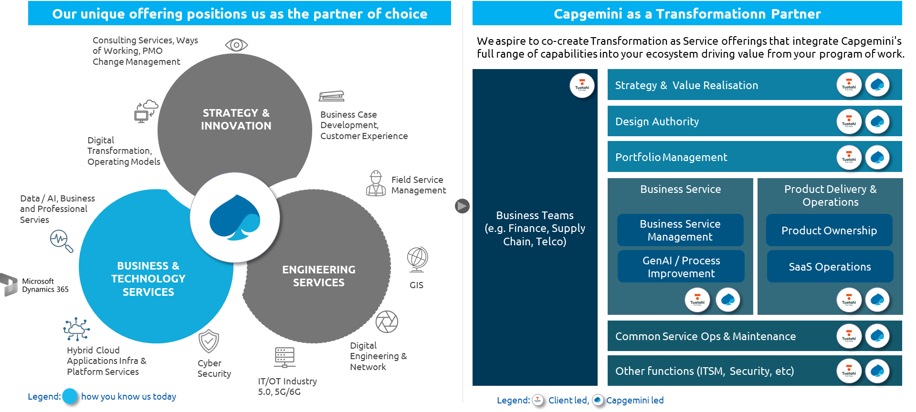

For Programme Horizon specifically, Capgemini brings the profile of a Prime System Integrator able to simplify delivery across a complex ecosystem while maintaining clear accountability for outcomes. We combine strong experience in large-scale business and systems transformation with deep capability across integration, data migration, programme governance, change management and post-go-live transition. This breadth matters for Horizon because success depends not only on implementing individual platforms, but on orchestrating them effectively across Portal & Customer, Network and Field Force workstreams, while protecting service continuity and supporting operational readiness.
Capgemini also brings a pragmatic, business-led approach designed to help Tuatahi realise value with lower delivery risk. We are recognised for combining strategic insight with practical execution, transparent collaboration and disciplined delivery controls. Our approach is grounded in scalable architecture, structured governance, embedded quality, and sustainable adoption, ensuring that Programme Horizon is not only delivered successfully, but also positioned to support Tuatahi’s long-term growth, customer experience ambitions and wholesale operating model transformation.

Our commercial approach
Capgemini proposes a phased commercial model for Programme Horizon that balances early delivery commitment with appropriate commercial discipline for a complex, multi-workstream transformation. The model is designed to enable Tuatahi First Fibre to commit to the programme in a controlled, outcome-led manner, with clear cost certainty for the upfront foundation phase and an estimate-based pathway for the remaining implementation scope.
This commercial approach has two components:
- Fixed component covering Initiation, Discovery and Detailed Design / Target Operating Model definition.
- Estimated component covering Build, Implementation, Hypercare and Support.
This structure provides Tuatahi First Fibre with a clear commercial commitment for the work required to mobilise, validate, shape and de-risk the programme before committing to the broader implementation scope.
It also supports progressive decision-making by allowing the delivery scope, assumptions, dependencies, implementation sequencing, data readiness, integration complexity and third-party inputs to be refined before the full delivery commitment is finalised.

Our Values
Much like Tuatahi’s Values meaning First
- First choice for Internet connectivity
- Putting our communities first
- First to recognise our place in society
- A track record of first
- First to the future
- People first culture
Capgemini is committed to fostering inclusive, respectful and culturally aware workplaces and delivery models.
Our approach supports business outcomes while:
- Promoting diversity, inclusion and equitable participation across the workforce
- Aligning delivery practices with New Zealand public sector values and community expectations
- Supporting engagement models that are respectful of Māori and Pasifika communities where relevant to the engagement
Capgemini recognises the importance of cultural context in Aotearoa New Zealand and works to ensure that its people, practices and behaviours reflect this understanding.
  - Capgemini supports the principles of the Te Tiriti o Waitangi
  - Capgemini staff are encouraged to participate in cultural activities
  - Capgemini offers voluntary attendance to regular Te Reo training classes
At Capgemini, our culture stems from our values. For more than 50 years, the way we operate, work and collaborate has been guided by our seven core values. They are at the heart of everything we do. These values shape who we are today, a responsible leader, determined to create a positive impact on our stakeholders and industry.
In 2023 we translated our Capgemini seven values to guide our mahi (work) into te reo Māori. These are being proudly displayed in all our four offices in Aotearoa New Zealand.
Our values provide the foundation for how we engage and lead our industry. In our interactions with clients and peers:
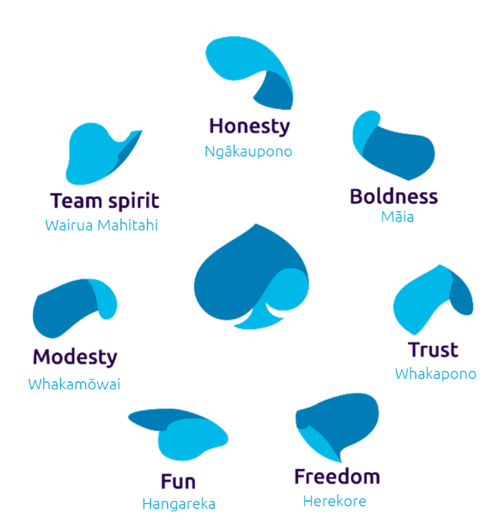

Environmental Sustainability
Environmental sustainability is embedded within Capgemini’s global operating model and informs how services are delivered locally.
This engagement will support environmental outcomes through:
  - Digital first delivery that reduces travel related emissions
  - Efficient use of technology to minimise resource consumption
  - Alignment with Capgemini’s broader sustainability commitments, including emissions reduction and responsible sourcing
In 2025 Capgemini saw a 94% reduction in overall carbon emissions, including a 70% reduction in CO2 emissions per head by reducing unnecessary travel.
Where applicable, digital solutions will be designed to improve operational efficiency and reduce environmental impact over time.
Our 2026 sustainability report Approach to ESG

Our love for Rugby
Much like Tuatahi’s love for Rugby with its major sponsorship of the Gallagher Chiefs. Capgemini also loves Rugby with our support and sponsorship of Rugby World Cup 2023, Women’s Rugby World Cup 2025, Rugby Sevens, 6 Nations Sponsor and we developed TryZone IQ as Principal Partner of the Women’s Rugby World Cup 2025, we bring real-time, AI-driven match insights to the Women’s Rugby World Cup 2025, a first for World Rugby. TryZone IQ will provide live match insights throughout the global competition, offering millions of rugby fans a clearer understanding of each game as it unfolds.
Capgemini brings real-time, AI-driven match insights to the Women’s Rugby World Cup 2025, a first for World Rugby
Capgemini becomes an Official Partner of Six Nations Rugby

Proposed Solution & High-Level Design
This section outlines Capgemini’s proposed high-level solution and design approach for Programme Horizon. It describes the target solution architecture, guiding design principles, core platform components, integration approach, scalability considerations, and key scope boundaries. The proposed solution builds on Tuatahi First Fibre’s existing architectural direction and mandated technology choices, with a focus on enabling a scalable, automated, data-driven, and customer-centric wholesale operating model.
Capgemini’s approach is to configure, integrate, and orchestrate the agreed platforms - including ServiceNow, Microsoft Dynamics 365, 3-GIS/ArcGIS, Okta, the RSP Portal, and Tuatahi’s broader data and integration ecosystem - to support the end-to-end order-to-bill lifecycle. The architecture is based on modular, API-first, catalogue-driven and governed design principles, with clear systems of record and strong traceability across customer, order, service, network, and billing domains.
The solution is also designed to minimise disruption to Tuatahi’s existing business operations through a phased transition approach. New capabilities will be introduced progressively, with controlled integration points, iterative data validation, planned cutover activities, and structured hypercare to support operational stability. The following sections describe the proposed architecture and the design considerations that underpin Capgemini’s response.

Overview of Solution Architecture
Tuatahi First Fibre have put significant effort in over the past couple of years to formulate a high-level plan for the digital transformation necessary to underpin the scalability, efficiency and improved customer experience that is critical to realise their vision of becoming New Zealand’s preferred connectivity provider. This has included a deep analysis of platforms and applications that can provide the requisite functionality to realise this vision. As such, the starting point for our solution architecture is the solid foundation that Tuatahi has laid in the selection of key applications and defined target state architecture.
Capgemini’s solution architecture is grounded in five key design principles that directly reflect Tuatahi’s objectives, constraints, and target-state architecture:

- API-first, modular and loosely coupled architecture – The solution is designed around an API-first, event-driven architecture with clear separation of domains (e.g. Product, Order, Billing, Network) to avoid tight coupling and fragile integrations. This aligns to the TM Forum ODA direction and ensures all customer and system interactions are exposed through governed APIs (including the Experience APIs and portal), enabling scalability, partner onboarding, and resilience to system change. Direct database access will be avoided unless explicitly agreed through design governance. Orchestration logic will remain centralised (e.g. in ServiceNow SOMT) while downstream systems execute discrete responsibilities, preventing duplication of logic and maintaining end-to-end traceability.
- Configuration-driven, catalogue-centric design (OPSR-aligned) – All core business capabilities (products, pricing, workflows, and rules) are driven through configurable catalogues aligned to the Offer–Product–Service–Resource (OPSR) model. This allows rapid introduction of new wholesale products and pricing without code changes and ensures consistency of data and behaviour across ordering, fulfilment, and billing. Centralised catalogues and lifecycle/version control are essential to enable automation, maintain auditability, and reduce reliance on custom logic, directly addressing current data fragmentation and operational inefficiencies.
- End-to-end automation with human exception handling – The design prioritises straight-through processing across the full order-to-bill lifecycle, including qualification, ordering, fulfilment, provisioning, and billing, such that manual intervention is the exception rather than the norm. Automated orchestration, SLA tracking, Work Order generation, and billing triggers are seamlessly integrated across systems, with humans focused on exception handling and risk management. This principle is fundamental to improving customer experience, reducing operational overhead, and increasing SLA performance.
- Single source of truth with governed data integrity and traceability – The solution enforces authoritative systems of record for key domains (catalogues, parties, orders, billing, and physical network inventory), eliminating duplication and inconsistency. Data will be consistent, auditable, and traceable across the lifecycle, from customer order through to underlying network resources and billing events. This includes enforcing Place-based traceability, OPSR relationships, and reconciliation between systems (e.g. fulfilment and billing). Strong data governance is essential to enable automation, compliance reporting, and operational visibility.
- Design for extensibility, maintainability and upgrade safety – The architecture supports long-term evolution without rework, including the ability to scale data volumes, onboard new partners, and extend capabilities (e.g. additional portal features or services). This requires strict adherence to vendor-supported patterns (e.g. ServiceNow, Dynamics 365), isolation of custom extensions, and avoidance of monolithic or shadow systems. Configuration will be maintainable by Tuatahi teams post-implementation, with clear separation between configuration and custom code, ensuring upgrade safety and reducing total cost of ownership over time.

Together, these principles ensure the solution directly addresses Tuatahi’s core challenges, being fragmented data, manual processes, and rigid legacy systems, whilst enabling a scalable, automated, and customer-centric wholesale digital platform. This solution is illustrated below, noting that the components are described in more detail in Section 6.

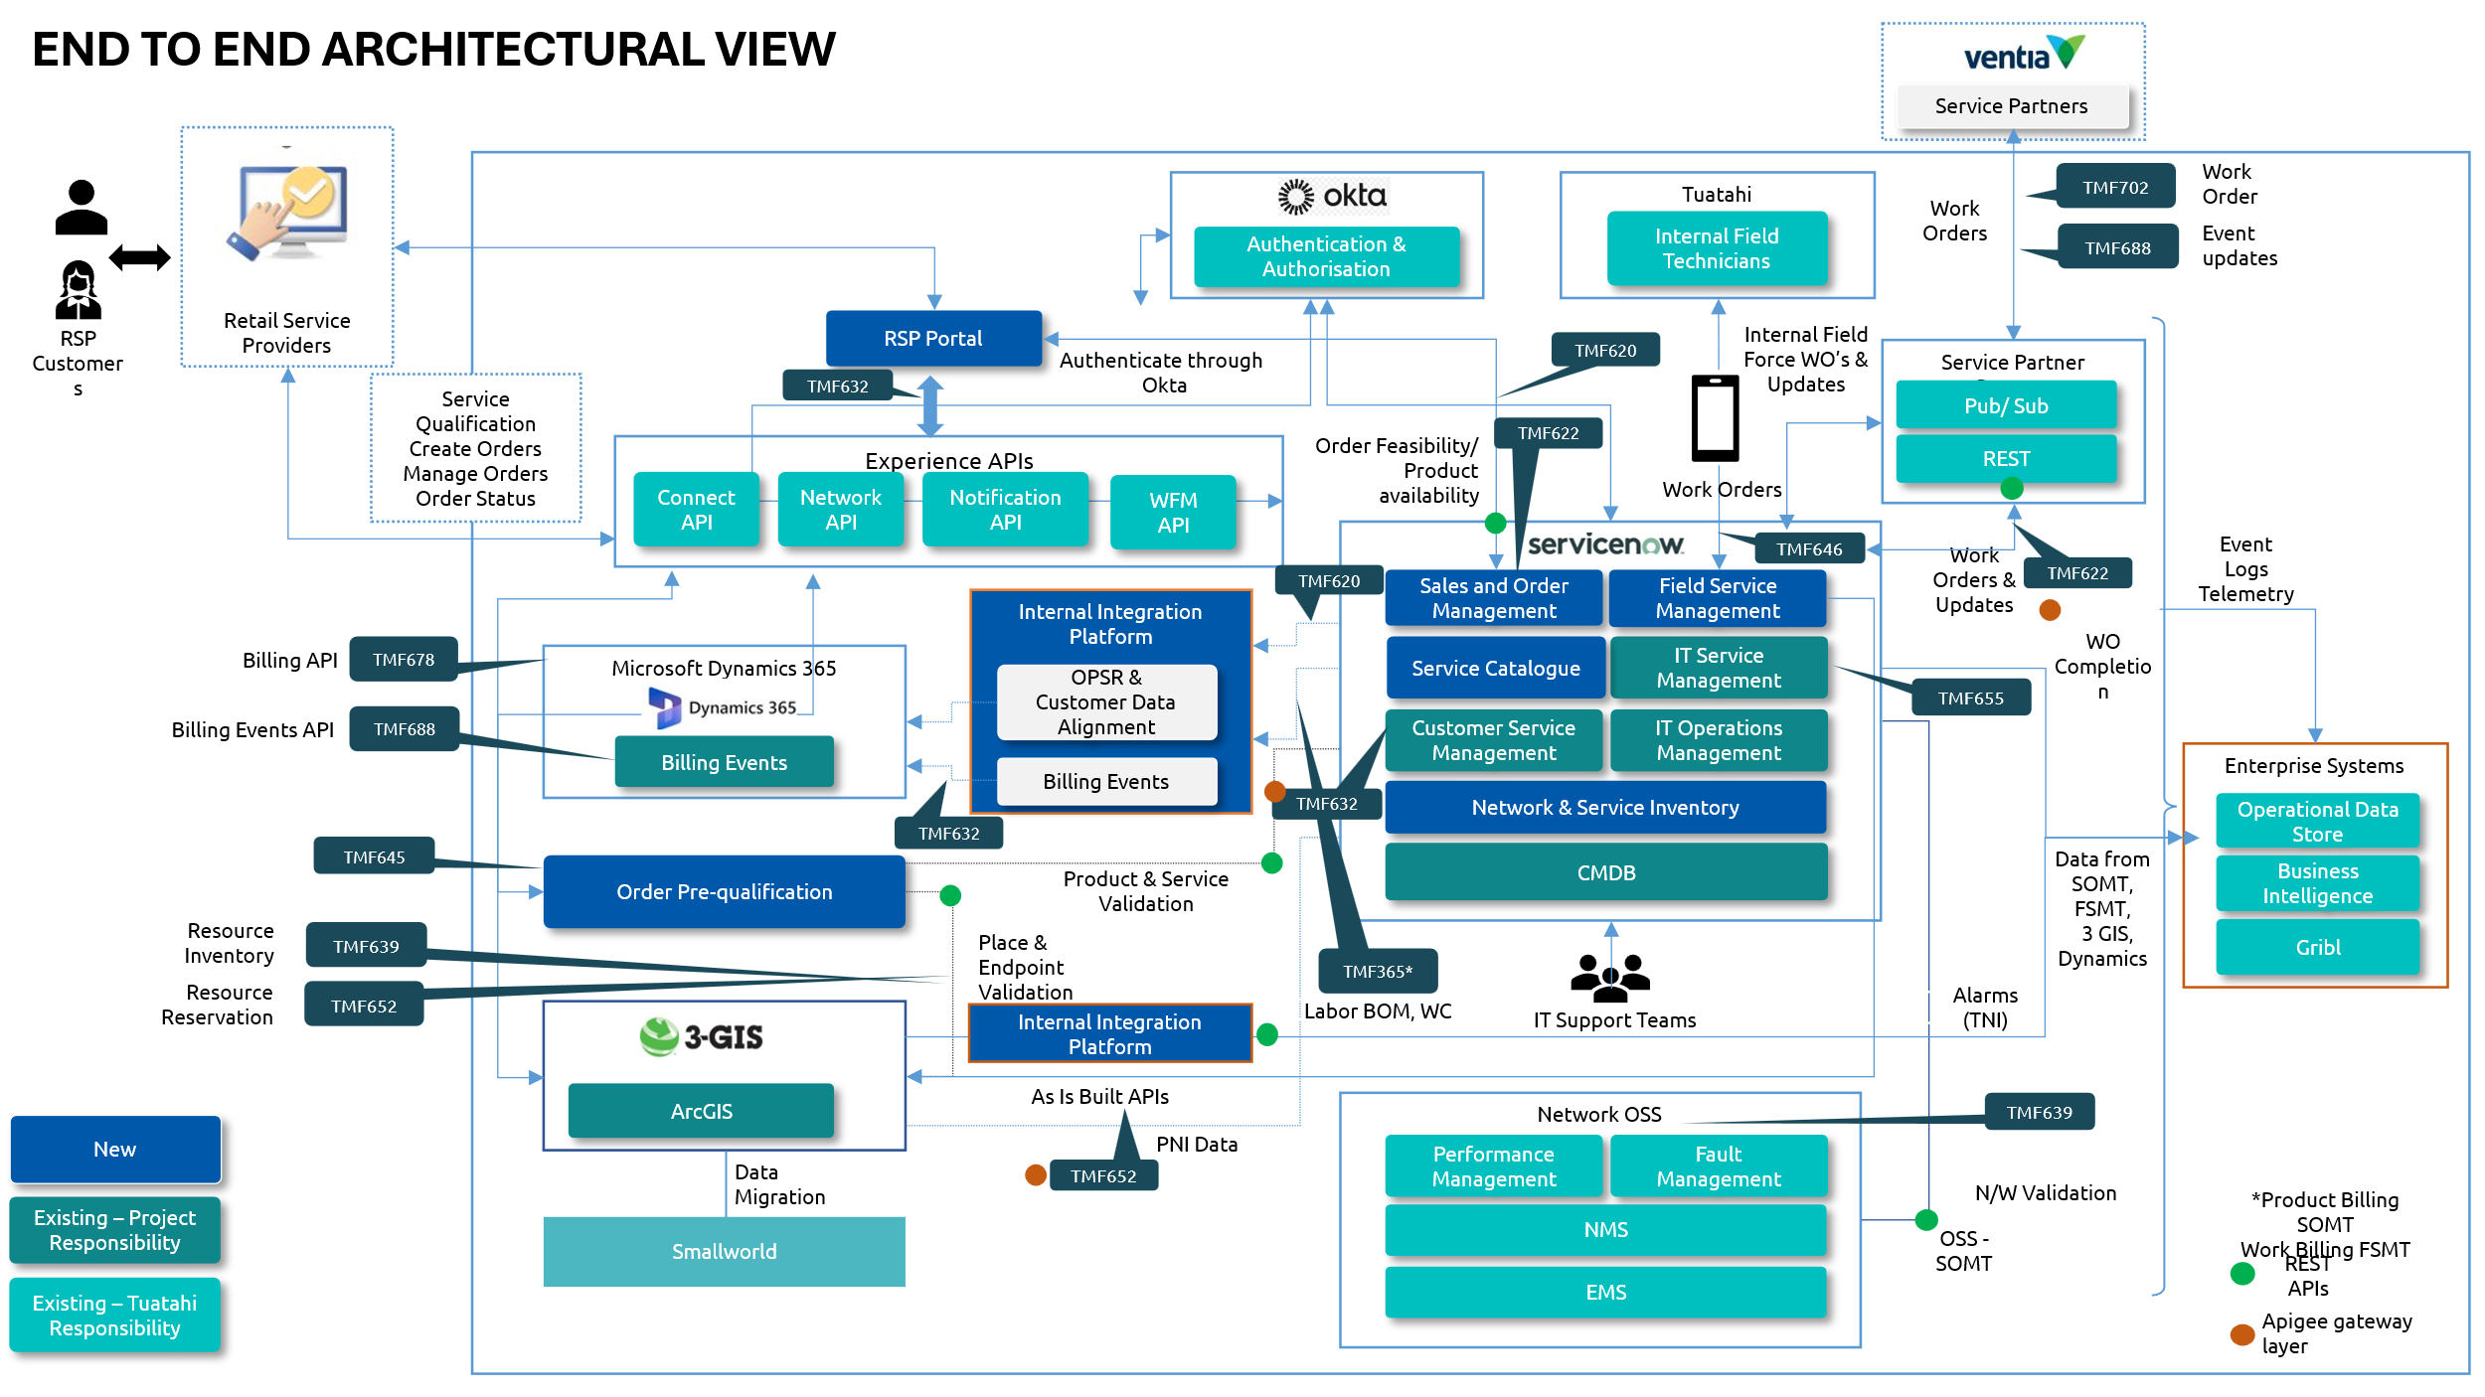

The proposed solution also respects Tuatahi’s mandatory systems and associated licensing constructs:
- ServiceNow TSM – Provides the CSM, ITSM and ITOM applications that are leveraged by the solution, with no uplift in existing licensing required.
- ServiceNow TSOM – Provides the Telecommunications-specific ITOM and Event Management capabilities will drive the assurance processes. This is an input into the assurance workflow automation, and will utilise existing configuration and licensing.
- Okta – Will integrate with the new Party Management capability for authentication and authorisation of RSP personnel.
- Microsoft Dynamics 365 – Provides the billing capability, in alignment with existing licensing.
- Microsoft Power BI – Part of the Business Intelligence stack that solution components will feed into, in alignment with existing licensing.
- Purview – Part of the Business Intelligence stack that solution components will feed into, in alignment with existing licensing.
- Synapse – Part of the Business Intelligence stack that solution components will feed into, in alignment with existing licensing.
- ArcGIS – Underpins the 3-GIS application for PNI.
Further to the technology that makes up the solution, we have also given significant consideration to how this solution can be delivered in a manner to minimise disruption to Tuatahi’s existing business operations, by adopting a phased, parallel, and low-risk transformation strategy. Core capabilities, such as the new catalogues, ordering orchestration, and portal, will be introduced incrementally alongside existing systems, with controlled integration points ensuring continuity of service during transition. Data migration will be executed through iterative cycles with validation and reconciliation at each stage, allowing defects to be identified and resolved early without impacting live operations. Cutover will be carefully planned with rollback and contingency measures, and legacy systems will only be decommissioned once full functional parity and data integrity is achieved. This is reinforced by a structured hypercare period post release, providing dedicated support, rapid issue resolution, and continuous monitoring to stabilise the environment while maintaining service continuity for RSPs and internal teams. This deliver approach is described in more detail in Section 4.

    - Scalability of the solution
The solution leverages enterprise-grade platforms that are inherently designed for scale and high-volume transaction processing. ServiceNow (SOMT, FSMT, CSM) operates on a multi‑tenant, cloud-native architecture with horizontal scaling across application nodes and database tiers, supporting high concurrency through stateless services and load-balanced API layers. It is proven to handle large-scale telecom workloads, including high transaction throughput (orders, Work Orders, API calls) and can elastically scale infrastructure resources to meet peak demand without service interruption. Its event-driven architecture and asynchronous processing model also allow integration workloads and orchestration logic to scale independently, ensuring that spikes in ordering or fulfilment activity do not degrade overall system performance.
Microsoft Dynamics 365 provides scalable financial and billing capabilities through its Azure-based platform, supporting elastic compute, distributed data services, and partitioned workloads for invoice generation, revenue calculation, and reconciliation. It can handle large billing volumes (hundreds of thousands of records per cycle) through batch processing and parallel execution, while maintaining transactional integrity.
3-GIS (on ArcGIS) delivers scalable network inventory management by leveraging ArcGIS Enterprise’s distributed architecture, including scalable map services, geospatial databases, and real-time data services. It supports large, complex network models with high read/write concurrency, enabling simultaneous planning, provisioning, and analytics workloads.
The qualification engine platform, InRule, supports high-throughput, parallel rule execution, making it suitable for synchronous API-driven use cases such as real-time pre‑qualification. It can also be integrated into asynchronous processing pipelines where needed (e.g. for batch or retry scenarios), and benefits from caching of reference data and pre-initialised rule sessions to minimise execution overhead. Since rule sets in this context remain relatively stable and modest in size, the primary scaling lever is compute elasticity, achieved through containerisation and auto-scaling based on request volume. This will ensure the qualification engine can meet peak demand without compromising response times or introducing bottlenecks in the ordering workflow.
The RSP portal, built as a lightweight React web application and hosted on AWS, is inherently scalable through a separation of static front-end delivery and backend API orchestration. The React application can be deployed via services such as AWS S3 with CloudFront, enabling effectively unlimited horizontal scaling for user access with minimal latency, although expected user loads are expected to be relatively low, due to the limited number of RSPs and their personnel.
Together, these platforms provide a proven, horizontally scalable foundation across orchestration, billing, and network domains, aligned to Tuatahi’s requirements for growth (≥4.5x data scale) and sustained peak performance.

    - Enterprise integration for monitoring, observability and operational telemetry
The solution is designed to integrate seamlessly with Tuatahi’s enterprise monitoring, observability, and logging ecosystem by embedding instrumentation and telemetry as a foundational capability across all components. All APIs, orchestration layers (e.g. ServiceNow SOMT), and field/workflow systems can emit structured logs, metrics, and events that conform to enterprise standards, ensuring consistent visibility across the full order‑to‑bill and Work Order lifecycle. Correlation identifiers are propagated end‑to‑end, enabling tracing of individual transactions across multiple systems and integration layers, from customer order through fulfilment, network allocation, and billing. This ensures that operational teams can rapidly diagnose issues, understand system behaviour, and maintain full traceability across distributed workflows, in line with the requirement for end‑to‑end observability and diagnosable integration behaviour.
In addition, the solution can integrate with Tuatahi’s central monitoring and alerting platforms to provide real-time operational visibility and proactive incident management. Business and technical metrics (such as order throughput, SLA performance, Work Order progression, and API response times) are exposed through dashboards, while alerting mechanisms are aligned to agreed severity levels with clear ownership and remediation pathways. Failure scenarios generate actionable alerts and structured error responses, enabling rapid triage without reliance on customer-reported issues. Logging and monitoring outputs are also designed to support audit, security, and compliance requirements, ensuring that all system activity (including exceptions, retries, and integration failures) is captured, traceable, and available for analysis, continuous improvement, and governance.

Programme Plan and Delivery Methodology
This section outlines Capgemini’s end-to-end delivery approach for Programme Horizon, combining a structured, governance-led foundation with an iterative, release-based execution model to ensure controlled delivery, progressive value realisation, and alignment to Tuatahi’s strategic outcomes.

Integrated Programme Plan on a Page
Capgemini’s programme plan and delivery approach for the Programme Horizon is structured to provide a clear, phased, and collaborative pathway across a three-release delivery model. This approach combines disciplined planning with iterative validation to ensure transparency, predictable outcomes, and early risk mitigation.
The Plan on a Page below outlines key activities, deliverables, governance checkpoints, and milestones from initiation through to completion across approximately 27 months. It provides Tuatahi stakeholders with clear visibility of objectives, responsibilities, sequencing, and indicative delivery timeframes, while maintaining flexibility to adapt as required.

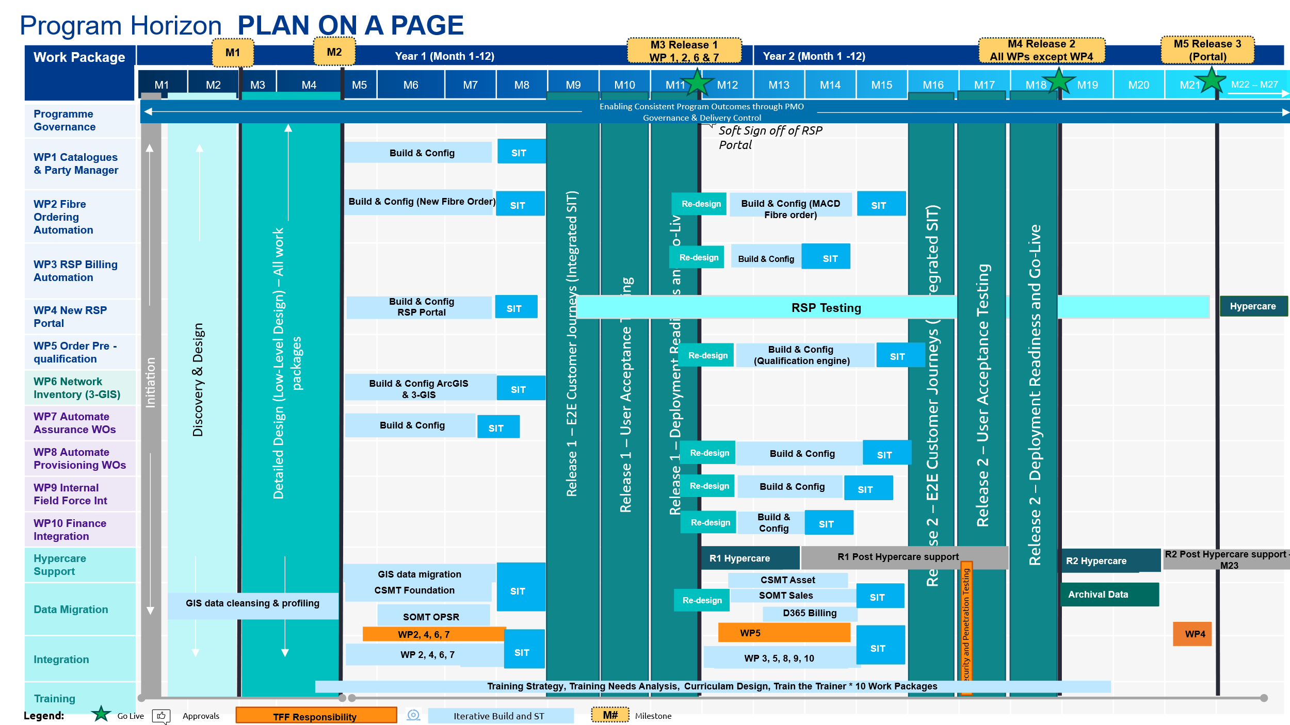
The highlights of this plan include:
- Programme initiation through Discovery & Design (M1–M4) establishes scope, architecture, and detailed delivery planning across all work packages.
- A formal scope and timeline checkpoint (decision gate) is embedded at the end of the Design phase and prior to the build activities in each release.
- Build, configuration, integration, and testing activities are iteratively delivered and refined across releases, with detailed sequencing confirmed during Design phase and re-baselined before Build.
- Each release includes a dedicated cycle:
  - System Integration Testing (SIT)
  - User Acceptance Testing (UAT) and security/penetration testing (Execution by TFF) (combined ~4 weeks)
  - Deployment readiness and controlled go-live
  - Hypercare support (~4 weeks-12 weeks depending on the complexity of work package)
- A transition window between Release 1 and Release 2 ensures stability and readiness before scaling delivery.
- Ongoing programme governance, delivery control, and training enablement run across the full timeline to support adoption and business readiness.
The monthly view presented is indicative and will be refined based on finalised commencement dates and outcomes of the Discovery phase.

Proposed Delivery Approach and Methodology
Capgemini proposes a hybrid delivery methodology for the Programme Horizon. This approach adopts a structured front-end with iterative downstream execution, aligned to a three-release delivery model that ensures control, transparency, and progressive value realisation.
The programme commences with a fixed priced, structured four-month Discovery and Design phase (M1–M4), as reflected in the Plan-on-a-Page. This phase is deliberately designed as a comprehensive, all-work-package activity, ensuring that scope, architecture, and delivery pathways are established holistically rather than incrementally.
During this period, all work packages progress through:
- Discovery activities to establish current state, requirements, and constraints
- Detailed design to define future-state processes, integrations, data models, and solution architecture
- Data readiness activities, including cleansing, profiling, and migration strategy definition
- Integration and environment planning, ensuring downstream build readiness
A key characteristic of this phase is formal governance and controlled sign-offs. Clearly defined outputs covering scope, design artefacts, architecture, and delivery plans are validated and signed off at the end of the phase, creating a baseline for execution. This acts as a critical decision gate, ensuring alignment on scope, timeline, and investment before entering build.
Transition to build: Following Discovery & Design sign-off, the programme transitions into an iterative build and testing model across parallel work packages, with progressive validation and planned convergence into integrated testing and release events.
This hybrid delivery methodology provides Tuatahi with:
- Upfront certainty through a fixed priced, sign-off driven Discovery & Design phase
- Execution flexibility via iterative build and testing across work packages
- Reduced integration risk through structured convergence into integrated SIT and UAT
- Predictable value delivery through a clearly sequenced three-release model
The result is a balanced approach combining control and agility, ensuring that Tuatahi achieves a scalable, high-quality solution while maintaining confidence in delivery outcomes at every stage of the programme.

Discovery & Design Phase
The Discovery & Design phase is a critical control point, ensuring full alignment across scope, architecture, data, and integration, and establishing a governed baseline for execution through formal sign-offs and re-baselining of the programme plan.
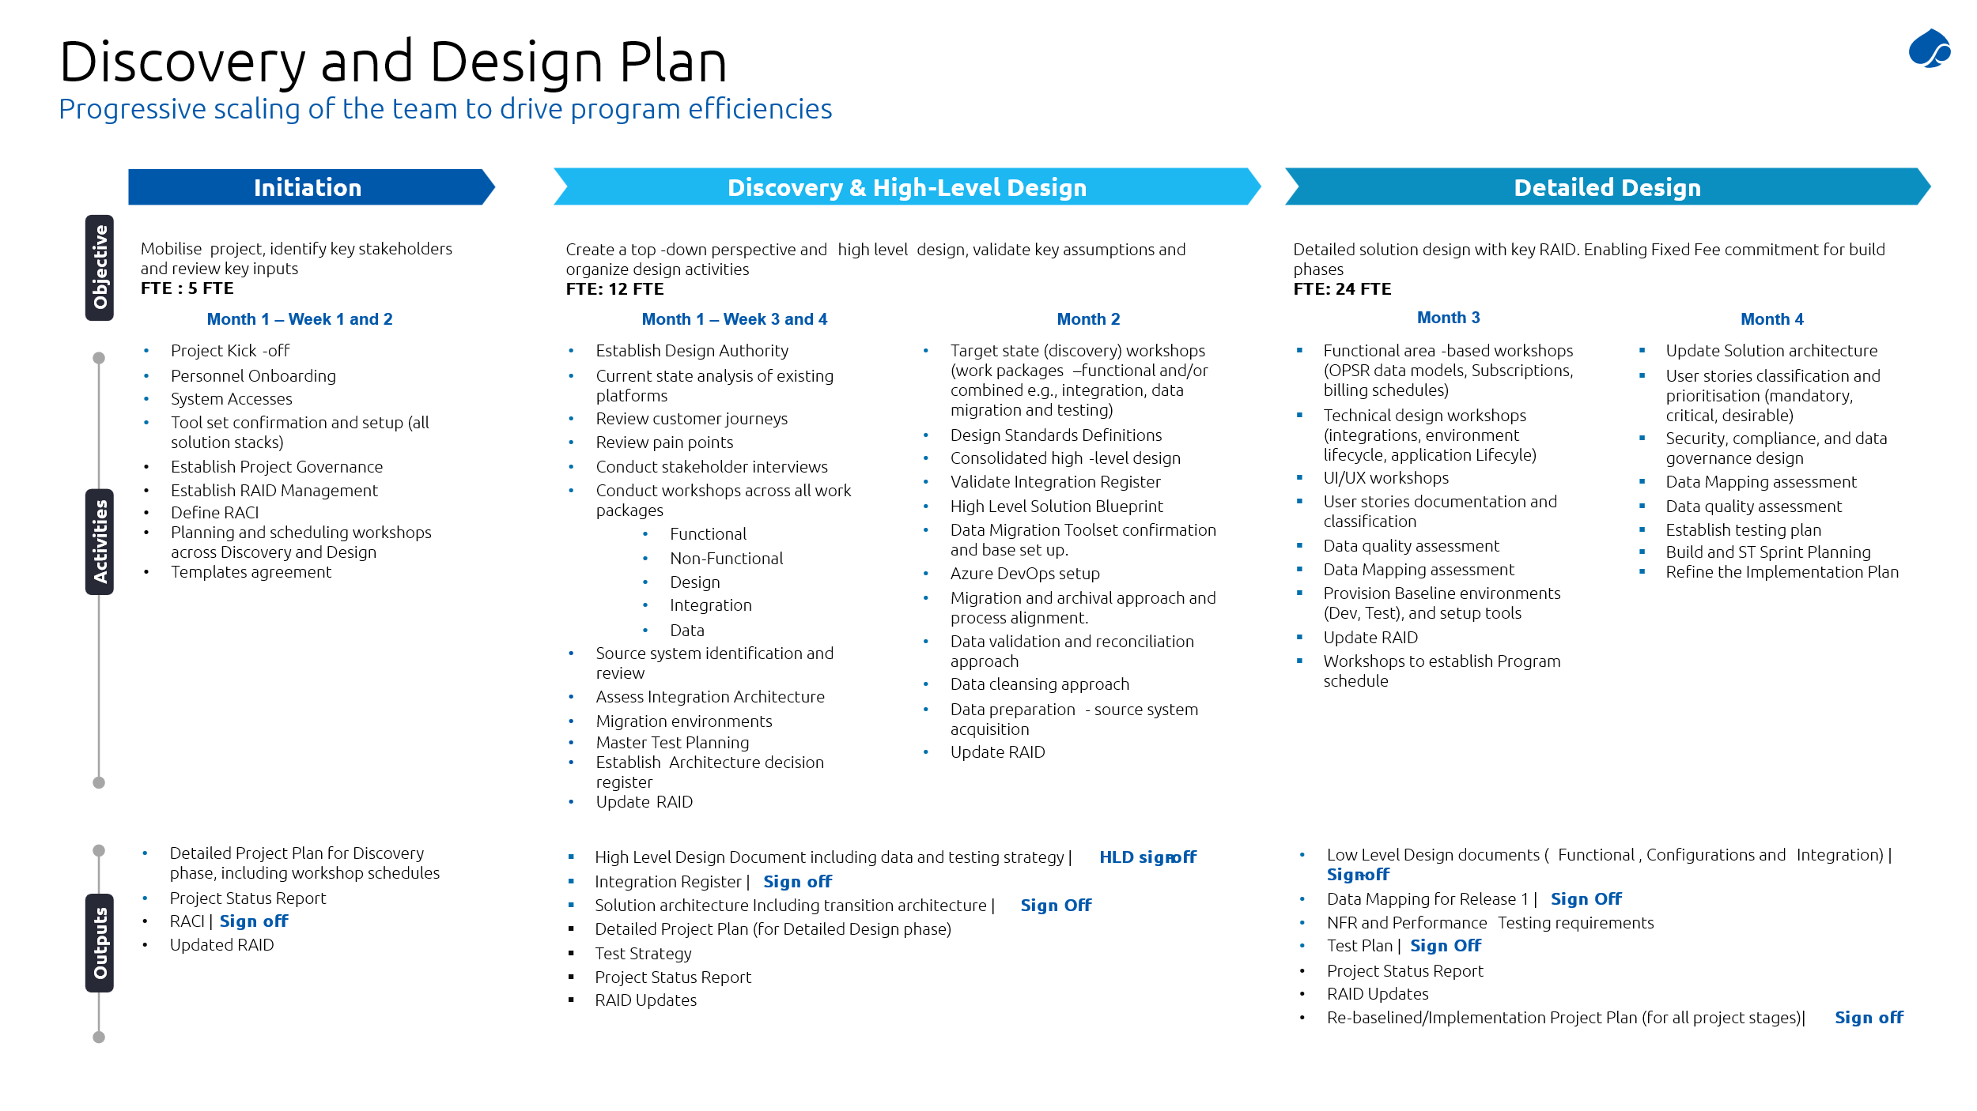
As illustrated in the Discovery and Design plan above, the programme begins with a fixed four-month phase (M1–M4), designed to establish a robust, fully validated foundation for execution. This phase is structured across three progressive stages - Initiation, Discovery & High-Level Design, and Detailed Design with progressive scaling of the team (5 → 12 → 24 FTE) in order to drive efficiency and depth.
    - Initiation (Month 1 – Weeks 1–2)
The programme is mobilised with a strong governance and operational foundation:
- Project mobilisation, onboarding, and environment/tool setup
- Establishment of governance structures (RAID, RACI, reporting cadence)
- Confirmation of delivery approach, workshop plans, and stakeholder alignment
    - Discovery & High-Level Design (Month 1–2)
This stage establishes a top-down view of the solution, validating scope and shaping the future state across all work packages:
- Current state analysis, pain-point identification, and stakeholder interviews
- Cross-work-package workshops (functional, non-functional, integration, data)
- Definition of target state customer journeys and integrated processes
- Establishment of design authority and design standards
- High-level solution architecture, integration patterns, and migration strategy
- Data strategy including cleansing, validation, and tooling setup
    - Detailed Design (Month 3–4)
The final stage converts high-level designs into build-ready, execution-level artefacts, enabling a fixed-fee, controlled build phase:
- Functional, technical, integration, and UI/UX design completion
- User story definition and prioritisation
- Data mapping, data quality assessment, and migration planning
- Security, compliance, and governance design
- Environment provisioning (Dev/Test) and testing strategy definition
- Build and sprint planning aligned to work packages
    - Team Structure
The team structure is designed to align with the phased delivery approach, enabling efficient mobilisation during Discovery and progressive scaling during Design and Build.
During the Initiation and early Discovery phase, a lean core team (~5 FTE) is mobilised to establish programme foundations. This includes key roles across programme management, architecture, and business analysis to drive stakeholder alignment, governance setup, and initial discovery activities.
As the programme progresses into Discovery & High-Level Design, the team expands to approximately 12 FTE, bringing in additional functional, integration, and data specialists to support parallel workshops across work packages. This ensures comprehensive coverage of requirements, architecture, and cross-domain dependencies.
Capgemini proposes an in integrated team structure aligned to the Discovery and Design Phases, combining programme leadership, governance and specialist delivery capability across Portal & Customer and Field Force workstreams. This structure ensures clear accountability, strong architectural oversight and coordinated delivery across all work packages.
Executive and Governance Layer
Role | Description
Executive Sponsor | Provides strategic direction and executive oversight of Programme Horizon, ensuring alignment to Tuatahi’s business objectives and transformation outcomes. Acts as the escalation point for enterprise-level risks, champions the programme across leadership forums, and ensures sustained executive sponsorship and decision-making momentum.
Programme Leadership & Delivery Management
Role | Description
Delivery Executive | Holds end-to-end accountability for programme delivery, ensuring integration across all workstreams and alignment to scope, schedule, cost, and quality objectives. Drives delivery performance, manages cross-programme risks and dependencies, and ensures outcomes remain aligned to business value and Programme Horizon objectives.
Engagement Manager | Leads day-to-day engagement with Tuatahi stakeholders, ensuring clear communication, alignment to business priorities, and effective governance execution. Coordinates across delivery teams to resolve issues, maintain stakeholder confidence, and ensure delivery remains responsive to evolving programme needs.
Programme Control Office
Role | Description
PMO Lead | Establishes and operates the Programme Control Office (PCO) as the central coordination and control function. Oversees integrated planning, RAID management, dependency tracking, financial and resource governance, and reporting. Ensures delivery transparency, proactive risk management, and timely escalation to governance forums.
PMO Scheduler | Develops and maintains the integrated programme plan, ensuring alignment across work packages, milestones, and dependencies. Works closely with workstream leads to manage sequencing, critical path, and re-baselining activities to support effective delivery planning and decision-making.
Design Authority
Role | Description
Enterprise / Design Authority | Provides overarching architectural governance across Programme Horizon, ensuring alignment to target-state architecture, design principles (e.g. API-first, OPSR), and integration standards. Chairs design forums, governs key technical decisions, and ensures consistency and scalability across all workstreams.
Workstream Specific Delivery Roles
Portal & Customer (Workstream A)
Role | Description
Portal Technical Lead | Owns the end-to-end technical design of the RSP Portal, ensuring alignment with Experience APIs, security, and front-end architecture. Drives portal solution decisions, manages technical dependencies, and ensures scalability, performance, and integration with backend systems.
UI/UX Lead | Leads the design of user journeys and interface experiences, ensuring the portal is intuitive, accessible, and aligned to RSP needs. Facilitates co-design workshops, produces high-fidelity designs, and ensures alignment between user requirements and technical delivery.
Rules Expert (Pre-Qualification / InRule specialist) | Designs and configures the rules engine underpinning order pre-qualification and eligibility. Translates business logic into maintainable, auditable rule sets, ensuring flexibility for business users and supporting automation, accuracy, and decision transparency.
ServiceNow Architect (CSM/SOMT) | Leads configuration and design of ServiceNow platforms, including catalogue, ordering, and customer management capabilities. Ensures alignment to OPSR data model, supports automation of customer journeys, and governs platform design across work packages.
Billing & Finance (Cross Workstream)
Role | Description
Finance Lead (Dynamics 365 F&O) | Leads the design of billing and financial processes, ensuring alignment to subscription billing, invoicing, reconciliation, and financial controls. Works closely with business stakeholders to ensure the solution meets accounting, compliance, and reporting requirements.
F&O Integration Lead | Owns integration between ServiceNow and Dynamics 365, ensuring accurate, event-driven data flow for billing and financial transactions. Manages interface design, data mapping, and exception handling to ensure billing accuracy and traceability.

Network (Workstream B)
Role | Description
3-GIS Solution Architect | Owns the design and implementation of the Physical Network Inventory (PNI) solution, ensuring it operates as the authoritative source of truth for network assets. Ensures data integrity, spatial accuracy, and alignment to integration requirements.
Network Integration | Leads integration between GIS, ServiceNow, and downstream systems, ensuring seamless data exchange for provisioning, fulfilment, and inventory management. Manages dependencies and ensures alignment between logical and physical network layers.
Field Force (Workstream C)
Role | Description
FSMT / ServiceNow Architect | Leads the design of field service capabilities using FSMT, ensuring effective orchestration of assurance and provisioning work orders. Defines workflows, lifecycle states, and integration points to support automated and controlled field operations.
Integration Specialists | Supports integration with the Service Partner Gateway (SPG), enabling seamless routing of work orders to internal and external partners. Ensures consistent execution models, real-time status updates, and alignment across field service operations.
Cross Cutting Delivery Roles
Role | Description
Integration Lead | Provides overall integration oversight across systems and workstreams, ensuring consistency of integration patterns, API design, and data exchange. Coordinates cross-system dependencies and mitigates integration risks.
Data Migration Lead | Owns the data strategy across migration, cleansing, and reconciliation activities. Ensures data quality, integrity, and traceability across systems, supporting accurate reporting and enabling automation.
Test Manager | Defines and governs the end-to-end testing strategy, ensuring quality across SIT, UAT, and integrated customer journeys. Coordinates test execution, defect management, and readiness for transition into build and deployment.
Training Lead | Leads the training and enablement strategy, driving a train-the-trainer model to support business readiness. Develops training materials, supports knowledge transfer, and ensures users are equipped to adopt new systems and processes.
Business Analysts | Business Analysts are embedded within each workstream (Portal & Customer, Network, Field Force) to support detailed requirements elicitation, stakeholder workshops, and process design. They work closely with SMEs, architects, and technical teams to define user journeys, validate business logic, and ensure that solution designs accurately reflect operational needs and programme objectives.
The team structure is designed to:
- Provide clear accountability across governance, design and delivery layers
- Enable parallel workstream execution while maintaining integration control
- Ensure strong architectural governance through the Design Authority
- Support progressive scaling aligned to Discovery and Design phases
- Deliver a fully integrated Capgemini–Tuatahi team model
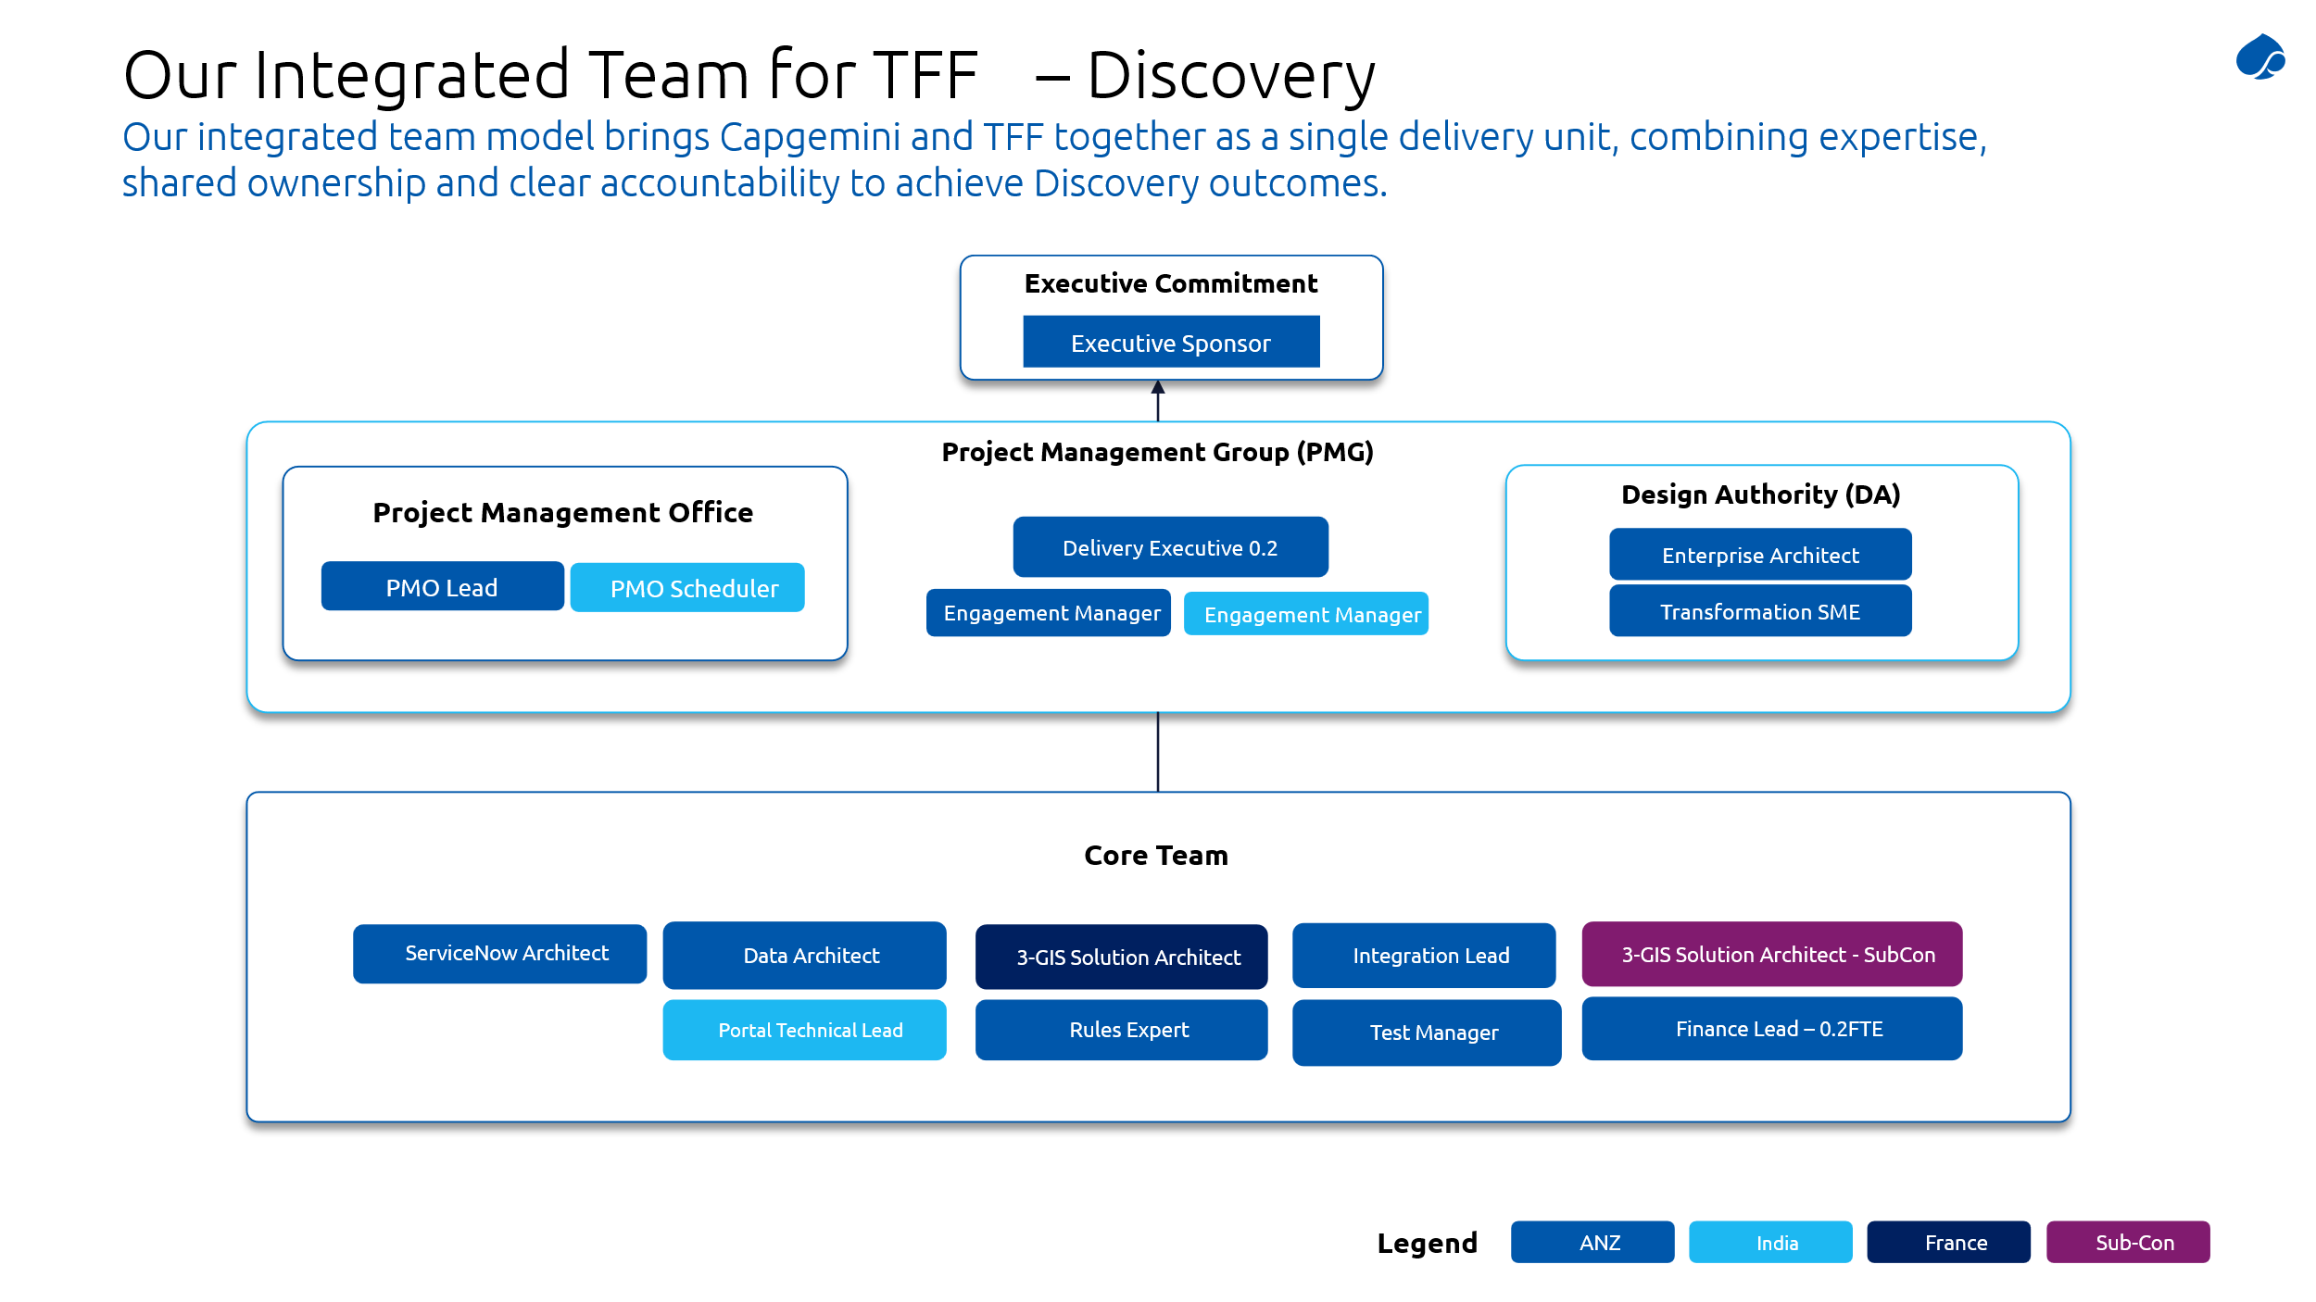
During Detailed Design, the team further scales to approximately 24 FTE, reflecting the increased intensity of design activities. This broader team includes functional designers, technical architects, integration specialists, data analysts, and testing leads, enabling the development of build-ready artefacts across all work packages.
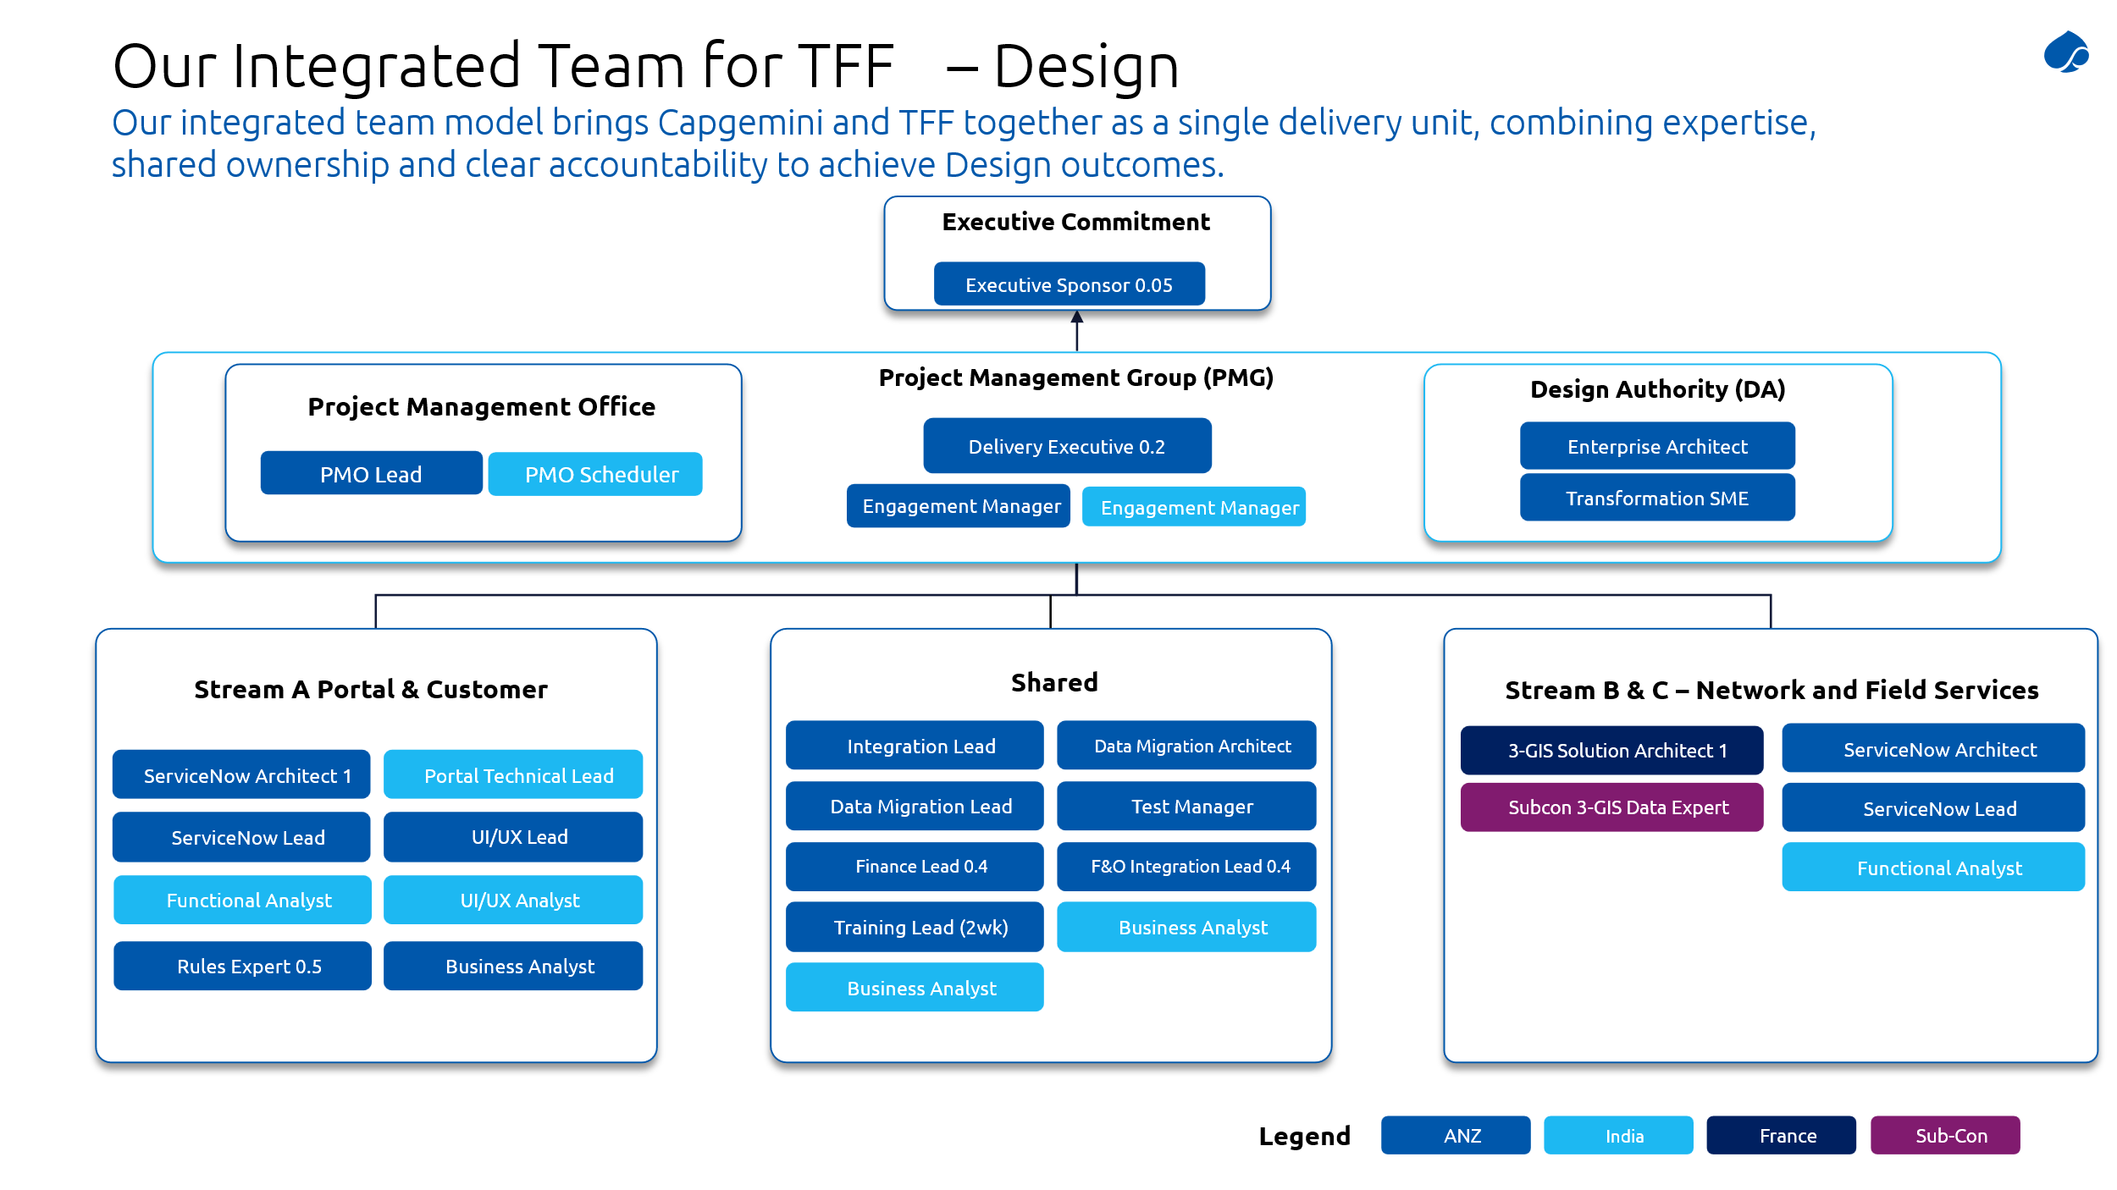
This progressive scaling model:
- Optimises cost and resource utilisation during early phases
- Ensures the right expertise is introduced at the right time
- Supports parallelisation across work packages without compromising quality
- Aligns with the transition into an iterative build and testing model post Design sign-off
The structure ensures continuity of key leadership roles throughout, while flexibly scaling delivery capacity in line with programme demands.

    - Iterative Build and Configuration and Testing (execute)

Following the sign-off from Design phase, the programme transitions into an iterative build and testing model, spanning multiple work packages running in parallel.

As illustrated in the Plan-on-a-Page:
- Work packages such as Catalogues, Fibre Ordering, Billing, Network Inventory, and Provisioning progress through build and configuration cycles, with embedded System Integration Testing (SIT) at the work package level
- Certain capabilities in later releases undergo targeted redesign cycles, reflecting evolving requirements and lessons learned from earlier releases
- Data migration, integration, and training activities continue progressively and are aligned with build maturity
This iterative approach enables:
- Early development of functional components
- Continuous validation at the work package level
- Flexibility to refine and enhance design elements without impacting overall programme control
A detailed description of the solution approach, scope, and design considerations for each individual work package including functional coverage, integration touchpoints, data requirements, and delivery sequencing is provided in Section 4, offering further granularity on how each component contributes to the overall delivery outcomes.
    - Convergence into Integrated Testing and Go-Live
While build and testing occur iteratively at the work package level, a defining feature of the methodology is the planned convergence of relevant work packages into integrated testing and release events.
For each release:
- Work packages scheduled for that release come together into an integrated System Integration Testing (SIT) phase, validating end-to-end customer journeys (E2E journeys) across systems
- This is followed by User Acceptance Testing (UAT), ensuring business validation of complete workflows rather than isolated components
- Additional security and penetration testing is performed within the same window
- The release then progresses through deployment readiness, go-live, and hypercare
This convergence model ensures that although delivery is iterative, integration risk is actively managed and retired before go-live, and the business experiences fully functioning, end-to-end capabilities at each release milestone.

    - Proposed Cut over and Go-Live/ Release Plan
Work packages are grouped by integration dependency and business value, not by workstream ensuring that each release delivers a coherent, operational capabilities rather than an isolated technical component.

During M1-M5 the programme will operate on the existing product catalogue pending WP1 go-live at Release 1 (Month 11). WP3 Billing Automation is dependent on upstream order and field order processes being in place prior to go-live. These are delivered in Release 2 (Month18). WP7 Assurance Work Orders will continue to follow existing manual processes until Release 1 go-live.

 | Release 1 | Release 2 | Release 3 | Applies across all releases
Timing | - Year 1 Q4  - (Month 11) | - Year 2 Q2  - (Month 18) | - Year 2 Q4  - (Month 22) | - Go live criteria, hypercare governance and BAU handover plan required for each release
Work Packages | - WP1 Catalogue & Party Manager  - WP2 Fibre Ordering (New Fibre)  - WP6 Network Inventory (3-GIS)  - WP7 Automate Assurance WOs | - WP2 Fibre Ordering (MACD/RSP)  - WP3 RSP Billing Automation, WP5 Order Pre-qualification, WP8 Provisioning WOs, WP9 Internal Field Force Integration, WP10 Finance Integration | - WP4 New RSP Portal  - (Portal release only) | - Release readiness gate criteria applied consistently across all three releases
Key Capability Delivered | - SOMT operational with new Fibre ordering  OPSR catalogue and party management live  - PNI authoritative source, assurance Wos automated | - MACD order journeys live, billing automation active provisioning WOs automated end to end, internal field force integrated | - RSP Portal live with full self-service product catalogue via Experience APIs, BOM & billing events | - Steering Committee approval required before each go-live SIT exit evidence, UAT acceptance, migration validation, OCM readiness and no production promotion without TFF sign off
- Key Dependencies | - WP2 <->WP6 PNI allocation  - WP6 <-> WP5 qualification feeds  - WP7 <-> SPG + Ventia Integration | - WP3 <-> SOMT billing events  - WP8 <-> Ventia + SPG  - WP9<-> FSMT  - WP2 <-> RSP Portal feeds | - WP4 <-> Experience API (12-month RSP notice)  - WP10 <-> D365 + Survey 123  - WP3<-> OSD Pipeline | - All cross WP dependencies tracked in the PCO dependency register, updated and reviewed at Programme Delivery Board

Note:
- WP4 (New RSP Portal) carries a hard Month 22 delivery constraint driven by the mandatory 12-month RSP notice period. The RSP testing window runs M9-M20 and tracked as a critical external dependency from Month 1. Any risk to this window triggers immediate Steering Committee escalation.
- Release plan presented in this section is proposed with the available details and will be validated & adjusted during the discovery & design phase.

    - Hypercare and Post Go-Live Support
Post-implementation support will be provided through a structured hypercare period followed by transition to steady-state support. Services include:
- Incident, problem, and defect support aligned to agreed severity levels
- Knowledge transfer and shadowing with the managed services team
- Ongoing documentation updates during hypercare
- Clear escalation paths and governance aligned to Tuatahi arrangements

Once the solution is deployed into production, key members of the build team remain engaged to ensure a smooth transition to support. Our process is described below.
- Stabilisation and Hypercare: After Business Go-live, the solution enters a stabilisation phase supported by a dedicated Hypercare period. Our team will proactively address emerging issues, provide ongoing support, and ensure a seamless transition to the regular operational support model. During the Hypercare period, our team will provide comprehensive support, as illustrated below, to ensure a smooth transition to regular operations.
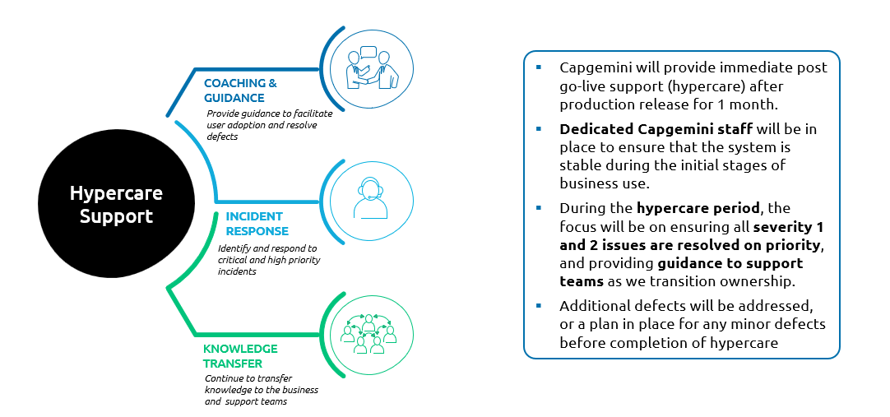
- Seamless Handover: Our Global Transition Methodology ensures a smooth, secure, and effective transfer of knowledge and services without impacting business performance. A dedicated team will transition into Hypercare and Warranty, working alongside the support team mobilised four weeks prior to the end of Hypercare to facilitate knowledge transfer and joint support activities.

Capgemini proposes below indicative target service levels, subject to confirmation during contracting and Discovery.

Priority of Incident | Response SLA | Minimum | Resolution SLA | Minimum
P1 | 30 mins | 95% | 2hrs | 95%
P2 | 60 mins | 95% | 4 hrs | 95%
P3 | 1 business day | 95% | 2 business day | 95%
P4 | 2 business days | 95% | 4 business days | 95%

For P1 and P2, the start time for the incident response and resolution is taken as the time of the call received from the service desk to the on-call SME.
A brief definition of the Priority levels is provided below as reference.

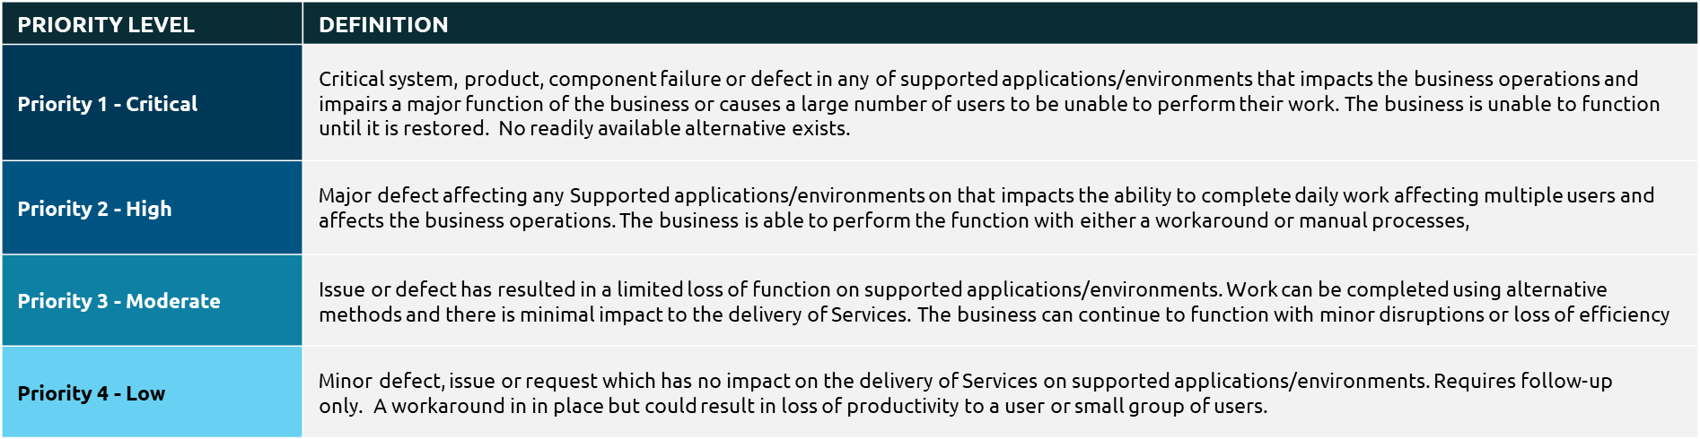
The model outlined in this section is based on the information currently available and will be further validated and refined through the Discovery and Design phases, with subsequent stabilisation, hypercare, and structured transition to steady-state support ensuring alignment with operational requirements.
    - Post-Hypercare Support Model
As detailed in the RFP document, work packages will enter the post hypercare phase only when all work packages in that stream have completed their hypercare phase.
During this period primary support will be provided by TFF and lean team from Capgemini will be there to support any critical issues
    - Archival and Decommissioning
Decommissioning support is a shared responsibility between Capgemini and TFF, with Tuatahi retaining accountability for final decommissioning decisions, approvals and execution.

The following systems are expected to require decommissioning support:
- Telflow
- Inomial
- Place
The activities in scope include:
- Decommission plan for an application will coincide with its go-live, data migration and archival requirements
- Capgemini team will create a dependency matrix to confirm impacted systems, interfaces and downstream
- Capgemini team to validate with impacted work package leads to ensure the data archival requirements, if any, for the system have been taken care of
- Capgemini team to validate if the impacted system has completed the hypercare phase before the decommission request can be raised
- TFF will provide a readiness criteria like the one’s listed below:
  - Successful migration and reconciliation
  - Data archival / retention arrangements completed
  - UAT and business sign-off
  - Compliance validation
  - Operational readiness
- Capgemini will support validation against the checklist and prepare evidence for Tuatahi’s decommissioning readiness review.
- Once readiness evidence has been reviewed, TFF will raise the decommissioning request, obtain required approvals and execute the final system shutdown or retirement.

RACI for Decommissioning activities

(R) | Responsible | Carries out the process or activity
(A) | Accountable | Owns the process or activity being completed
(C) | Consulted | Stakeholder or subject matter who is consulted to provide input
(I) | Informed | Receive the output of activity

Activities | Capgemini | TFF
Decommissioning support strategy and plan | C | A, R
Dependency matrix | C | A, R
Data archival and retention planning inputs | C | A, R
Readiness criteria checklist | C | A, R
Readiness evidence gathering | R, C | A
Cutover alignment and rollback planning inputs | R, C | A
Final system shutdown / disabling legacy platforms — TFF execution | C | A, R
Vendor-led retirement activities for legacy systems — TFF/vendor execution | C | A, R
Decommissioning of non-Capgemini integration components — TFF/vendor execution | C | A, R

For clarity, Capgemini’s role is limited to decommissioning support, planning inputs, dependency analysis and readiness evidence. Tuatahi remains accountable for all final decommissioning approvals, production changes, system shutdown and vendor-led retirement activities.

Data archival details are covered in detail in data migration (Section 6.5) and 3-GIS work package section

Use of AI
Gen AI accelerators have been solutioned across the programme wherever appropriate, the different accelerators being planned are listed below:

- RSP Portal & Integrations:
  - Github Copilot for Visual Studio/VS code will be used for efficiencies & quality across below phases:
    - Development
    - Unit Test case and draft design document generation
- Training
  - TNA & Curriculum - Identifies skill gaps and dynamically refines role-based learning paths.
  - Training Materials: Rapidly generates and personalises content (guides, videos, QRGs).
- Testing
  - GitHub Copilot will be leveraged during the test design phase SIT, E2E and UAT test cases to improve efficiency and accelerate the creation of high-quality test cases.

Key Assumptions
Topic | Assumptions
Scope, Planning & Delivery Assumptions​ | - The proposed project plan, sequencing and timelines are indicative and based on information available at the time of proposal. ​  - Tuatahi and Capgemini will jointly validate requirements, volumetrics, backlog, and delivery approach during negotiations​  - Final scope, estimates, and delivery timelines will be jointly confirmed and re-baselined. Any subsequent variances will be managed through agreed governance and change control processes.  - Scope, Solution design and delivery modelling is based on documentation, volumetrics considerations and data artefacts provided during the proposal process. ​
Governance, Decision-Making & Change Control​ | - Material organisational, regulatory, legislative, or compliance model changes introduced after Design sign-off will be jointly assessed and managed through agreed governance and change control processes, recognising obligation to respond to legislative direction while maintaining delivery stability​
Resourcing | - The programme will be delivered using a hybrid onshore/offshore delivery model, with the core team based in NZ and delivery team based in offshore to provide scale and efficiency.​  - Technical leadership will be provided both onshore and offshore to ensure solution alignment, day-to-day delivery coordination while managing continued stakeholder engagement. ​  - Core functional and solution resources will be primarily onshore to enable effective engagement with key business SMEs and technical client stakeholders, ensuring timely collaboration, decision-making, and alignment.​
Dependencies & External Engagement​ | - Tuatahi will coordinate all external agencies and vendors, upstream/downstream system owners, and integration providers to ensure required availability for workshops, testing, and cutover.​  - Any external system changes with potential regulatory or delivery impact will be jointly assessed and managed through governance to protect compliance outcomes and delivery timelines​  - TFF will provide Copado licences and resources to work on wider branching strategy​  - Tuatahi will manage data masking where data is needed to test functionality​
Commercials | - Fixed pricing is valid for the 4 month structured Initiation, Discovery and Design phase  - ROM Pricing for is indicative only and will change based on actual delivery ​

Pre-requisites and Dependencies
Successful delivery of Programme Horizon is contingent on a set of defined pre-requisites and actively managed dependencies, which together establish both the baseline readiness to commence delivery and the external conditions that influence execution and sequencing. These will be actively tracked through the Programme Control Office (PCO) and governed through established forums.
The following must be in place prior to, or at the start of, Discovery & Design to enable controlled mobilisation and execution:

    - Pre-requisites
- Joint governance framework, decision forums, escalation pathways, and turnaround SLAs agreed and operational
- Confirmed scope boundaries, exclusions, and out-of-scope alignment
- Agreed delivery approach, sequencing, and resourcing model
- Defined data ownership, migration strategy, and reconciliation principles
- Dedicated Tuatahi counterpart team aligned to each workstream, with clear accountability
- Availability of business SMEs, architecture, and data owners to support Discovery and Design
- Confirmed decision-makers and approval authorities (TDA/ARB, SteerCo, business owners)
- Provisioning and access to non-production environments (Dev, Test, E2E, RSP Test)
- System access, tools, licences, and security clearances for delivery teams
- Availability of baseline architecture, mandated platforms, and integration principles
- Initial availability of source systems and data for profiling and design validation
Failure to meet these pre-requisites may delay mobilisation and impact the start of the Discovery phase.
    - Dependencies
The following dependencies are noted as key points that will influence delivery sequencing, integration readiness, and go-live timelines.
- Compliance with RSP consultation timelines and mandatory notice periods impacting release sequencing
- Coordination with parallel initiatives, decommissioning activities, and transformation programmes
- Timely completion of prerequisite work packages (e.g. catalogue and data foundations)
- Readiness of business processes, operational support, and service transition frameworks
- Dependency on external vendor timelines and integration readiness (managed by Tuatahi- external vendors (e.g. Ventia) and RSP stakeholders
- Stability, performance, and availability of:
- Upstream and downstream systems
- Experience APIs and integration endpoints
- Maturity and quality of Product Catalogue and PNI data
- Delivery of Tuatahi-owned platform components (e.g. Experience API enhancements, AWS provisioning)
- Readiness of integration interfaces, test environments, and test data
All dependencies will be maintained within a central dependency register, continuously monitored, and escalated through governance forums where risks to delivery milestones are identified.

TFF Responsibilities
Tuatahi retains ownership and accountability for critical business, process, and platform elements required to enable successful delivery. These responsibilities are distinct from dependencies in that they represent active obligations rather than external conditions.
The Programme Control Office (PCO) will track fulfilment of these responsibilities, with delays escalated where they impact programme sequencing or outcomes.

Item | Description | Required by | Owner
Dedicated counterpart team | TFF programme team members assigned on a dedicated basis as counterparts to Capgemini Key Personnel per workstream. Detailed structure confirmed prior to commencement. | Month 1 Initiate | TFF Programme Lead
Data provision source systems | Materially accurate data from Telflow, Inomial, ArcGIS/ODN and other legacy systems. Data quality baseline agreed in discovery/design. Gaps identified and remediation plan owned by TFF. | Month 1 Initiate | TFF Data Owner
RSP relationship management | TFF owns all engagement with RSPs including the 12-month notice process, consultation window and RSP testing coordination. Capgemini provides inputs and tracks milestones. | WP4 Month 1 planning critical: RSP testing window opens Month 9, portal go-live Month 22 | TFF Commercial Lead
Ventia integration access | TFF owns the Ventia partner relationship and integration timeline. Confirmed Ventia window required before WP7/WP8 build can be sequenced. | Month 4 confirm Ventia window (WP7/WP8 dependency) | TFF Operations Lead
Experience API ownership | TFF owns the Experience API layer and controls production release governance. API contracts and test stubs provided by Capgemini for TFF to implement. | WP4/WP5 design phase | TFF Architecture / TDA
Architecture and governance approvals | TDA/ARB approval for all design decisions, solution options and deviation requests within agreed turnaround times (urgent: 2 business days; standard: 5 business days). | Ongoing all phases | TFF TDA / ARB
Business process change documentation | TFF is responsible for identifying, implementing and documenting process changes required to support the Solution. Capgemini provides impact analysis and design inputs. | Per WP release before UAT | TFF Business Owner per WP
UAT and acceptance participation | Capgemini will support UAT Test case design and execution, with active participation from TFF business users. TFF remains responsible for business validation and formal acceptance sign off. | Per WP release | TFF-nominated business owner
Production environment access | TFF owns production environment. Capgemini provides approved release packages for TFF to promote. Access to non-production environments provided as agreed. | Month 1 environment setup | TFF Technical Lead
Security and Penetration testing | Security and penetration testing execution will be TFF responsibility and support will be provided by Capgemini team | Per WP release during UAT | TFF Security Lead
Funding and change authority | TFF provides budget approval for base scope, and timely decisions on change requests within agreed commercial thresholds. | Ongoing as change requests arise | TFF Executive Sponsor / SteerCo

In conclusion:
- Tuatahi owns: business outcomes, data, external relationships, production control, and change adoption
- Capgemini owns: delivery execution, integration within scope, testing, and solution implementation
This clear separation ensures end-to-end accountability while enabling coordinated delivery across all programme components.

Out of Scope
  - Experience API
    - Ownership, design, build, enhancement, and production operation of the Experience API remains with TFF
    - Production releases and operational control of the Experience API are excluded from SI scope
  - Experience API Integrations
    - Any additional integrations not explicitly included in an agreed Work Package
- Service Partner Gateway
    - Ownership, design, build, enhancement, and production operation of the Service Partner Gateway (SPG) remains with TFF
    - Production releases and operational control of the SPG are excluded from SI scope
  - OSS and Network Management Systems
    - All OSS systems, except where expressly included in Work Package 6
    - All network management systems, including monitoring, fault, performance, and capacity management
    - Any implied OSS or network scope arising from dependencies or upstream/downstream system interactions
  - Data Migration and Inventory
    - SmallWorld to ArcGIS data migration, including:
      - Migration tooling
      - Execution and reconciliation
      - Data quality remediation beyond agreed thresholds
    - PNI allocation MVP required for Work Package 6, delivered by TFF prior to programme start
    - Legacy data remediation not directly related to in-scope Work Packages
  - Operational Data Store (ODS)
    - Any build, configuration, or enhancement of the ODS
    - Modification of ODS schemas or internal logic
    - Integration of in-scope Work Package data feeds into ODS beyond agreed interfaces
  - Decommissioning Execution
    - Final shutdown, disablement or retirement of systems is excluded. Capgemini will support planning, dependency analysis, agreed archival inputs and readiness checks.
  - Production Environments and Releases
    - Access to production environments
    - Execution of production deployments, cutovers, or releases
    - Ongoing production operations beyond agreed hypercare
  - Security, Assurance, and Testing
    - Independent security testing and penetration testing execution
    - External audits, certifications, or accreditations
    - Remediation of findings not directly attributable to SI-delivered components unless explicitly agreed
  - Custom or Bespoke Software
    - Design or development of custom or bespoke software
    - Deviation from configured-off-the-shelf principles without formal governance approval
    - Customisation of mandated platforms beyond approved configuration limits
  - Tooling and Licences
    - Licences for GitHub Copilot or equivalent AI-assisted development tools
    - Licences for tools not explicitly listed as mandated systems
    - Developer tooling costs not included in the agreed pricing model
    - Licences for Figma Make and Dev mode (Full Seats and Dev Seats) or licences for Claude[SS1.1][MB1.2] for two-way AI workflows using Figma’s MCP server.
  - Cloud Infrastructure and Costs
    - AWS infrastructure and service consumption costs
    - Fixed cost commitments prior to finalisation of solution architecture
    - AWS services will be deployed in the TFF AWS environment, with costs calculated post-architecture based on actual usage
    - Provisioning of the AWS services, networking, DNS etc is not solutioned and is assumed will be provided by TFF’s infrastructure vendor.
    - Securing the hosting environment and network perimeter will be TFF responsibility.
- Hypercare and Post Hypercare
    - Any enhancements or functional changes during hypercare and post hypercare period

Governance and Programme Control
Programme Horizon will not be delivered through a generic PMO model. It will require a deliberate and adaptive Programme Control approach, grounded in the reality that success will depend as much on integration readiness, external coordination, and business adoption as it will on technical delivery.

In this context, Capgemini will operate as Tuatahi’s Strategy Delivery Partner. Our role will extend beyond governance structure into actively shaping programme outcomes. We will work alongside Tuatahi to ensure that delivery remains aligned to its business objectives throughout the lifecycle, continuously adjusting the control model as complexity, risks, and dependencies evolve.

The Programme Control capability we will establish will be purpose-built for this transformation. It will be intentionally designed to reflect both the demands of Programme Horizon and the operating characteristics of Tuatahi. This includes:
- Operating at the pace of a lean and highly accessible 250-person organisation, where decision-making speed is a core strength that must be preserved
- Recognising that delivery sequencing will be influenced by external constraints, including RSP timelines, vendor readiness, and adoption cycles
- Managing a programme where value is realised incrementally and non-linearly, rather than at a single point in time
- Applying governance that creates clarity and control without introducing friction or unnecessary overhead

This approach will be enabled by an Always-On Control Framework, providing continuous visibility and active steering across all phases of the programme. It ensures that the programme is never passively monitored; it will be actively directed based on real-time insight.
In practical terms, we will:
- Establish a Programme Control Office embedded within delivery, integrated into the daily rhythm of programme activity
- Implement mechanisms that provide real-time insight into progress, risk and readiness, allowing rapid course correction
- Align governance forums and processes to Tuatahi’s existing ways of working, ensuring they enable decision-making rather than disrupt it

The outcome will be a programme that progresses with discipline and coordination, where decision-making remains timely, dependencies are understood, and delivery remains aligned to outcomes.

A Customised Approach for Tuatahi
Designed for Your Organisation, Not Imposed onto it
Programme Control will not be introduced as a generic framework. It will be developed with Tuatahi to ensure that it reflects the organisation’s current ways of operating while strengthening its ability to manage the added complexity of Programme Horizon.

In the early stages, we will build a detailed understanding of how decisions today, including where approval paths may become constraint under programme pressure, where integration, dependency and business readiness risks are likely to emerge, and how much governance is necessary to enable delivery success, and where additional control would add limited value. From the foundation a model will be established, rather than imposed.

Capgemini as Strategy Delivery Partner
Capgemini’s role will extend beyond delivery execution. We will act as the integrating control layer across the programme, ensuring that outcomes, delivery activity and decision-making remain aligned throughout.
The model below defines how this works in practice: three foundational layers operating continuously, four enablers sustaining delivery across all phases, and clear accountability for every programme partner at every phase.
We will:
- Maintain continuous alignment between all delivery activity and Programme Horizon objectives
- Provide integrated visibility across workstreams, systems and vendors
- Embed governance into the flow of delivery, ensuring it remains proactive and forward-looking
- Support Tuatahi in retaining ownership and authority while enabling structured execution

Through this, governance will evolve from a reporting function into a mechanism for maintaining pace, clarity and confidence across delivery.
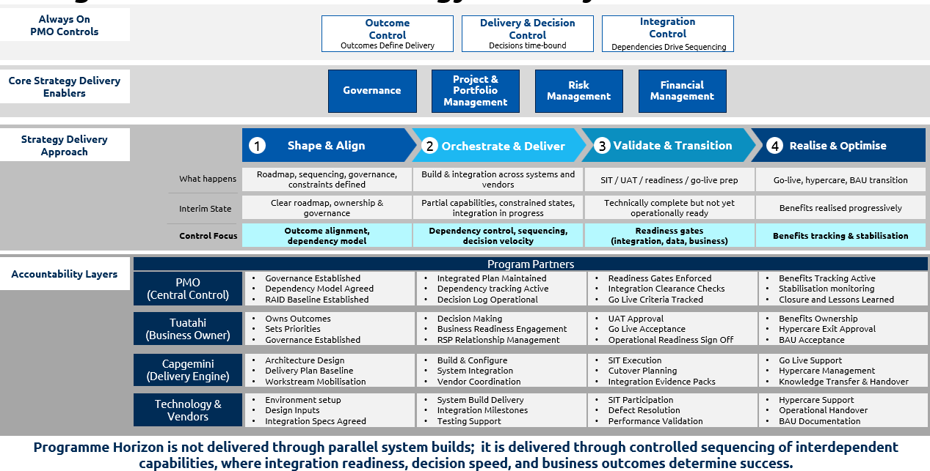
Integrated Governance Framework

Always-On Control Framework
Control as a Continuous Discipline
Programme Horizon will be governed through three integrated control loops that operate continuously rather than at fixed checkpoints. Together they ensure the programme is never passively monitored, it is actively directed based on real time insight.

Integrated Control Loops
Control Loop | Focus |  | How It Strengthens Delivery
Outcome Control | Alignment to business objectives |  | Ensures all delivery decisions and activities contribute directly to Programme Horizon outcomes
Integration & Dependency Control | End-to-end operability | Coordinates sequencing across systems, vendors and work packages
Delivery & Decision Control | Pace and execution clarity | Enables timely decisions and prevents delays caused by governance bottlenecks

Outcome Control
Outcome Control will support successful delivery through structured governance and controls.
  - Governance will begin with a view of outcomes at risk, not delivery status
  - Benefits will be tracked against enabling conditions, such as data readiness and external adoption
  - Decisions will be evaluated based on their impact on value realisation

This creates a direct and continuous link between delivery activity and business outcomes.

Integration and Dependency Control
This will act as the primary mechanism for coordinating delivery.
  - A cross-programme dependency model will inform sequencing and prioritisation
  - Integration readiness will guide release decisions
  - Coordination will extend across all platforms, vendors and teams

This ensures that delivery progresses cohesively, avoiding fragmented or partial implementations.

Delivery and Decision Control
This loop will maintain clarity and pace.
  - Decision pathways will be clearly defined, with ownership understood across stakeholders
  - Turnaround expectations will be monitored and enforced
  - Escalation will be structured and linked to impact

This enables delivery to move forward consistently without unnecessary delay.

Core Strategy Delivery Enablers
Governance | Project & Portfolio Management | Risk Management | Financial Management
Joint governance model aligned to Tuatahi decision rights. Three-tier framework, Strategic, Tactical, Operational. Outcome alignment enforced at every forum. Formal decision log with turnaround SLAs. | Single integrated plan across all 10 work packages. Portfolio-level visibility of delivery progress, KPIs and readiness. Sequenced delivery for go-live readiness. Dependency model and release roadmap maintained throughout. | RAID register across all workstreams, systems and external dependencies. Risk scoring, escalation thresholds and action ownership. Dependency heat maps. Architecture decision gates. Exception volume forecasting. | Budget vs actuals tracking per work package. Fortnightly forecast updates. Licence assumption tracking. Commercial change request impact modelling. Resource capacity planning aligned to priority work packages.
Four core enablers underpin Capgemini's Strategic Delivery Partner role across all phases. These are not phase-specific, they are sustained disciplines applied from mobilisation through to BAU transition.

Strategy Delivery Approach
 | 1 Shape & Align | 2 Orchestrate & Deliver | 3 Validate & Transition | 4 Realise & Optimise
What happens | Roadmap, sequencing, governance, constraints defined | Build & integration across systems and vendors | SIT / UAT / readiness / go-live prep | Go-live, hypercare, BAU transition
Interim State | Clear roadmap, ownership & governance live | Partial capabilities, constrained states, integration in progress | Technically complete but not yet operationally ready | Benefits realised progressively
Control Focus | Outcome alignment, dependency model | Dependency control, sequencing, decision velocity | Readiness gates, integration, data, business | Benefits tracking & stabilisation
Programme Horizon is delivered across four structured phases. Each phase has a defined delivery focus, interim state and control priority, ensuring the programme is governed as a cohesive, outcome-led transformation rather than a fragmented series of technical deployments.

Programme Horizon is not delivered through parallel system builds
It is delivered through controlled sequencing of interdependent capabilities, where integration readiness decision speed and business outcomes determine success. The Strategy Delivery Partner model ensures every phase, every decision and every accountability layer is oriented to this single principle.

Strategy Delivery Model
Tailored to Organisational Scale & Agility | Tailored to External Constraints | Tailored to Outcome-Led Transformation | Tailored to Programme Complexity
Governance will be designed to complement and reinforce Tuatahi’s agility. | Programme Horizon will be shaped as much by external factors as by internal delivery progress. These constraints will be actively managed as part of programme control. | Programme control will remain anchored to the outcomes Tuatahi is seeking to achieve. | Programme Horizon introduces significant complexity due to the number of interdependencies across systems, teams and external parties. An active orchestration model will be applied.
- Governance forums will be limited in number but high in purpose, each with a clearly defined decision mandate  - Decision authority will be pushed to the lowest appropriate level, preserving speed while maintaining control  - Escalations will be triggered based on material impact, rather than routine escalation of issues  - Reporting will focus on what requires attention, enabling leadership to act quickly rather than interpret large volumes of activity data | - A live and continuously updated view of external dependencies will be embedded into planning  - Critical path management will reflect real-world constraints, not just internal delivery sequencing  - Planned pauses or delays driven by external timing will be clearly separated from delivery performance issues | - Progress will be measured against business value delivered, not simply completion of activities  - The conditions required for success will be actively tracked, including data quality, integration maturity, and adoption readiness  - Work will be aligned to end-to-end business journeys, ensuring outcomes are realised across the programme rather than within isolated components | - Dependencies will be maintained within a living model, continuously updated and used to guide sequencing decisions  - Integration readiness will determine when delivery progresses, rather than isolated workstream milestones  - Structured decision governance will be applied to architectural choices, recognising their long-term impact on cost, scalability and benefits
This ensures that governance enhances Tuatahi’s existing strengths rather than diluting them. | This approach will provide a more accurate, transparent view of programme health and maintain alignment between expectations and reality. | This ensures that delivery remains connected to operational impact, not just technical completion. | This creates a disciplined environment where the programme progresses as a unified whole.

Programme Control Office – the delivery engine for Programme Horizon
As a Strategic Delivery Partner, Capgemini will establish a Programme Control Office (PCO) as the delivery engine for Programme Horizon. The PCO is not a reporting overlay, it is the operating mechanism through which delivery is controlled, dependencies are managed, decisions are accelerated and business outcomes are assured.

The PCO is right sized for Tuatahi’s context, a circa 250-person organisation, where key stakeholders are accessible and decisions can be made quickly. Our model provides the controls that this programme requires, without adding bureaucracy that impedes Tuatahi’s natural agility.
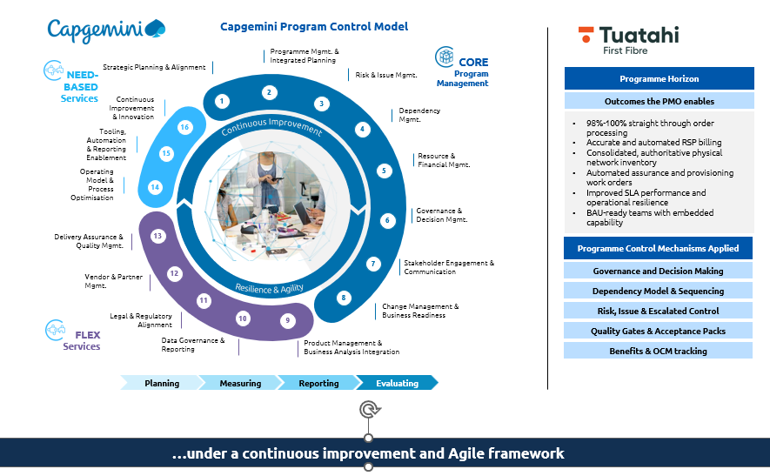
Programme Management Control Model
Core PMO Capabilities
The Programme Control Office forms the backbone of Programme Horizon, delivering essential capabilities to maintain robust control over the programme. These core functions are tightly integrated across all workstreams, ensuring consistent application and alignment to Tuatahi’s objectives:
- Strategic governance and alignment: Keeps delivery focused on achieving tangible outcomes, ensuring every effort remains connected to business goals.
- Integrated planning and portfolio management: Establishes a single source of truth across the programme, enabling coordinated planning and clear visibility for all stakeholders.
- Risk, issue and dependency management: Actively manages the complexities of delivery, addressing risks and dependencies as they arise to maintain momentum.
- Financial and resource management: Ensures that delivery remains viable by aligning resources and finances with programme priorities, supporting efficient use of assets.
- Quality and readiness assurance: Enables controlled progression through each stage of delivery, ensuring readiness at every step and maintaining high standards.
These capabilities are not siloed; instead, they operate as a cohesive system, applied consistently throughout every workstream to uphold programme integrity and enable effective governance.
Capgemini’s Programme Control Office leverages our Programme Excellence methodology, providing a structured, integrated and scalable approach tailored to Programme Horizon. Each capability directly addresses the governance requirements outlined in the RFP, demonstrating how Capgemini’s PMO disciplines meet the specific needs of Programme Horizon’s delivery.

Governance Model
A joint governance model will be established, aligned to Tuatahi’s decision structures. The model is structured across three tiers, Strategic, Tactical and Operational, each with defined authority, forum cadence and PCO outputs. This ensures decisions are made at the right level by the right people, with the right information.

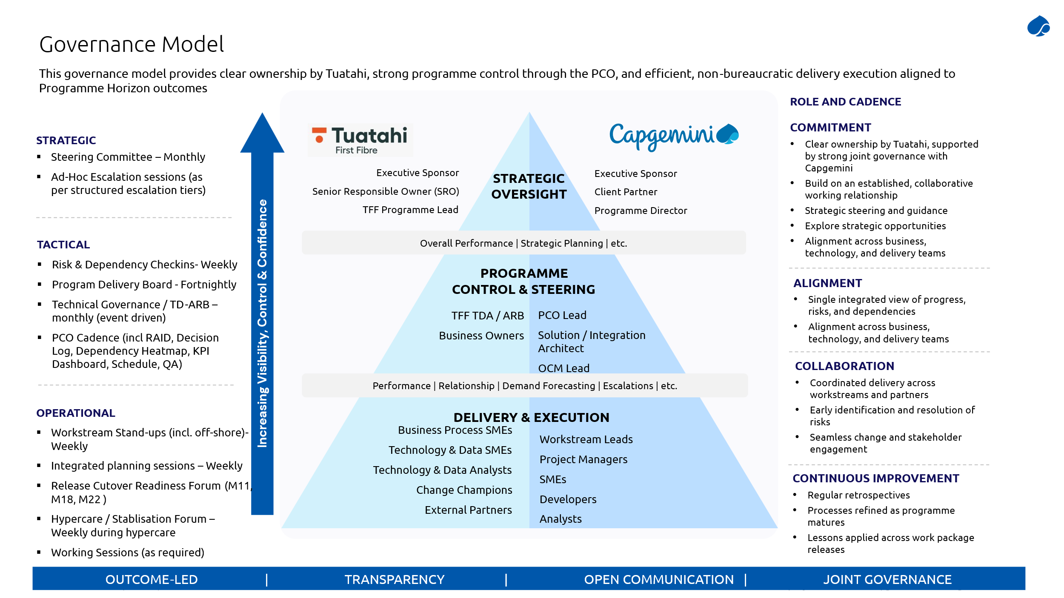
Programme Governance Model
Tuatahi retains business ownership, executive decision rights, TDA/ ARB architecture governance authority, acceptance authority, production promotion and business process change ownership. Capgemini is accountable for delivery execution across all Workstreams and Work Packages, coordinating across all Tuatahi teams and third-party system owners.

Governance will remain proportionate, transparent, and focused on enabling delivery rather than constraining it. The detailed accountability matrix for programme activities across Tuatahi, Capgemini, TDA/ ARB, third party vendors and RSPs is set out in the RACI Matrix, which forums part of the PMO governance framework.

Governance Cadence and Ways of Working
The PMO will operate a structured governance rhythm throughout the Programme. The cadence below is the baseline; frequency will be adjusted at Steering Committee discretion and in response to Programme events such as go-live readiness periods or escalated risks.
All governance forums will operate with pre-read materials distributed a minimum of two business days in advance, a standing decision log review, and a formal action tracker reviewed at each session. The PMO maintains all logs and is accountable for turnaround tracking.

The governance rhythm below applies throughout the 27-month programme lifecycle, with frequency adjustments at key programme events, notably the RSP testing window, each go live readiness period and the Post-Hypercare exit.

Proposed Governance and Ways of Working
Forum | Frequency | Chaired by | PMO Output
Steering Committee | Monthly | TFF Executive Sponsor | - Outcome alignment status  - Steering Committee Pack  - Budget variance  - Go live readiness assessment  - Escalation log  - External constraint status
Programme Delivery Board | Fortnightly | Capgemini Programme Delivery Executive | - Integrated delivery status  - RAID update  - Decision log  - Dependency heatmap  - Milestone tracker  - KPI dashboard
Technical Governance / TDA -ARB | Monthly (event-driven) | TFF TDA/ ARB | - Architecture decision records  - Design deviation log  - Configure versus customise approvals  - Technical decision register
Workstream Delivery Standups | Weekly per Workstream | Capgemini Workstream Lead | - WIP progress  - Sprint status  - Blockers  - Backlog  - Feature and test readiness  - Resource availability flag
Risks & Dependency Check-ins | Weekly | Capgemini PMO Lead | - RAID Register update  - Action tracking  - Dependency heat map  - External dependency status  - Escalation decision
Release / Cutover Readiness | Per go-live event | Capgemini Engagement Manager & TFF Technical Lead | - SIT/UAT exit evidence  - Migration rehearsal results  - Cutover readiness pack  - Rollback validation  - OCM readiness
Hypercare / stabilisation | Weekly during hypercare | Capgemini Support Lead & TFF Operations | - Defect trend report  - Knowledge maturity assessment  - Monitoring health  - Exception volume tracking  - Hypercare exit readiness

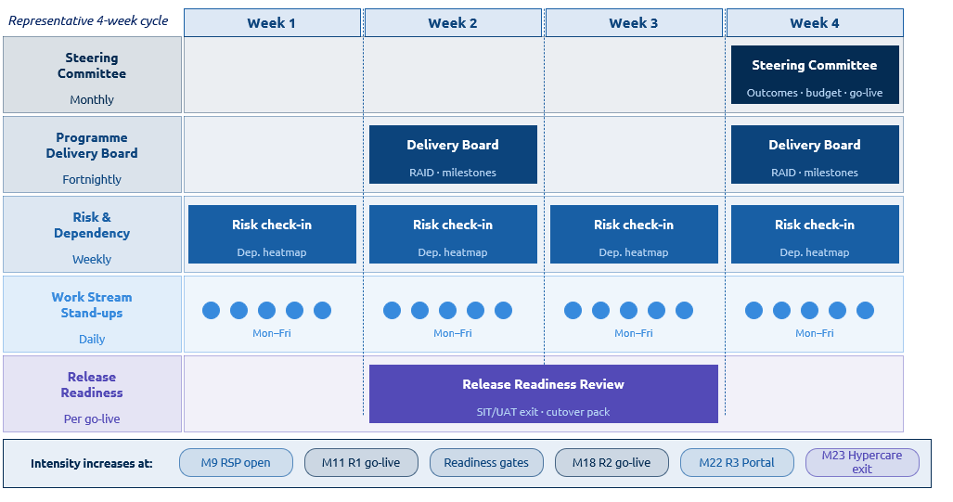
Example of Governance Cadence 4 Week Cycle

Cadence and ways of working to be established during Discovery Phase Cadence, governance forums, and ways of working will be collaboratively defined and baseline established during the Discovery phase, ensuring alignment to Tuatahi’s operating model and programme needs.

5.2.1 Decisions and Turnaround assumptions
All decision requests are submitted in writing, categorised and tracked in the consolidated Decision Log maintained by the PMO. Tuatahi's demonstrated ability to make decisions quickly is a programme asset. The PMO model is designed to leverage this, not slow it down.
Proposed Decision and Turnaround Assumptions
Category | Target response | Definition
Urgent decision | 2 business days | Decision required to unblock delivery, prevent milestone slippage or avoid irreversible action. Classification agreed between PMO and TFF at programme initiation.
Standard decision | 5 business days | Design, scope, process or governance decisions not on the critical path. Tracked in decision log and reviewed at next Programme Delivery Board.
Technical decision (no cost/scope impact) | Captured on technical decision register, no formal escalation required | Technical decisions with no additional cost and no scope deviation. Agreed by Capgemini and TFF technical leads. Noted in governance reporting.
Escalated decision | Next Steering Committee (within 4 weeks) | Decisions requiring executive authority: budget variance, major scope change, go-live readiness, material residual risk, contractual dispute, custom software approval.

5.2.2 Escalation Framework
The following categories trigger immediate escalation to the Steering Committee. All escalations are recorded in the formal issue log within two business days of identification, with traceability from identification through to resolution.

Proposed Escalation Framework
Escalation Trigger | Definition Examples
Timeline Impact | Expected miss of a delivery milestone, RSP testing window (M9) or portal go-live (M22) at risk, or go-live readiness gate cannot be met
Financial Impact | Forecast costs exceeding approved budget, material resourcing changes, licensing cost changes, or change requests above agreed threshold
Scope Impact | Required change resulting in non-delivery of a mandatory feature, or material change to an out-of-scope by design boundary
Quality and Risk Severity | Defect remediation impacting timelines, SIT/UAT exit criteria not met, migration reconciliation failures, repeated P1 incidents during hypercare
Architecture Decision | Irreversible design decisions, configure versus customise exception, or API boundary revision requiring TDA/ARB review
External Constraint Breach | RSP notice window at risk, Ventia dependency unresolved within agreed window, or other external constraint impacting programme sequencing
Compliance Exposure | Breach or potential breach of NZ regulatory obligations, privacy, security, billing accuracy or audit requirements

Embedding Control Loops into Governance and Escalation
The three Always-On Control Loops are not theoretical constructs; they are actively embedded into Programme Horizon’s governance cadence, decision-making forums, and escalation framework to ensure continuous alignment between delivery activity and business outcomes.
Each control loop is operationalised through specific governance forums and escalation pathways:
- Outcome Control is embedded within the Steering Committee and Programme Delivery Board, ensuring all decisions and escalations are assessed against Programme Horizon objectives and value realisation. Escalations relating to scope, benefits or strategic alignment are prioritised and surfaced through this control loop.
- Integration & Dependency Control is embedded within Programme Delivery Board and weekly Risk & Dependency forums, where cross-workstream dependencies, integration readiness and external constraints are actively monitored. Escalations relating to integration failure, sequencing conflicts or external dependencies are managed through this control loop.
- Delivery & Decision Control is embedded across all governance tiers, with a focus on maintaining decision velocity, resolving blockers, and ensuring timely escalation of risks. Decision turnaround SLAs and escalation triggers are aligned to this control loop to prevent delivery delays.

The escalation framework is therefore not standalone, it is directly driven by these control loops, ensuring that every escalation is categorised, prioritised, and resolved based on its impact on outcomes, integration readiness, and delivery progression.

5.2.3 Programme Challenges and Risk Considerations
We will work alongside you, adapting to evolving circumstances. We have established methods that enable fast allocation of resources, prompt pricing for new work packages based on our rate card provided and swift execution of change orders over the course of the project. Monthly reporting and briefing sessions will provide the opportunity for timely management of risks and issues and to surface emerging resourcing needs. Capgemini has identified governance risks specific to Programme Horizon and has designed our PMO model to proactively mitigate each
Programme Horizon introduces structural challenges that will be actively managed.
- External constraints influencing sequencing and timing
- Complex interdependencies across work packages
- Risk of misalignment between delivery and outcomes
- Availability and capacity of key stakeholders
- Need to embed change alongside technical delivery
- Risk of delayed or fragmented decision-making
These will be continuously monitored and addressed through the control framework.
Capgemini has identified governance risks specific to Programme Horizon and has designed our PMO model to proactively mitigate each.
Programme Risks and Capgemini Mitigations
 | Risk | Description | Capgemini mitigation
Delivery & Governance Risks | Resource availability | Critical SMEs and specialist resources may become bottlenecks if unavailable, impacting delivery timelines and quality | PMO establishes role criticality mapping and contingency planning, including backfill strategies and knowledge transfer
Delivery & Governance Risks | Decision latency | Multi-layered governance (TDA/ARB, Steering Committee, business owners) may delay critical decisions and impact delivery timelines | A tiered decision framework is implemented, supported by decision logs, defined SLAs, and fast-track escalation for time-critical decisions with quantified impact
Delivery & Governance Risks | Scope boundary fragility | Stakeholder pressure to extend beyond defined scope boundaries (e.g. CPQ, CRM, AI) risks scope creep and delivery dilution. | PMO enforces “out-of-scope-by-design” principles, with structured backlog/roadmap management of deferred capabilities and proactive stakeholder communication
Delivery & Governance Risks | Customer-supplied item delays | Delays in customer-provided inputs (data, access, approvals, operational windows) may impact delivery timelines without visibility. | PMO maintains a customer dependency register, with clear ownership, tracking, and escalation through governance forums
Strategy, Outcomes & Benefits Risks | Technology-first delivery risk | Delivery may prioritise technical optimisation over business outcomes, or become influenced by stakeholder preferences that deviate from programme objectives | Governance is outcome-led by design, with Steering Committees anchored in outcome performance. Architecture and design decisions are gated against defined business objectives and traceability
Strategy, Outcomes & Benefits Risks | Benefits realisation credibility | Benefits (e.g. 98–100% automation) are dependent on external enablers (data quality, API adoption), risking perceived under delivery if not contextualised | Benefits are tracked through a conditions-based realisation model, ensuring dependencies are visible and benefits are measured against readiness, not just system delivery.
Strategy, Outcomes & Benefits Risks | Outcome misalignment | Delivery decisions and governance forums may prioritise technology optimisation, stakeholder preferences or activity reporting over the defined Programme Horizon objectives, resulting in strategic drift and reduced benefits realisation. | PMO enforces outcome-led governance by design. The Outcome Control loop of the Always-On Control Framework ensures every governance forum opens with outcome alignment status as its first agenda item not activity summaries. All decision packs include explicit traceability to the relevant Programme Horizon objective. Steering Committee packs lead with benefits conditions and objective status. This ensures all delivery decisions remain anchored to outcomes throughout all 27 months.
Technology, Data & Integration Risks | Third-party dependency | Dependencies on external vendors (e.g. Eagle, CSG, ServiceNow, Dynamics teams) may introduce delays due to misaligned priorities or delivery constraints | A vendor-integrated governance model is established, including joint planning cycles, shared milestones, and escalation forums.
Technology, Data & Integration Risks | Data Quality and Readiness Risk | Poor or incomplete data may limit automation, impact solution effectiveness, and delay downstream delivery milestones | PMO enforces data readiness checkpoints aligned to delivery phases, with data ownership, cleansing plans, and escalation of gaps ahead of build and testing
Technology, Data & Integration Risks | RSP adoption and Integration Risk | Reliance on external RSP adoption and integration readiness may delay end-state functionality and benefits realisation. | PMO tracks RSP onboarding and API adoption as critical dependencies, with clear engagement, escalation pathways, and integration readiness milestones.
Delivery Dependencies | External critical path misread | Externally constrained periods (e.g. RSP notice timelines) may be misinterpreted as delivery underperformance, reducing executive confidence | PMO provides transparent programme state reporting, clearly distinguishing planned constraints from delivery risk. External dependencies are actively tracked and reviewed at Programme Delivery Board
Business Readiness, Change & Operations | Change adoption failure | Transition to automated processes may be resisted, with users reverting to manual workarounds, reducing expected benefits | OCM is fully embedded within PCO execution, with adoption measured through readiness gates, targeted training, and behavioural tracking not just go-live completion.
Business Readiness, Change & Operations | Business readiness lagging technical delivery | Technical readiness may outpace business preparedness, resulting in ineffective or high-risk go-live | Go-live decisions are governed by a composite readiness model, including OCM, process, and operational readiness metrics.
Business Readiness, Change & Operations | Service Transition and Operational | Transition to BAU, including ServiceNow and operational teams, may be delayed or incomplete, affecting service continuity post go-live. | PMO ensures structured service transition planning, including handover criteria, support model definition, and operational readiness sign-off prior to go-live

Capgemini will proactively manage all programme-level dependencies through the Project Control Office (PCO), underpinned by integrated RAID and Dependency Registers to ensure end-to-end visibility and control. Key external dependencies with programme-level significance are identified in Section 4.5 and embedded within each work package to ensure alignment with delivery planning and sequencing.
Dependency status is actively monitored through a structured governance cadence, including weekly Risk and Dependency Check-ins to drive early identification and mitigation, and formal reporting to the Programme Delivery Board on a fortnightly basis. This approach ensures timely escalation, informed decision-making, and sustained delivery momentum across the programme.

Outcome-Led Performance Management
Performance management combines predictive lead indicators, early signs of delivery health, with outcome-based lag indicators confirming value realisation. This ensures governance remains proactive and evidence based, not reactive.

Lead Indicator | What it measures | Lag Confirmation | What it confirms
Decision log turnaround rate | % of decisions resolved within agreed SLA (urgent: 2BD, standard: 5BD) | Straight-through order processing rate | % of orders processed end-to-end without manual intervention
Dependency risk heat | Number of At-Risk dependencies vs total active dependencies | Work package acceptance rate | % of WP acceptance packs formally accepted by Tuatahi without rework
Integration readiness score | % of cross-WP integration points with agreed interface specs, test stubs and shared SIT protocol in place | Benefits realisation conditions met | % of enabling conditions (data readiness, RSP API adoption, legacy retirement) satisfied per WP release
Resource availability index | Tuatahi counterpart confirmed availability vs required per release | SIT/UAT exit quality | % of SIT/UAT exit criteria met at first submission (no re-entry)
Architecture decision debt | Number of open architecture decisions past their agreed time-box | Hypercare exit maturity | % of hypercare exit criteria met: KT Level 4, defect trend stable, monitoring validated
Change readiness index | % of impacted roles with completed change impact assessment and training plan | Exception volume vs forecast | Actual exception volumes vs forecast per journey validates automation baseline

RACI Matrix
The matrix below defines accountability across all programme parties. Each activity has a single Accountable Owner (A). Tuatahi retains accountability for executive decisions, acceptance authority, architecture, governance and production promotion. Capgemini is accountable for delivery execution, integration, migration testing and hypercare. Third-party vendors and RSPs carry defined Responsible and Consulted roles where their platforms or relationships are directly engaged.

Ownership Principles
- Capgemini owns integrated delivery reporting and RAID management. The PMO is accountable for maintaining the programme plan, tracking milestones, managing the RAID log and producing delivery reporting across all workstreams. Tuatahi Programme Lead is the primary recipient and decision-maker on escalations.
- Tuatahi holds executive decision-making and Steering committee authority. Programme sponsorship, Steering Committee decisions, budget approval, change request authority and go-live sign-off remain with Tuatahi. Capgemini supports with options analysis, recommendations and delivery evidence but does not hold final authority on any of these.
- Production promotion and environment access remain Tuatahi-controlled. Capgemini provides approved release packages. Tuatahi Technical Lead controls the production environment and authorises all promotions.
- Tuatahi owns the change outcome. Tuatahi is accountable for internal adoption. Stakeholder alignment, business readiness and external ecosystem engagement
- Capgemini enables change with delivery knowledge. Capgemini provides change impact inputs, training content, technical collateral and adoption support aligned to each workstream and release.
- OCM is embedded into delivery governance. Change impacts, readiness, communications, training and adoption risks are tracked through PMO, RAID, release governance and go-live readiness gates.
- Capgemini owns supplier-scope integration design and delivery. Integration patterns, API contracts, delivery coordination and testing for components within the SI scope are Capgemini-led.
- Tuatahi owns retained architecture and platform decisions. Enterprise architecture approvals, AWS alignment, the retained Experience API layer and systems outside Capgemini's direct control remain Tuatahi-owned.
- Shared interfaces require explicit dependency governance. Where integration depends on Tuatahi-owned, third-party or downstream systems, the dependency, decision owner and required date are tracked through PMO and workstream RAID.

(R) | Responsible | Carries out the process or activity
(A) | Accountable | Owns the process or activity being completed
(C) | Consulted | Stakeholder or subject matter who is consulted to provide input
(I) | Informed | Receive the output of activity

Proposed RACI Matrix
Activity | Tuatahi  First Fibre | Capgemini  (Prime SI) | TDA / ARB (TFF) | Third Party Vendors | RSPs
Programme Governance and Oversight
Programme sponsorship and executive decision making | A | C | I | - | -
Steering Committee participation and decisions | A | R | I | - | -
Integrated delivery management (plan, RAID, decision log, reporting) | C | A | I | I | -
Governance framework and ways of working design | A | R | C | - | -
Architecture & Technical Governance
TDA/ ARB approval and architectural acceptance | A | C | R | I | -
Solution design, options analysis and rationale | C | A | R | C | -
Configure over customise decisions and deviations | A | R | R | I | -
Experience API layer ownership and production release governance | A | R | C | I | I
Build, Configuration and Integration
Solution build, configuration and workstream delivery | I | A | C | R | -
Third party integration (ArcGIS, Telflow, Dynamics 365, Ventia) | C | A | C | R | -
Data migration source data provision and quality baseline | A | R | C | C | -
Business process change (identification, implementation & documentation) | A | C | I | - | -
Testing & Quality
Test strategy, automated testing and QA gates | C | A | C | I | -
SIT certification | A | R | R | I | -
UAT execution | A/R | C | C | I | I
RSP portal and API testing | C | R | C | - | A
Go Live, Cutover and Hypercare
Go Live readiness, sign off assessment & recommendations | C | A/R | C | R | -
Go Live Approval and formal sign off (Steering Committee) | A | C | C | I
Production promotion and environment access | A | R | C | I | -
Hypercare management defect remediation, monitoring, knowledge transfer | A | R | C | I | I
BAU Transition and Benefits Realisation
Knowledge transfer, runbooks and operational documentation | A | I | I | - | R
BAU operational ownership acceptance | A | R | I | C | -
Benefits realisation conditions, tracking | A | R | I | - | -
External and Commercial
RSP engagement 12-month notice process and consultation window | A | I | I | - | R
Third party vendor relationship management | A | R | I | C | -
Budget approval, change request authority and commercial decisions | A | R | I | - | -

Conclusion
Programme Horizon will require a Programme Control capability that is not only structured, but actively engaged and responsive to Tuatahi’s environment.
As Strategy Delivery Partner, Capgemini will deliver a PMO that is:
- Tailored to Tuatahi and its operating model
- Focused on outcomes rather than activity
- Designed to manage complexity through active control
- Embedded within delivery to enable visibility and coordination
This will provide the conditions for delivery with clarity, control and confidence, ensuring that Programme Horizon achieves its intended outcomes in a sustainable and practical way.

Detailed Workstream & Work Package Response
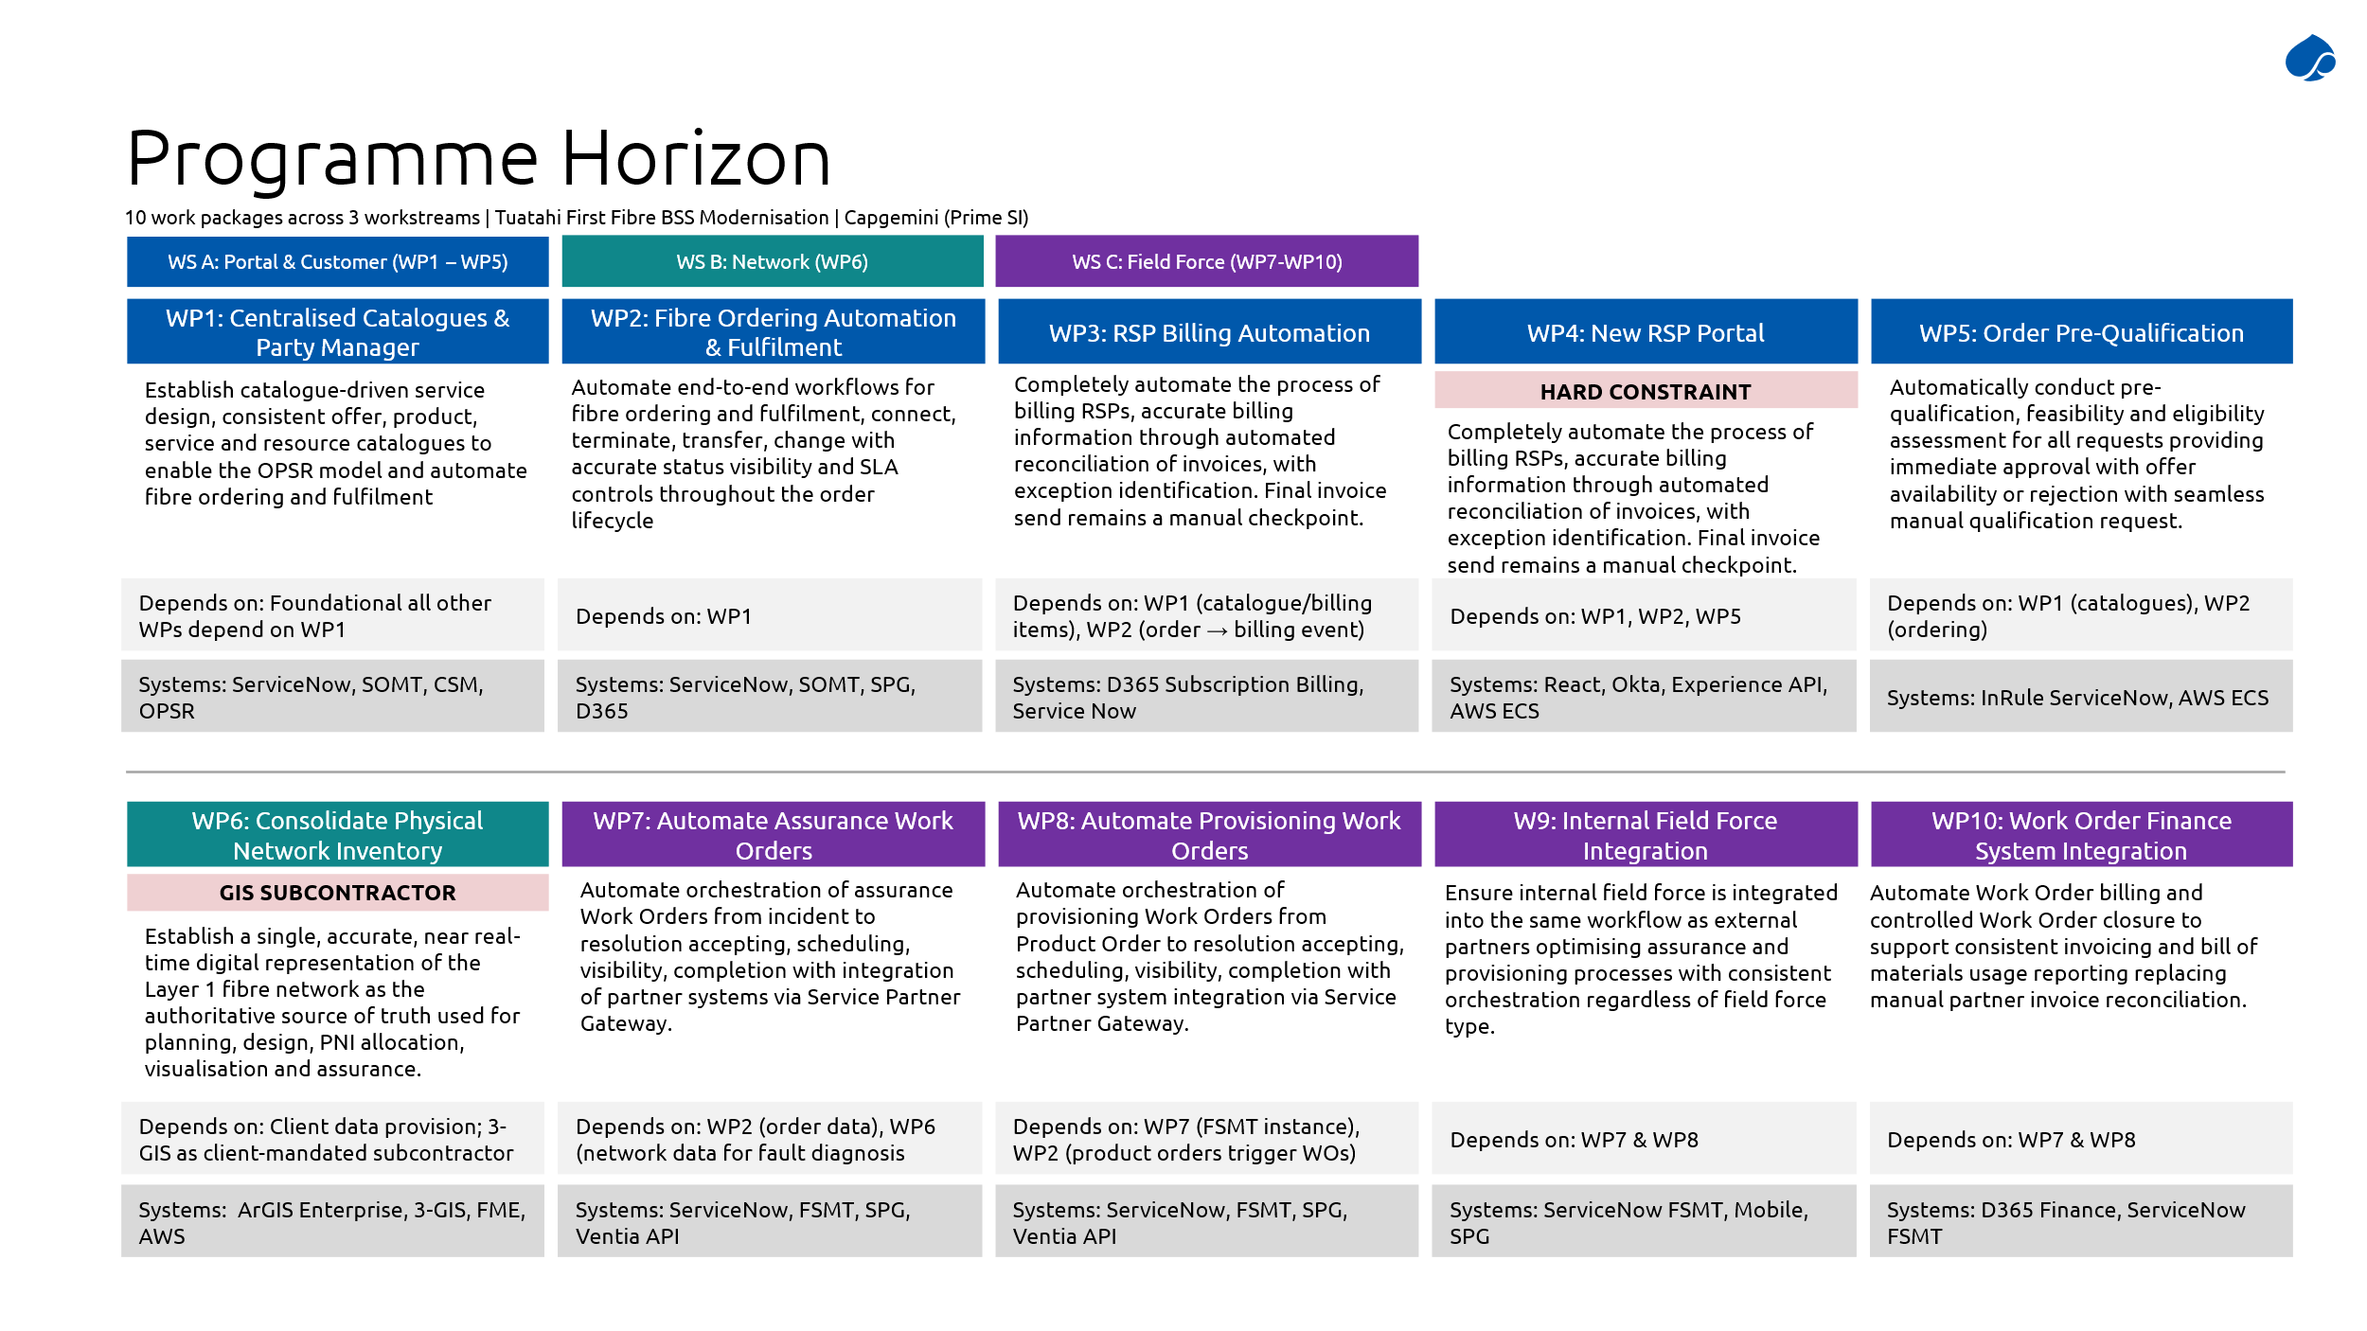
Tuatahi First Fibre have put significant effort in over the past couple of years to formulate a high-level plan for the digital transformation necessary to underpin the scalability, efficiency and improved customer experience that is critical to realise their vision of becoming New Zealand’s preferred connectivity provider. This plan groups their business objectives into three work streams that can be delivered in parallel, each providing logical pieces of functionality that, when fully delivered, will enable end-to-end automated operations for fibre ordering, billing and field force operations.

The work streams proposed by Tuatahi are organised as follows:
- Work Stream A – Portal & Customer
  - Business Objective 1 – Centralised Catalogues and Party Manager
  - Business Objective 2 – Fibre Ordering Automation and Fulfilment
  - Business Objective 3 – RSP Billing Automation
  - Business Objective 4 – New RSP Portal
  - Business Objective 5 – Order Prequalification
- Work Stream B – Network
  - Business Objective 6 – Consolidated Physical Network Inventory
- Work Stream C – Field Force
  - Business Objective 7 – Automate Assurance Work Orders
  - Business Objective 8 – Automate Provisioning Work Orders
  - Business Objective 9 – Internal Field Force Integration
  - Business Objective 10 – Work Order Finance System Integration
Capgemini has reviewed this high-level structure for organising the delivery and believe it represents a sensible and well thought out approach. We believe that leveraging the thought, planning and effort that Tuatahi has put in over the past couple of years is the quickest path to value and so have built upon this for our proposed implementation, and augmenting it where appropriate. This is detailed in the following sections, where we detail the considerations for delivering each work stream and their associated work packages.

Workstream A: Portal & Customer
Workstream A focuses on establishing the core customer-facing and commercial foundations of the Programme by introducing a new Retail Service Provider (RSP) portal and creating the structured data backbone required for a modern, automated wholesale BSS environment. This workstream delivers the transition to an OPSR (Offer–Product–Service–Resource) model by building centralised catalogues and a party management capability, enabling consistent data, clear ownership, and end-to-end traceability of orders. This foundation supports the automation of key customer journeys, particularly fibre ordering, billing triggers, and pre-qualification, while replacing fragmented legacy systems (such as Telflow, Layer2, and uFibre) with a consolidated, API-first architecture anchored in ServiceNow and integrated enterprise platforms.
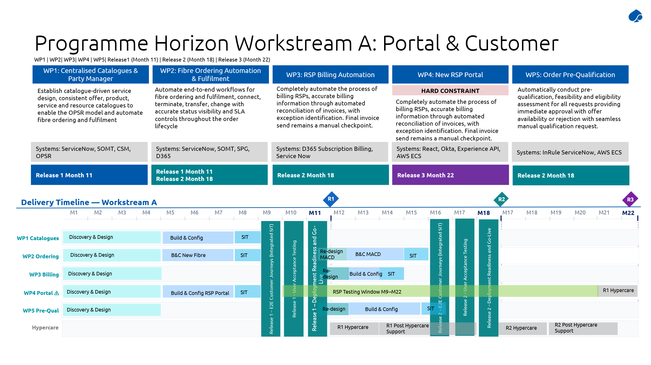
In parallel, Workstream A delivers a secure, API-driven self-service portal that mirrors the Experience APIs and allows RSPs to independently manage core operational functions such as service qualification, order submission and management, and real-time status tracking. This includes enabling automated order lifecycle processing (from validation through fulfilment), billing integration, and pre-order eligibility checks via a dedicated qualification engine. The workstream is designed to eliminate manual handling, enforce consistent workflows and SLA governance, and provide transparent, real-time visibility across orders, inventory, and billing states. Overall, it establishes a scalable, configuration-driven, and customer-centric interface layer that underpins the broader transformation to automated, end-to-end digital operations.
    - Work Package 1: Centralised Catalogues and Party Manager
Objective 1 is achieved by leveraging the capabilities of ServiceNow’s Customer Service Management (CSM) application as the Party Manager, and their Sales and Order Management for Telecommunications (SOMT) application for the centralized OPSR catalogue.

Solution Details
The following considerations have been made for the implementation of the Party Manager capability:
- The CSM B2B model will be adopted.
- The “Customer Account” and “Customer Contact” tables will be utilized to represent parties (i.e. the RSPs and their authorized personnel), including any hierarchical relationships between parties, thus supporting RSPs that operate multiple brands or business units.
- The “Sold Product” and “Install Base Item” tables will be utilized to represent what fibre products have been “subscribed” to RSPs on behalf of their end customers, thereby linking parties to orders, products and services.
- As ServiceNow CSM will be the new master system of record for Party information, it will be integrated with Okta for the purposes of synchronizing identities to Okta.
  - Inbound requests from the Experience API (direct or via the RSP portal) will be authenticated by Okta with the appropriate authentication context being supplied to ServiceNow, which will govern what is exposed.
- Processes for onboarding new RSP companies and staff will be determined during discovery and design, and will be implemented accordingly.

The following considerations have been made for the implementation of the centralized OPSR catalogue:
- The SOMT OPSR model will be adopted as the central System of Record (SOR) for:
  - Product & offer definition, including pricing.
  - Customer order structure
  - Service decomposition logic
  - Resource intent (logical linkage, not physical allocation)
This replaces fragmented logic currently spread across Telflow, Layer2, uFibre, and partial ServiceNow modules.
- SOMT will be configured to establish four governed catalogues:
  - Offer Catalogue – Commercial bundles and market-facing propositions
  - Product Catalogue – Sellable service units
  - Service Catalogue – Logical services required to deliver products
  - Resource Catalogue – Underlying technical dependencies
These catalogues will be fully aligned to the OPSR hierarchy, will maintain strict separation of concerns (commercial vs technical, and will enable standardised decomposition from offer to resource
- All catalogue elements will be:
  - Metadata-driven (no hardcoding)
  - Configurable by business users via the standard ServiceNow SOMT UI
  - Designed for rapid product creation and change, supporting new offers including short-term promotional offers.
This satisfies the requirement for “easy for non-technical users to rapidly configure”.
- Each catalogue entity will implement:
  - Versioning (draft → active → retired)
  - Controlled lifecycle transitions
  - Full auditability of changes
This ensures regulatory traceability and the safe evolution of products and services.
- User roles will be configured to enable Tuatahi product personnel to fully manage the OPSR catalogue through the ServiceNow SOMT user interface, enabling rapid configuration of catalogues, and supporting the execution of marketing campaigns and the creation of qualified or time-bound promotional offers.
- Experience API integration
  - Support the TFF team in implementing their changes to the Experience API by providing the necessary information and connectivity to allow ServiceNow to expose the required functionality, including:
    - Offer and Product catalogues – Using the ServiceNow Table API so that the Experience API can query ServiceNow for order status.
  - Identity context will be supplied by the Experience API (possibly in the form of an OIDC token, to be fully resolved during discovery and design), which will be used by ServiceNow SOMT to only expose the offers and products to which the RSP is entitled to order (based on products and/or offer definitions).

Once implemented, ServiceNow SOMT will:
- Master product offers and definitions across catalogues
- Link orders to party context
- Maintain consistent OPSR relationships
- Provide the foundation for:
  - Order decomposition
  - Fulfilment orchestration
  - Billing accuracy

Exception handling
Exception handling in WP1 is primarily data and governance-centric, focusing on preventing and managing inconsistencies in catalogue and party data before they propagate downstream. The design will include strict validation rules on catalogue entities (Offer, Product, Service, Resource) and party records, ensuring that invalid configurations, incomplete metadata, or conflicting relationships are rejected at source. Where exceptions do occur (for example, duplicate party identities, invalid hierarchy structures, or misaligned catalogue definitions) they will be captured through structured validation errors, logged with full audit trails, and routed to governed remediation workflows. This will ensure catalogue integrity is preserved as the single source of truth, aligning with the requirement for auditability, lifecycle control, and metadata-driven configuration.
In addition, exception handling should support controlled lifecycle management and recovery, particularly where catalogue or party changes impact live operations, for example deprecating a product that is still subject to active activation work orders. Rollback or correction pathways should allow safe remediation without corrupting downstream systems. Integration with identity systems (Okta) and consuming APIs requires that errors are surfaced clearly and consistently, ensuring that downstream systems don’t consume invalid data.
Overall, WP1 exception handling must emphasise prevention, strict governance, and traceability, because errors at this layer have the potential to cascade across ordering, fulfilment, and billing processes.

Data Migration and Consolidation
Party data will be migrated from Telflow, and it is anticipated that this data will require cleanup and review prior to loading into ServiceNow CSM. Alignment to existing “sold products” will be done based on the existing data that is available.
Catalogue data is not available in a single source and so the full OPSR catalogue will need to be defined, leveraging what is available from Telflow, Layer2 and uFibre, and existing ServiceNow datasets. We are proposing:
- Data mapping into OPSR model
- Cleansing and normalisation
- Incremental migration with validation
- Providing input for decommissioning of legacy systems post-cutover
The approach for automated migration for CSMT customer Foundation and SOMT OPSR data for WP 1 & 2 (for Release 1) is detailed in section 6.5 Data Migration and Data Archival.

Delivery approach
As WP1 provides key foundation capability, we propose to deliver WP1 for Release 1. This will allow us to deliver not just the party manager and OPSR catalogue, but also to enable the delivery of dependent functionality in WP2, WP4 and WP6 for the same release. Close coordination will be required with WP6 for the PNI integration that underpins the OPSR catalogue.
Release 2 will then build upon this work to deliver the full functionality for WP2, WP3 and WP5, with no rework anticipated for WP1.

Activities and Key Dependencies
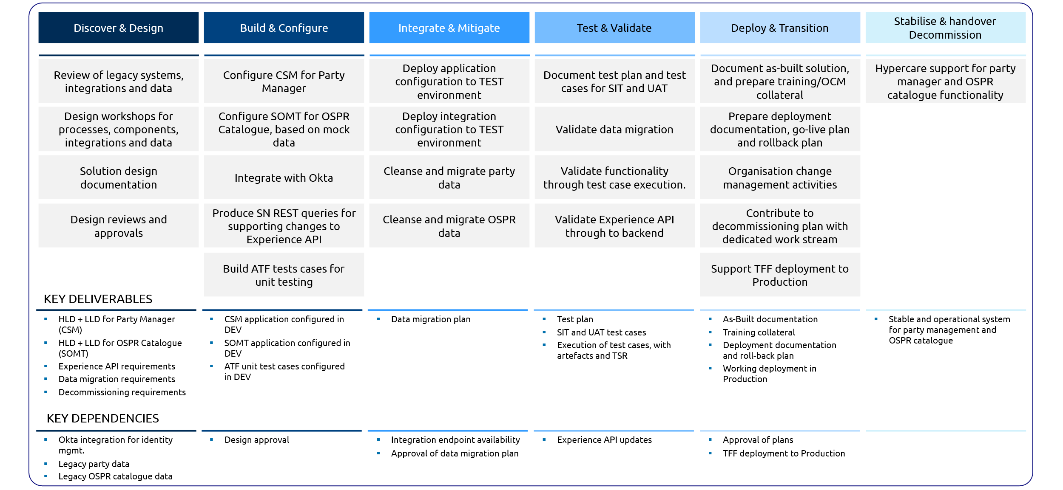

Detailed Dependencies
- New catalogue and party structures will be exposed via the existing Experience APIs.
- Tuatahi will implement required changes to the Experience APIs, but Capgemini will provide detailed ServiceNow API details for underpinning these changes, based primarily on the Table API capabilities of ServiceNow. These details will include endpoints and connectivity, and queries to execute to retrieve the required data.
- The uplifted Experience APIs will consume SOMT catalogue data as the source of truth, providing consistent data to the RSP Portal and external systems.

    - Work Package 2: Fibre Ordering Automation and Fulfilment
This work package delivers the end-to-end automation of fibre ordering and fulfilment, leveraging the catalogue foundation created in Work Package 1. Business Objective 2 requires:
- Full automation of order workflows
- Accurate lifecycle status visibility
- SLA-driven control of execution and exceptions
ServiceNow SOMT becomes the central orchestration and lifecycle control engine enabling straight-through processing, covering order intake and validation, OPSR-based decomposition, workflow orchestration across OSS/BSS, lifecycle state management, status visibility and SLA monitoring.

Solution Details
The end-to-end order lifecycle will be implemented as follows:
- Order Ingestion
  - Orders are initiated via the Experience APIs or the RSP Portal (via the Experience APIs). For internal-only convenience, for troubleshooting or manual intervention, catalogue items will also be configured to initiate the ordering process.
  - SOMT will then validate the order structure and inputs and associate the order to a party (RSP), place and catalogue entities.
  - This approach ensures that all orders are standardized and traceable from any entry point.
- Pre-validated Acceptance (with WP5 integration)
  - SOMT integrates with the pre-qualification engine (via the Experience APIs) to confirm serviceability, eligibility and feasibility.
  - During the transition, before the pre-qualification engine is available, an alternate approach will be used, the specifics of which will be determined during discovery and design. Options include relying on the current qualification process in Telflow, or implementing a temporary minimum-viable qualification process in ServiceNow that leverages TNI data in ServiceNow rather than the master PNI data in 3-GIS.
  - Only valid orders are processed, enabling high straight-through processing rates. Invalid orders can be reviewed for manual intervention.
- OPSR-based Decomposition
  - Once an order is accepted, SOMT decomposes the customer order into product orders, service orders and resource requirements.
  - This uses catalogue definitions from WP1 to ensure consistent and repeatable decomposition and a clear separation between commercial and technical layers.
- Fulfilment Orchestration across systems
  - Orchestration Model
    - SOMT will be configured as the central coordinator, while downstream systems will execute actions on issued requests.
    - SOMT – Orchestration, decision making, lifecycle control
    - 3-GIS/ArcGIS – Physical resource allocation
    - Network/OSS – Logical provisioning
    - FSMT – Work order execution
  - Event-driven Workflow Execution
    - SOMT drives an event-based workflow model in which order events trigger workflows. Each state produces state updates, downstream requests and/or integration events. For example:
    - Order accepted: Trigger decomposition
    - Resource required: Trigger PNI allocation
    - Field activity needed: Generate Work Order
  - Integration with Inventory & Network
    - SOMT needs to manage the reservation and assignment of resources and the synchronisation of inventory states, to ensure no fulfilment step proceeds without validated resources. This requires integrating with:
    - 3-GIS/ArcGIS (PNI): Physical fibre paths and ports
    - Network systems: Logical service provisioning
  - Automated Work Order Generation
    - Where physical work is required, SOMT generates demand tickets to trigger work orders in ServiceNow FSMT. These will be linked back to the product order, service instance and customer order to ensure full traceability between order and field execution.
  - Integration with Billing (D365)
    - When an order is fulfilled, either through resource re-allocation or through field provisioning, it will trigger a billing event for D365 to commence the subscription for recurring billing to the responsible RSP.
    - Since pricing of offers and products is mastered in ServiceNow SOMT, the pricing information for a fulfilled order will be propagated to D365 in the billing event.
- Controlled State Transitions
  - SOMT enforces strict lifecycle states (e.g. Created > In Progress > Completed), to prevent invalid transitions and out-of-sequence execution.
  - Inventory and billing updates will only occur upon successful completion of lifecycle stages, to guarantee accurate service state and alignment between fulfilment and billing.
  - This will ensure process integrity and compliance with regulatory and SLA rules.
- Experience API integration
  - Support the TFF team in implementing their changes to the Experience API by providing the necessary information and connectivity to allow ServiceNow to expose the required functionality, including:
    - Order submission – Using the ServiceNow Import API and associated processing so that the Experience API can submit new orders to ServiceNow.
    - Order status visibility – Using the ServiceNow Table API so that the Experience API can query ServiceNow for order status.
  - Identity context will be supplied by the Experience API (possibly in the form of an OIDC token, to be fully resolved during discovery and design), which will be used by ServiceNow SOMT to only expose the orders to which the RSP is entitled to view, or accept only the orders for which the RSP is entitled to submit (based on products and/or offer definitions).
  - Supporting the TFF team in implementing notification updates to RSPs, which will sent outbound via the Experience API when certain order updates occur.
    - Triggers will be implemented in SOMT to send defined notification payloads to the appropriate Experience API internal endpoint, as advised by the TFF team.

Exception handling
Exception handling in WP2 is centred on maintaining order lifecycle integrity while supporting controlled exception paths. The solution will enforce valid state transitions across the order lifecycle and prevent any invalid progression (for example, fulfilment before qualification, or completion without resource allocation). When exceptions occur, such as failed qualification, unavailable resources, or downstream system errors, the system will divert orders into clearly defined exception states without corrupting the lifecycle. These states will allow for intervention, reprocessing, or escalation while preserving the full traceability between customer orders, derived product/service/resource orders, and fulfilment activities.
A critical aspect is SLA-aware exception handling and operational visibility. Orders that are at risk of breaching SLAs must be automatically identified, flagged, and escalated, although rules will be defined to pause or adjust SLA timers for legitimate exceptions, such as awaiting customer input or external constraints. The system will provide real-time status visibility, clear reason codes, and audit trails for all exceptions, enabling operational teams to focus on jeopardy management. Additionally, bi-directional integration with downstream systems will ensure that exception conditions are synchronised and resolved consistently across the ecosystem, so that exceptions are managed systematically without compromising automation or compliance.

Data Migration and Consolidation
The approach for automated migration for CSMT Assets and SOMT Sales data for WP 1 & 2 (for Release 2) is detailed in section 6.5 Data Migration and Data Archival (non-GIS).

Delivery approach
As WP2 has dependencies on other work packages in realising its full functionality, we propose delivering WP2 across two releases.
Release 1 will focus on the automated fulfilment workflow for “New Fibre Order”. It will be developed in conjunction with WP1 (which provides the underpinning OPSR catalogue that enables an order to be decomposed) and WP6 (which provides the PNI allocation capability). It will require interim measures for order qualification (WP5), and for billing (WP3) until those are fully delivered in Release 2, but WP2 in Release 1 will be able to demonstrate the end-to-end ability to receive an order, decompose it to resources, allocate those resources and generate a work order for field provisioning (noting that the work order handling will require interim measures until WP8 is delivered in Release 2), and trigger a billing event upon completion.
Release 2 will then build upon this work to deliver the full functionality for WP2, leveraging the qualification engine in WP5, and the work order routing capabilities in WP8 and WP9, and the RSP billing capability in WP3. It will also deliver the automated fulfilment workflows for the other order types beyond “New Fibre Order”.

Activities and Dependencies
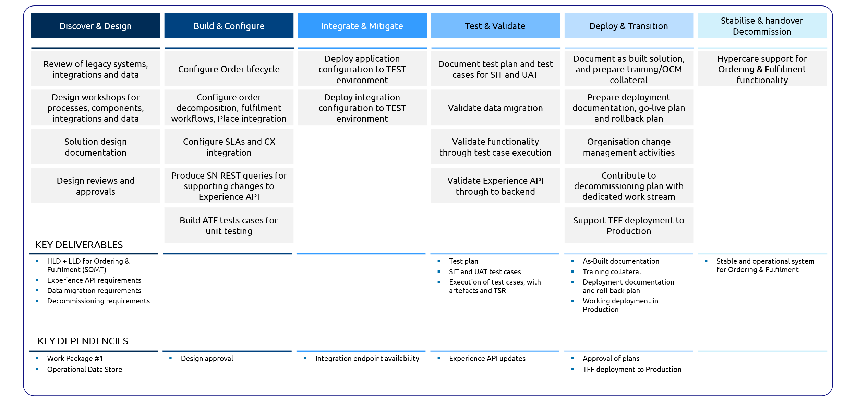

Detailed Dependencies
- A key requirement of Objective 2 is transparent status tracking, thus SOMT needs to provide real-time order status and visibility across ordering, fulfilment, field service and associated SLA positions. This will be exposed through the Experience APIs.
- Tuatahi will implement required changes to the Experience APIs, but Capgemini will provide detailed ServiceNow API details for underpinning these changes, based primarily on the Table API capabilities of ServiceNow. These details will include endpoints and connectivity, and queries to execute to retrieve the required data.
- As a result, the uplifted Experience APIs will consume SOMT order information as the source of truth, providing consistent data to the RSP Portal and external systems.

    - Work Package 3: RSP Billing Automation
The solution provided will automate the end-to-end RSP billing lifecycle by leveraging Dynamics 365 to generate subscription-based invoices triggered by fulfilment events. It improves billing accuracy, ensures lifecycle alignment, and strengthens reconciliation and exception handling.

Solution Details
To automate RSP billing and ensure accurate reconciliation and exception handling, the solution will use Dynamics 365 Subscription Billing integrated with ServiceNow (RSP Portal) through middleware.
The end-to-end RSP billing cycle will be implemented as follows:
- Billing Trigger & Subscription Creation
- Billing events will be triggered from ServiceNow (RSP Portal / SOMT) upon completion of Service fulfilment.
- The Subscription lifecycle events could be activation, modification, termination of the billing subscription.
- These events will be transmitted to D365 via middleware and will initiate the creation or update of Subscription Billing records
- Subscription Setup and billing in D365
- Customer subscription records will be created/updated with: Customer Account, billing frequency, billing start date and end date, billing items etc.
  - Based on the setups defined, D365 will automatically generate billing schedules
  - Charges will be calculated using:
    - Billing frequency
    - Pricing rules derived from product catalogue (WP1)
  - System will automatically generate subscription invoices
  - As a control measure, Invoice posting will remain a manual step to ensure final validation by finance users prior to dispatch
  - Middleware will manage data orchestration between ServiceNow and D365
  - System will send status updates back to ServiceNow:
    - Success → Subscription / Invoice created
    - Failure → Error message returned
  - When invoice gets posted, status will be updated back to the RSP Portal
  - Complete audit trail will be maintained starting from creation of invoice to posting.
  - Reconciliation controls will be maintained with unique identifiers like order id/service id.

Activities and Dependencies
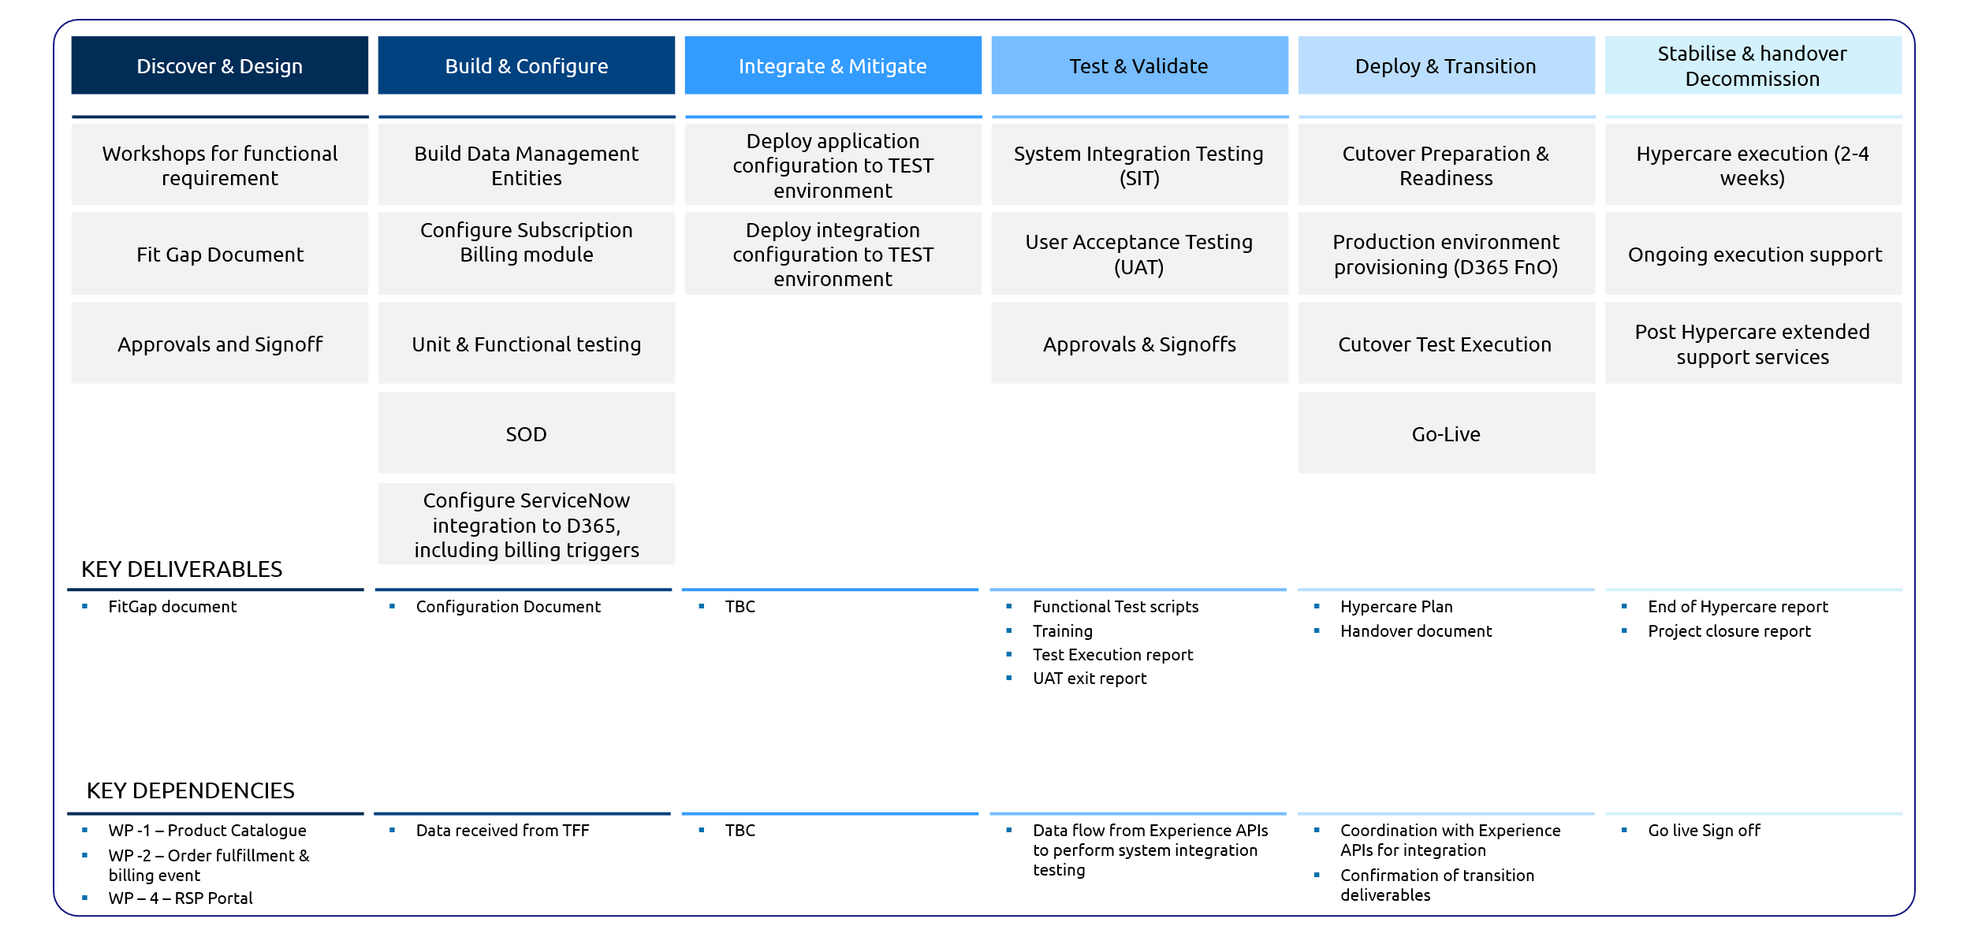

Assumptions
The following assumptions apply to the proposed solution:
- Customer creation will remain manual in D365
- Chart of Accounts (CoA) is pre-configured with required main accounts
- Product catalogue is already defined in D365 (aligned with WP1)
- Subscription invoice posting will be performed manually as a control step
- Middleware is responsible for:
  - Event orchestration
  - Data validation and transmission

Out of Scope

Handling of Customer invoice and customer payments are out of scope.

    - Work Package 4: New RSP Portal
Tuatahi’s RSP Portal architecture is designed as a secure, lightweight channel allowing Retail Service Providers (RSPs) to self-serve key fibre service management functions such as searching addresses, service qualification, placing/monitoring orders, viewing current services, and managing notifications via an easy-to-use web interface. The portal is built on a thin UI layer integrated entirely with Tuatahi’s Experience APIs, adhering to a strict API-first principle.

Solution Details

The Tuatahi requirements establish a clear need for a multi-tenant RSP model with strict tenant data isolation, whereby users operate within an organisation context and can only access data and functions have scoped to their respective RSP.
Accordingly, our solution adopts a secure multi-tenant architecture with logical data separation enforced through identity-driven access controls, API-level organisation scoping, and role-based permissions. This ensures compliant data isolation across all interactions, while the underlying cloud-native design supports scalable onboarding of additional RSPs and increasing transaction volumes without impacting security or performance.

The RSP portal will be a lightweight UI and all data retrieval will only happen via Experience API. There are no other interfaces for RSP portal, all communication to the dependent applications like Service Now, D365 happens via “Experience API” only. Design and build will utilise React Material Design components (20 components) and align to available brand guidance and WCAG 2.1 AA requirements. Design coverage is limited to defined components, priority views, and will not cover every possible edge case.

- Design engagement is expected to include discovery workshops, co-design sessions, and one round of usability testing with 3–4 participants (end users or client-nominated SMEs). Tuatahi is responsible for recruitment, scheduling, and incentives. Output includes a final developer handover pack.
- Design and user testing activities will be delivered using a timeboxed/capacity model. Within this fixed capacity, priority activities will be agreed and sequenced to maximise value.
- UX/UI design activities are dependent on the availability of high-level user stories and defined API/data structures. Delays or changes to these inputs may impact delivery sequencing and timelines.

UX/UI Volumetrics and Solution scope

UX/UI design will cover the defined 22 screens, focusing on priority flows rather than all possible permutations. Likely outputs include information architecture, task-based flows, high-fidelity designs, and interactive prototype for validation. Limited design support will be extended and available during the first three sprints to address clarifications, defect resolution, and minor refinements. UX/UI design activities are dependent on the availability of high-level user stories and defined API/data structures.

UX/UI volumetrics - Indicative WP4 Portal UX/UI volumetrics - based on the current 15-week estimate, we have assumed:
  - 6 priority user flows covering the key journeys as provided by Tuatahi.
  - 22 desktop screen designs based on priority experiences, not every future-state screen or edge case.
  - 1 clickable prototype covering key task interactions across multiple functional areas
  - 20 reusable components based on React Material Design.
  - 1 focused round of usability testing with 3-4 participants.

Other solution details -
The following 22 desktop screens have been estimated in scope – the complexity distribution and definitions are included below. Any changes to the number of screens or the complexity uncovered during the detailed design phase will result in impact to effort and timeline.
Journey Point | Screens | Complexity
RSP portal login | Login (SSO via Okta) | Small
 | Forgot Password | Small
Portal user landing page | Org Selection (Context)/ User Profile | Small
 | Orders Dashboard (Orders List) | Large
 | Order Tracking (read only, no interaction) | Small
 | Services Dashboard (Active Services List) | Large
 | Service Detail (Service Info & Device Data) | Medium
 | Customer orders for a location | Small
 | Notification Preferences (Settings) | Medium
 | Reports & Data Export (4 x Reports) | Large
 | Diagnostics Panel (in Service Detail) | Medium
Address search and service qualification | Address Search- Look up, Input, Qualification check | Medium
 | Address Search – Qualification Results (Success/ Failure) | Medium
 | List/ display product offers and select a product offer | Medium
Place service order | New Order - Service Details, upload attachments | Large
 | Order confirmation(Post-submission) | Small
 | Order rejection (Post-submission) | Small
Manage orders | Order detail | Large
 | Modify Order (change service details, upload attachments) | Medium
 | Cancel order (Confirmation dialog) | Small
Manage offers | List product offers | Medium
Network outage and maintenance | Outages & Maintenance page | Medium

- Report formats other than csv or pdf for download. The current estimate is for 4 reports. Any additional reports are out of scope
- AWS services used for the solution will be deployed in TFF AWS environment and cost incurred will be calculated after finalisation of architecture in design phase
- Collaboration with RSPs for testing of the RSP portal will be handled by TFF along with any other external vendor collaboration
- Provide support for UAT (2 rounds – one before RSP testing delivery and another one at the end of RSP Portal go live) to the test team
- Support for RSP testing phase of 12 months:
  - In the 12 months period of RSP testing phase, it was clarified in QnA that there will be very less changes encouraged from RSPs during this phase; in case there are major changes the plan and effort will be impacted
- Hypercare is solution for 1 month and post hypercare for 3 months

Deployment Architecture

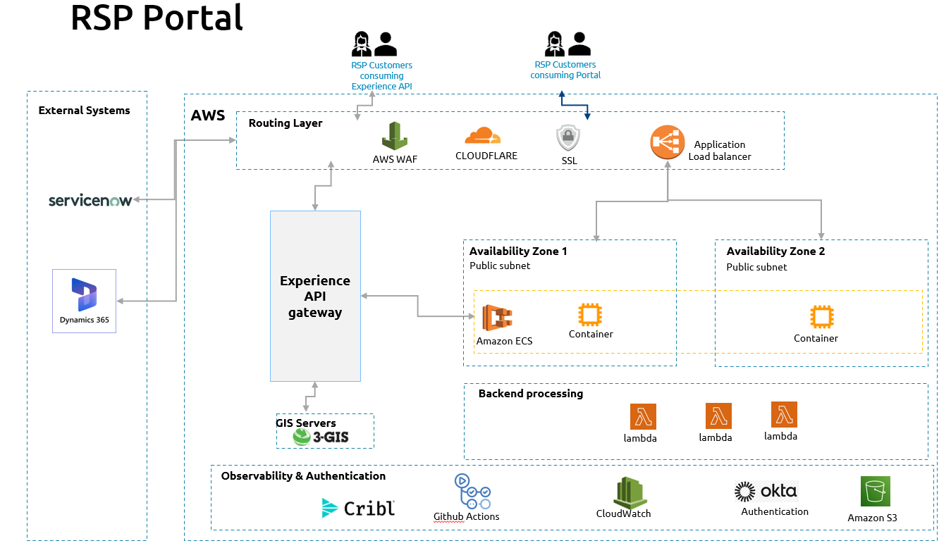
Following AWS services are planned for RSP Portal:

- ECS on EC2 or Fargate- The RSP Portal is a web-based Application accessible to RSP users through standard browsers. It’s built using React and served as static web content, it’s a lightweight, front-end-only app that runs in the user’s browser and delegates all data and process logic via Experience API layer owned by TFF. This will be deployed as docker containers using AWS Elastic Container Services.
- OKTA - User management happens outside the portal through user groups defined in OKTA and will be undertaken by TFF.
- RSP user access is secured via Okta Single Sign-On with OAuth2/OIDC. When an RSP user navigates to the portal, they are redirected to Okta to authenticate. Upon successful login, an access token is issued containing RSP identity and scopes. This token is stored in the user’s session and attached to every API call made from the portal. All User management is via OKTA
- Experience API - Tuatahi’s Experience APIs, maintained by TFF team, form the gateway between the portal and the core systems. These are domain-aligned microservices delivering external operations like address qualification, order submission, tracking, inventory and service queries, and so forth.
- Lambda functions - To handle a few data transformation scenarios without adding complexity to the portal or core systems, the solution includes a limited number of optional AWS Lambda utilities. These functions act as tightly governed edge-case handlers, invoked only when needed via specific Experience APIs or event triggers. This approach addresses edge cases pragmatically, preserving the RSP Portal’s API-first, thin-channel design while mitigating operational risks.
- Amazon S3 - Static assets used by the portal will be stored in the Amazon S3. Using S3 to serve these assets ensures fast, scalable distribution to RSP users and minimal operational overhead. S3’s inherent durability and elasticity support high availability. This can also be used to hold large reports requested by RSPs.

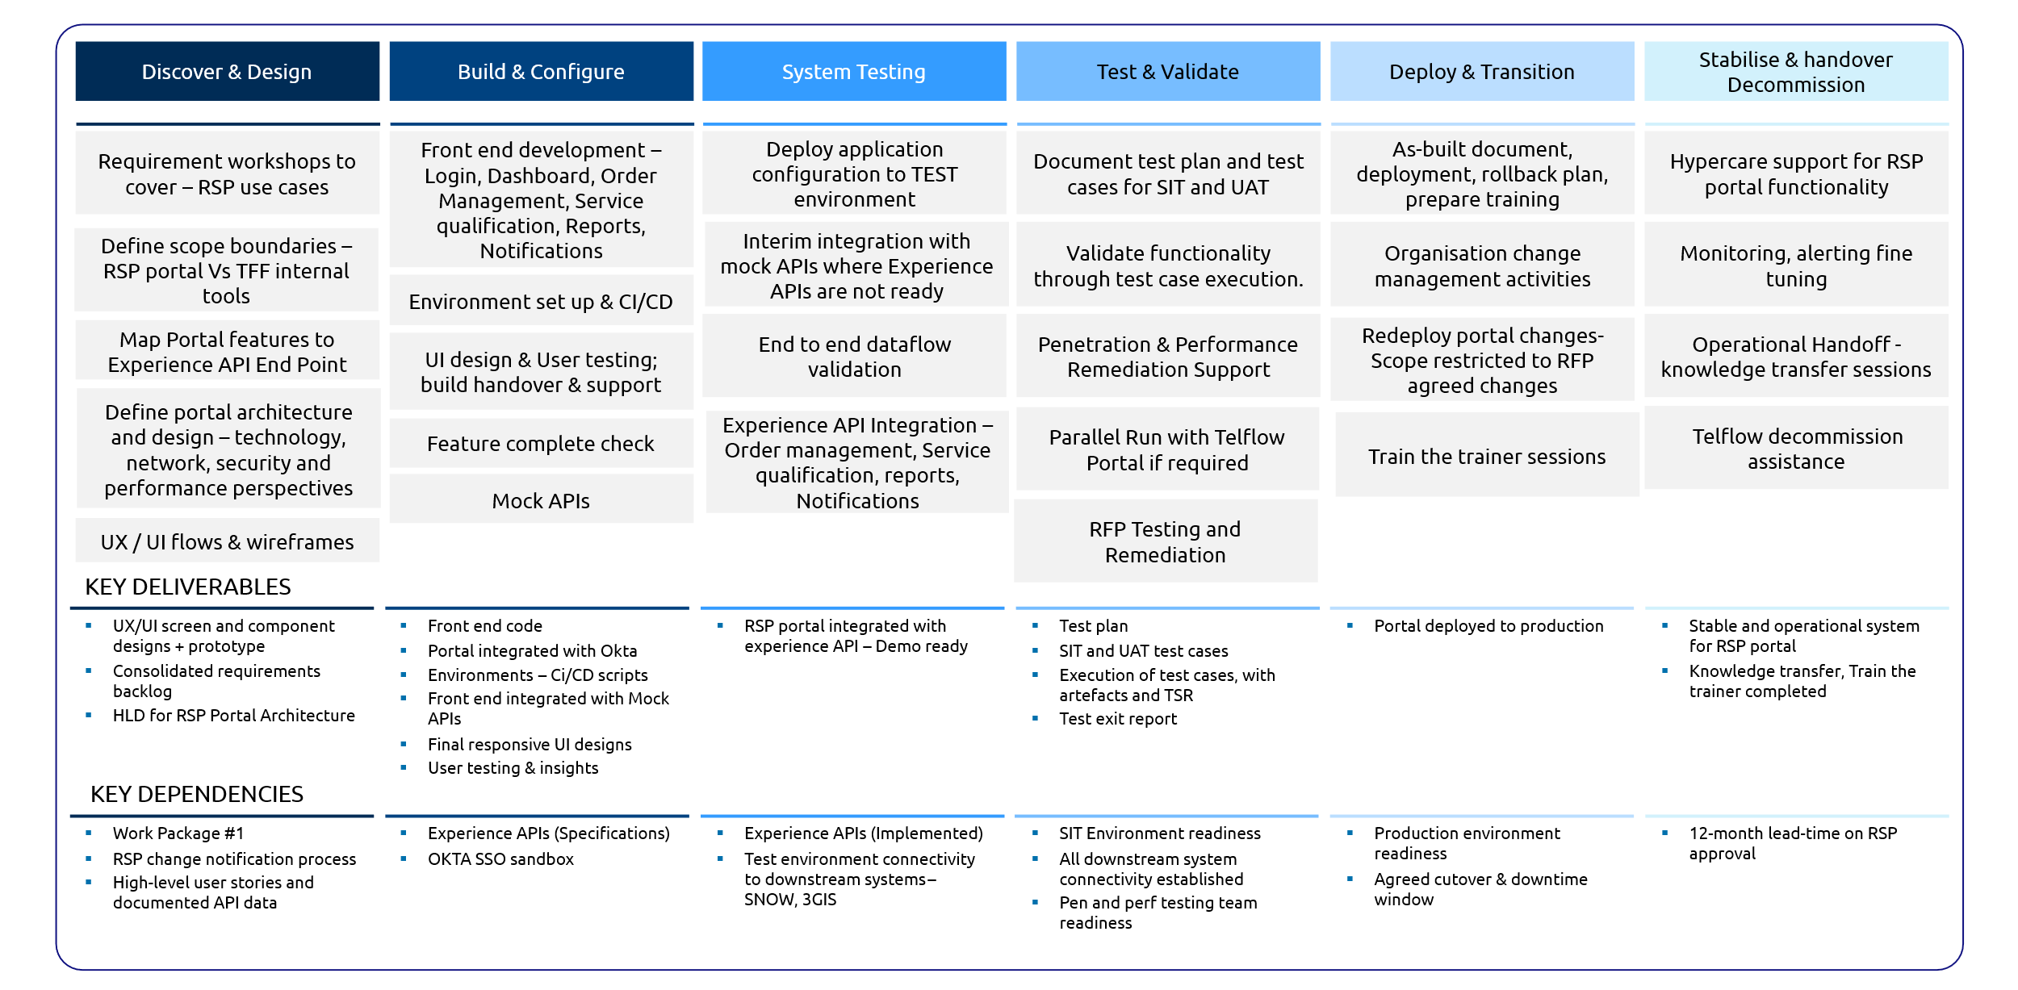
Activities & Key Dependencies

Detailed Dependencies

- A dedicated Tuatahi portal product owner will be available throughout the project to provide direction and resolve blockers.
- Access to required stakeholders and SMEs will be ensured, with availability supporting timely engagement, a single round of feedback per deliverable, and approvals and feedback provided by Tuatahi within 3 business days of submission.
- Experience API swagger definition will be made available to Capgemini prior to the discovery and design phase
- Experience APIs deployed in the platform by TFF at least 3 weeks prior to SIT phase.
- Strategy for notifications and outages needs to be discussed and confirmed with backend team during Analysis phase
- Accessibility/security standards to be supplied by TFF - this will need to be defined as part of the design phase.
- Execution of security and penetration testing will be carried out by TFF and Capgemini will provide support.

Out of Scope
- Scope is limited to the screens defined above along with complexity definitions. Any additional screens, flows, components, edge cases, design iterations, or testing cycles beyond this definition will be raised and discussed.
- Native mobile application design, development and deployment
- Multi-language support by the portal.
- Data migration from Telflow into any other system
- Design of a bespoke visual language, custom component library, or full design system beyond the React Material UI required for development.
- Securing the hosting environment and network perimeter will be TFF responsibility.
- Additional systems, screens, flows or non-React Material Design component design may impact timeline and efforts
- Ongoing or iterative design cycles beyond the defined timeboxed/capacity allocation
- Copywriting, content creation, testing participant recruitment, testing participant incentives and more than one testing round or one post-test iteration cycle for UI designs.

    - Work Package 5: Order pre-qualification

For order pre-qualification functionality a choice of off-the-shelf-package “InRule” is made over a custom-built solution based on items explained in In Scope section below.

Solution details
- InRule vendor package has been selected for implementing order pre-qualification functionality. This is inline with the requirements provided:
  - Configurable and maintainable, avoiding over-customisation (clarified in Q&A)
  - TFF doesn’t want to get caught in the heavy maintenance of custom applications (clarified in Q&A)
  - Business users should be able to update the rule (clarified in Q&A)
  - The rule engine should be outside of Service Now
  - Auditing of rule changes are required
  - Workflow for rules approval before posting into production
- Easy to maintain the application so off the shelf has been selected over custom-built application. Even though RFP called out custom built, we propose inRule will be faster deployment and easy maintenance
- Rules engine configuration and setup
- Importing the rules into InRule and unit testing
- Training the business team to be able to use the rules engine
- Hypercare (1 month) and post hypercare (3 months)
- Effort estimated for max of 120 rule implementation with complexity distribution
  - 30% simple rules
  - 50% medium rules
  - 20% complex rules
- Rule complexity is defined as below:
Category | Complexity
Simple | 1–2 conditions
Medium | multi-condition decision table
Complex | dependent / chained rules

- Our proposal is to install InRule inside AWS ECS, but if SaaS is preferred it can be evaluated and finalised during the discovery phase
- COTS package has been suggested for deployment but if TFF prefers a custom-built application, it will be discussed and mutually agreed during discovery
- Hypercare (1 month) and post hypercare (4 months)

Deployment Architecture

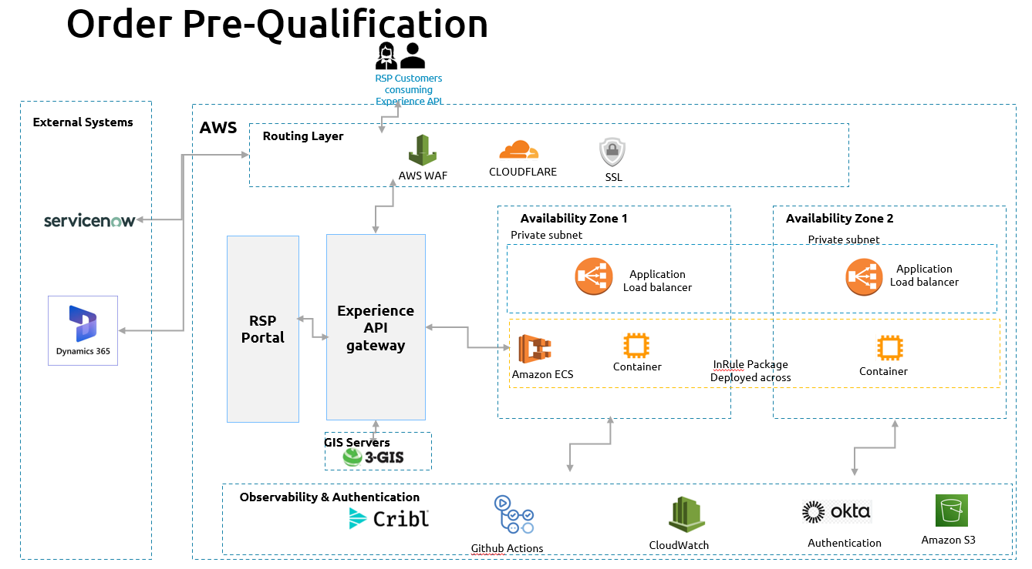
Considerations for deployment
- AWS ECS has been chosen as deployment platform, after discovery choice can be made if ECS on EC2 or ECS on Fargate to be selected or choice can be made for EKS as well

Activities & Dependencies
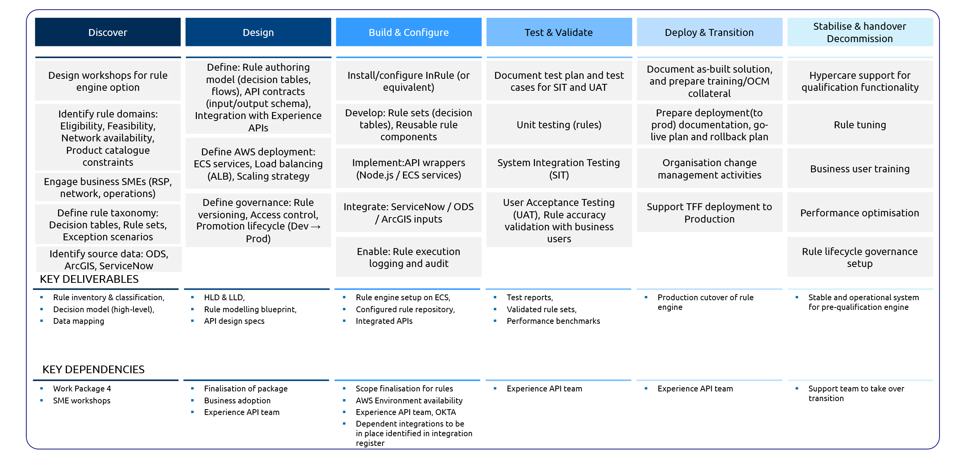

Detailed dependencies
- A dedicated Tuatahi portal product owner will be available throughout the project to provide direction and resolve blockers.
- It is mentioned that response time from rules engine should be in milliseconds; the exact NFR will be discussed during discovery and validated against the package capabilities
- Exact rules are not known and so 120 rule implementation has been assumed. During discovery this number will be validated against the list of rule provided by TFF
- Provisioning of the AWS services is not solutioned and it is assumed will be provided by TFF’s infra vendor.
- AWS services used for the solution will be deployed in TFF AWS environment and cost incurred will be calculated after finalisation of architecture
- Execution of security and penetration testing will be carried out by TFF and Capgemini will provide support.

Out of Scope
- InRule has been selected as the package for order pre-qualification functionality. Custom-built solution is not suggested
- Since a COTs package, no deployment pipelines have been estimated in the scope
- Data migration from any legacy system into InRule

Workstream B: Network
Workstream B focuses on transforming Tuatahi’s physical network data environment by consolidating all Layer 1 physical network inventory (PNI) into a single, authoritative system. This workstream addresses the current fragmentation of network data—spread across multiple systems, spreadsheets, and tools—by implementing a unified platform built on 3-GIS/ArcGIS that delivers an accurate, near real-time digital representation of the fibre network. The objective is to establish a single source of truth that enables consistent modelling, management, and visibility of all physical network components, including their location, connectivity, capacity, and lifecycle status. This consolidation improves data quality, eliminates duplication, and provides a scalable foundation for network planning, operations, and analytics.
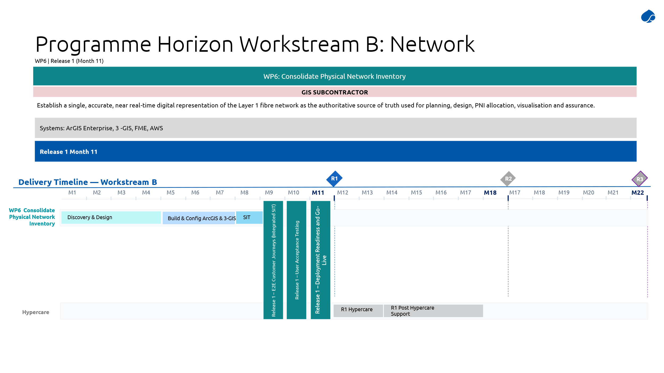
Beyond consolidation, this workstream enables advanced operational capabilities by integrating the physical network model directly into downstream processes such as service provisioning and order fulfilment. In particular, it supports automated allocation of network resources (e.g. fibre paths, ports) as part of the ordering workflow, allowing physical infrastructure to be assigned dynamically and accurately without manual intervention. The workstream also introduces end-to-end traceability across network assets, enhanced visualisation and reporting, and tighter integration with systems such as ServiceNow SOMT and field operations tools. Overall, it establishes a robust, data-driven network foundation that underpins automation, reduces operational risk, and enables faster, more reliable service delivery.

    - Work Package 6: Consolidate Physical Network Inventory

The GIS shall support the Physical Network Inventory (PNI), defined as the structured and authoritative record of all tangibles, spatially locatable network elements, including their geographic location, physical connectivity relationships, utilization status, and technical attributes.
The GIS represents the single source of truth for physical fibre infrastructure, while logical configuration and service connectivity are managed in complementary systems (e.g. Logical Network Inventory).

Solution Details

The Solution is based on 3-GIS Software, which itself relies on ArcGIS Platform for pure GIS (spatial and topological capabilities). 3-GIS components cover assets model, asset reference management (CRUD, traces, routes), and end user applications (web application, mobile native application).

The proposed solution effectively addresses both functional and technical coverage requirements, as illustrated in the diagram below, based on the “DS&A Requirements” sheet from the “Network - PNI User Interface Tool Requirements Version 0.1.xlsx” file.

Ref ID | Area | Principle | Description (summary) | Priority | How 3-GIS / ArcGIS + Our GIS Expertise Respond
1 | Integration & Interoperability | API-First Design | Expose functionalities and data through standard APIs | Must Have | ArcGIS Enterprise and 3-GIS expose documented REST APIs enabling secure access to GIS data and services. Our GIS expertise ensures API-first integration patterns aligned with enterprise architecture standards.
2 | Integration & Interoperability | Integration Readiness | Integration with OSS/BSS and enterprise systems | Must Have | 3-GIS and ArcGIS integrate natively with OSS/BSS ecosystems. We design scalable, secure integration flows (API, middleware, event) aligned with telecom OSS/BSS landscapes.
3 | Integration & Interoperability | Event-Driven Architecture | Publish/subscribe events for asset changes | — | ArcGIS supports webhooks and event notifications. Combined with our architecture expertise, we integrate GIS events into enterprise event platforms (Kafka / messaging layers) when required.
4 | Integration & Interoperability | Telco Alignment | TM Forum APIs and OPSR alignment | — | We align GIS and 3-GIS data models with TM Forum OPSR concepts, positioning GIS as the authoritative Resource (PNI) layer feeding Service and Order domains.
5 | Data Management & Governance | Data Management | Clear ownership and avoidance of data duplication | — | ArcGIS acts as the system of record for geospatial and physical network data. Our governance framework defines ownership boundaries between GIS, OSS, and BSS systems.
6 | Data Management & Governance | GIS Integration | Integration with GIS master system | Must Have | 3-GIS is natively built on ArcGIS, ensuring full consistency with the GIS master system. Our expertise ensures correct mastering, versioning, and synchronization patterns.
7 | Data Management & Governance | Data Lineage & Ownership | Define data origin and flows | Must Have | We define clear data lineage: creation, update, consumption flows between GIS, OSS, and downstream systems. ArcGIS metadata and governance features support traceability.
8 | Security & Compliance | Authentication & Authorization | Enterprise-grade auth & RBAC | Must Have | ArcGIS Enterprise supports SSO, LDAP, OAuth and role-based access control. 3-GIS inherits these controls. We align roles with operational personas.
9 | Security & Compliance | Enterprise Security Standards | Compliance with corporate standards | Must Have | ArcGIS and 3-GIS comply with enterprise security practices. We ensure alignment with vulnerability management, auditability, and security governance.
10 | Security & Compliance | Data Encryption | Encryption in transit and at rest | Must Have | ArcGIS supports TLS encryption and encrypted data storage. We ensure secure configuration aligned with enterprise security policies.
11 | Performance, Scalability & Resilience | Scalability & Performance | Horizontal scalability | Should Have | ArcGIS Enterprise is horizontally scalable. Our architecture designs support increasing data volumes and user concurrency without degradation.
12 | Performance, Scalability & Resilience | Resilience & Fault Tolerance | Graceful failure handling | Must Have | We design resilient GIS architectures (clustering, retry patterns, controlled degradation) leveraging ArcGIS Enterprise capabilities.
13 | Monitoring & Observability | Monitoring & Observability | Logs, metrics, health checks | Must Have | ArcGIS exposes health endpoints and logs. We integrate GIS monitoring into enterprise observability tools (logs, metrics, alerts).
14 | Modularity, Extensibility & Maintainability | Modularity & | Modular design | Should Have | 3-GIS is modular by design and fully extensible on ArcGIS. Our expertise ensures future enhancements without re-architecture.
15 | Modularity, Extensibility & Maintainability | Minimal Technical Debt | Clean code and sustainable design | — | We strictly follow vendor-supported extension patterns, avoiding unsupported customizations and minimizing technical debt.
16 | Lifecycle Management & Versioning | Lifecycle Management | Externalized configuration | Must Have | ArcGIS supports environment-specific configuration. We enforce configuration-over-code and controlled lifecycle management.
17 | Lifecycle Management & Versioning | Versioning & Compatibility | API and schema versioning | Must Have | ArcGIS REST APIs support versioning. We manage backward compatibility and controlled evolution of interfaces.
18 | Documentation & Handover | Documentation & Handover | Architecture & operational docs | — | We deliver architecture documentation, data models, API specifications and handover materials, ensuring operational readiness.
19 | Backup & Disaster Recovery | Backup | Robust backup strategy | Must Have | ArcGIS supports enterprise backup mechanisms. We define and validate backup strategies aligned with corporate DR policies.
20 | Backup & Disaster Recovery | Disaster Recovery | Tested recovery procedures | — | We design and document GIS DR scenarios (RTO/RPO) and support DR testing in line with enterprise continuity requirements.

The following schema shows the PNI System in context.
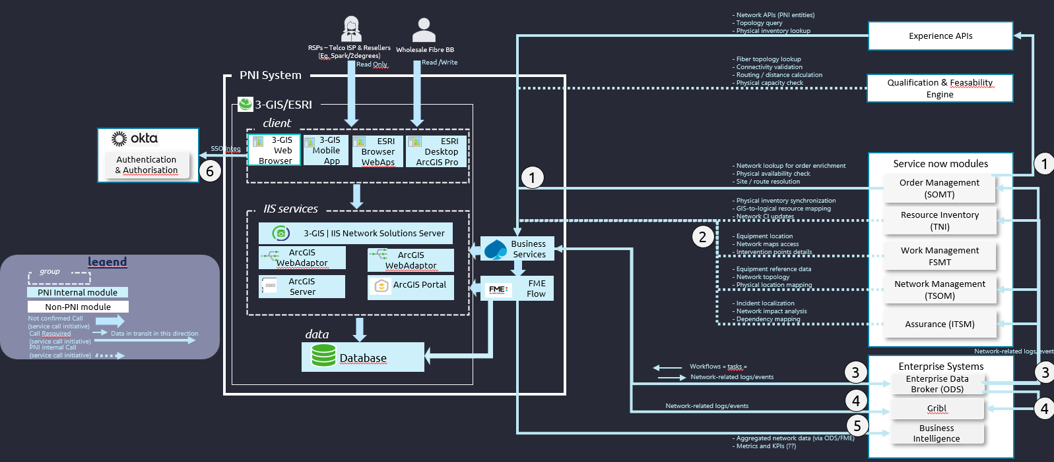

The hereunder table lists the components and their description

Component |  | Description
WebAdaptor |  | Technical component, wrapping web queries (HTTP, HTTP/S) to ESRI internal components (ArcGIS Portal, ArcGIS Server). It acts as a reverse proxy, inside IIS, and performs technical features. Essentially:  Web queries wrapping to ESRI ports  Users identification and SSO integration  There will be one webadaptor on top of ArGIS Portal, and one on top of ArcGIS Server.
ArcGIS Server |  | Expose REST Services for GIS Data, to deliver:  Backgrounds  Geographical assets layers  Geographical data layers (roads, administrative boundaries, …)  Advanced services (for instance addresses geocoding/reverse geocoding)
ArcGIS Portal |  | Front portal, that:  Manage users and RBAC policy  Expose webmaps (interactive maps: zoom, pan, add/remove layers)  Expose webapps (applications : advanced functionalities)  Expose surveys, dashboards, …  Expose and serve mobile apps : field workers, surveys, …
3-GIS Services |  | Expose Assets business services:  Datamodel for assets  CRUD, including constraints, for geographical and non geographical assets  Traces, routes, impacts…  3-GIS services rely on ArcGIS Services for geographical part.
3-GIS Mobile App |  | Mobile application, consuming 3-GIS and ArcGIS Services, for field workers
3-GIS Web application |  | Web Application, consuming 3-GIS and ArcGIS Services, that manage geographical and non geographical assets
Database |  | Geodatabase (ESRI) extended with Assets managed by 3-GIS.
FME |  | FME Tool is a “spatial ETL”, capable of:  Supporting ESRI API  Integrate and/or export CAD and/or Spatial files  Perform spatial checks  Perform spatial transformations.  FME will be mainly used for initial and/or incremental data migration. It will then be used for bulk import/export, or for asynchronous exports requiring advanced transformation or massive data processing. In this second case, it will be managed by specific services.

To simplify usage and integration of these services, we will add a set of specific services, that will use 3-GIS and/or ESRI services and expose a high-level API:
- Simplifying usage for logical network access
- Integrating transversal workflows (realize tasks and signal termination)
- managing observability

Component |  | Description and Role
Specific services |  | Manage integration, exposing a high-level interface, and consuming ESRI and 3-GIS Services. This layer will:  Call a set of internal vendor services (3-GIS and ESRI services) to expose a high level query  Integrate PNI contribution to transverse workflows, managing tasks and states  Integrate event asynchronous architecture, through consuming and providing notifications

All these components will be hosted on AWS, and based on the following middleware
Middleware |  | Description and Role
SQL Server |  | Hosts database
Internet Information Server |  | Hosts all the web-oriented components: Specific Business services, 3-GIS services, ArcGIS Server, ArcGIS Portal, ArcGIS Web Adaptor.

Additionally, some complementary services may be consumed, such as:
- ESRI ArcGIS Online services (for instance for background maps)
- External Open data services

The overall big picture of the PNI module and its integration looks can be described through the following schema
Integration Principles
The following principles will drive the architecture:
- 3-GIS/ArcGIS are the source of truth for the physical network. This means that 3-GIS is the reference for physical assets such as fibre connectivity (ports, splicing, paths), technical circuits, network routes at the physical connectivity level.
- ServiceNow supports the logical part, which is dynamic by parameterization, without physical operation on network (IP Addresses and tables, VPNs, VLANs, …)
- Service Now doesn’t maintain a copy of physical assets (no duplication). When needed, it can get information:
- To get the relevant physical asset for a subject, by querying the PNI API or by maintaining an ID (reference)
- To get details on an asset (location, attributes, …), by a query.
- When physical assets are created/deleted/modified, and when that may impact logical network or service delivery, a notification is sent through data broker. The modules who subscribed this event type may consume this event and perform the relevant actions.
- Interactive assets modification, may it be for location or attributes, will be realized on 3-GIS GUIs. Service or Logical layer can perform automated modifications, such as reservation, when needed.

The API will offer the capability of being technically integrated by three ways:
direct synchronous call of the API, when the needed action must be immediate, to be consistent with other actions, or when the “logical level” process need immediate information from physical network. These calls may be directly performed by ServiceNow modules, or raised through Experience API
asynchronous calls, for instance to ask for PNI evolutions in the context of a transverse workflow
notification from PNI to upper-level layers, for instance:
to notify that a task contributing to a transverse workflow has been terminated
to notify that Physical Network has been the object of modifications that may impact logical network and services.
There will not be synchronous call from PNI to ServiceNow, because il would generate some unattended dependency from the basic layer to the upper one.
Additionally, exports, mainly to the Data Platform, will be possible in bulk mode. FME will be used for that. FME can be useful when we need:
massive updates
advanced transformations of exported data
Finally, SSO integration is implemented in the solution.

Integration scope

The estimated scope is limited to identified requirements:
- SOMT updates using calls to PNI API, may it be through Experience API and/or by direct calls.
- SOMT notifications, by sending events to data broker.
- Observability, by sending events to Gribl.

During discovery phase, we deeply analyse needs and opportunities. Discovery effort is adjusted to make these complementary analyses, to be able:
- Considering additional interfaces
- To analyse the value and the costs, helping you to take a decision.

The hereunder table represents our current view of the potential integration subject, that will be consider in discovery phase.
Scope | Explicit ? | Assumption
Experience API | Implicit | Depending of the context, experience API may be used to mask the complexity of some functions for user interaction. May be used
Quality & Feasibility Engine | No | Get physical feasibility information:  Availability of physical assets  Connectivity routes  Place data
SOMT | Yes | The RFP is explicit on the SOMT integration need. It may be by direct calls or through experience API, depending on the context. The discovery phase will solve this point. The integration will allow SOMT module to:  find relevant assets to fulfil a new service  reserve these capacities
TNI | No | Notifications to TNI, to ensure logical/physical alignment
FSMT | No | Information to prepare filed services interventions:  location of assets, export of maps, navigation proposal  details about physical assets
TSOM | No
ITSM | No | Information relevant for assurance: localization or impact of an incident, associated assets, …

Single system
In this version, the 3-GIS / ArcGIS solution will be installed and parameterized, to be able to deliver the PNI management service without any connexion/sync with the other layers.

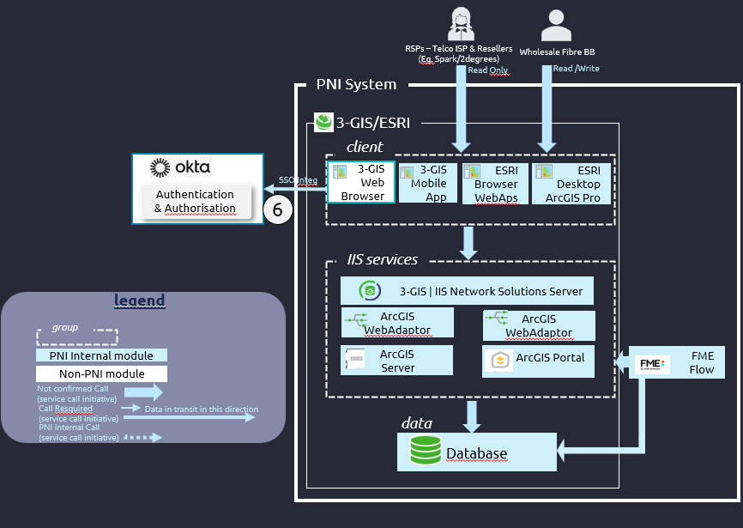

End to End traceability
Traceability is key to the system. We set up this traceability by implementing notifications to Gribl. At this step, the solution will have the following integrations:
- identification/authentication and WebSSO
- observability (including notification mechanism on which it is built)

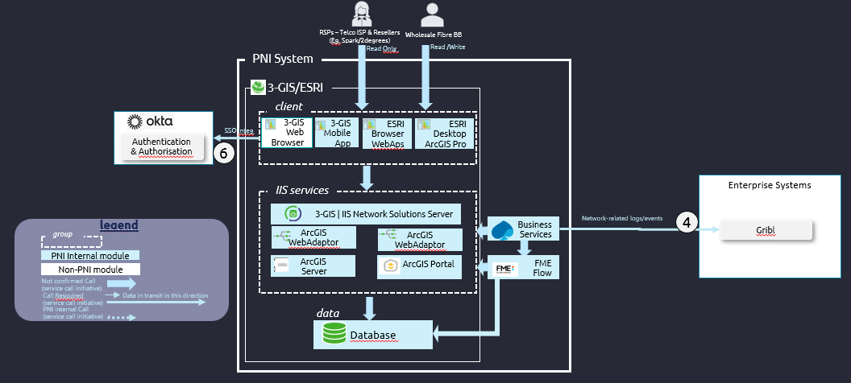

Integrated place management.
We initiate the business integration, with the most “geographical” support: place integration:
- services are developed, exposed and tested
- usage from ServiceNow is implemented and tested.
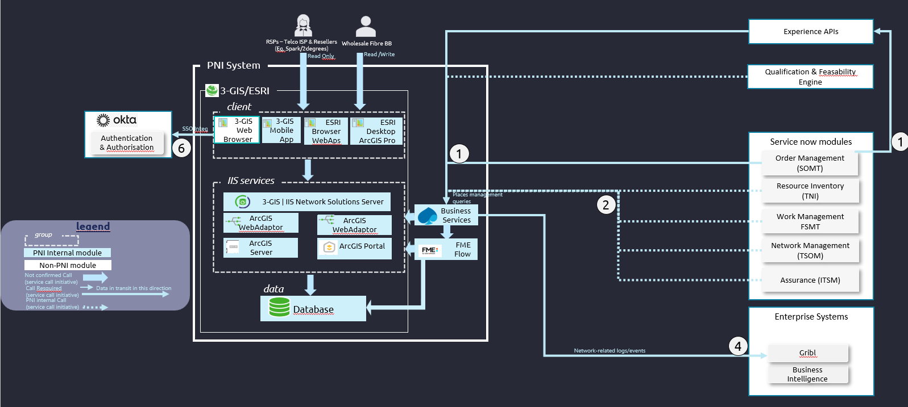

Automated PNI allocation
We then build the complete system, as described in the first figure of this chapter:
- The optional interfaces that have been decided will be made.
- The notifications to ServiceNow through Enterprise data broker are implemented

Activities and Dependencies
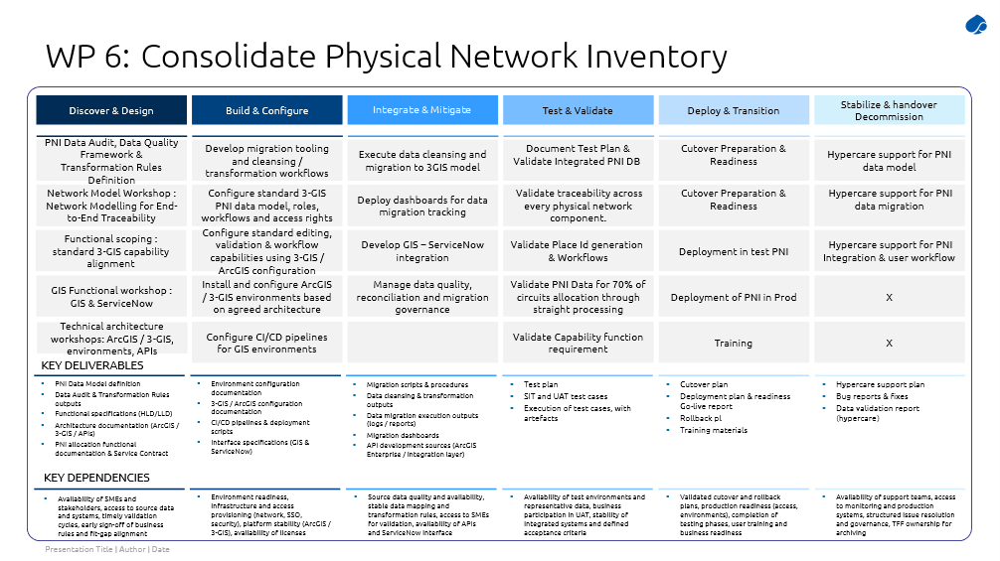

Details by stream

A – Discovery & Detailed Design
Capgemini will lead the Discovery and Detailed Design phase in close collaboration with 3‑GIS. This phase covers the definition of governance and planning foundations (GIS RACI and consolidated schedule), the production of functional specifications and detailed requirements, as well as the design of the technical architecture and associated security principles.
Working jointly with Tuatahi stakeholders, Capgemini and 3‑GIS will capture and structure functional and technical requirements, identify mandatory, critical and desirable features, and establish the basis for fit-gap analysis and subsequent implementation activities.
Activities are conducted in parallel through close collaboration between business analysis and solution architecture, ensuring consistent alignment between business needs and technical feasibility throughout the phase.
Main assumptions :
- Availability of TFF stakeholders and SMEs (planning, field ops, provisioning, GIS) to support requirements capture and validation
- Timely review and validation of deliverables within agreed governance cycles
- Completion of a fit-gap assessment confirming alignment with standard 3‑GIS / ArcGIS capabilities
- Early definition and sign-off of key business rules (fibre allocation, capacity, Place ID, etc.)
- Scope limited to Layer 1 (PNI), with L2/L3 addressed through integration only

B – Solution Build & Configuration
Capgemini will lead the GIS platform build and configuration activities, including the installation and configuration of ArcGIS Enterprise and supporting environments, environment standardisation, security hardening, operational readiness and the setup of CI/CD pipelines and Infrastructure-as-Code automation.
3‑GIS will support the installation and configuration of its product components, ensuring alignment with vendor best practices and standard capabilities, while Capgemini remains responsible for overall environment readiness and integration within the target architecture.
Executed in parallel with early integration activities, this stream enables interface design and preparation to progress alongside environment setup, including GIS REST API configuration, ServiceNow integration patterns and interface contract definition.
This approach reduces dependency bottlenecks while maintaining controlled validation gates prior to testing.
Main assumptions:
- ArcGIS Enterprise 11.5 and Utility Network 7 remain the baseline platforms (no major upgrades)
- 3-GIS implementation relies on standard product capabilities and supported configuration
- All environments (DEV, TEST, UAT, PROD), infrastructure, access, security and licenses are provisioned and available as per plan
- Environment readiness and provisioning delays may impact downstream activities

C – Data Cleansing & Profiling
Capgemini will lead the Data Cleaning & Profiling stream, covering legacy data profiling, identification of completeness, duplication and integrity issues, and the definition of rule-based cleansing using FME. This stream will also establish baseline data quality levels, defect categories, cleansing actions and go-live / hypercare acceptance thresholds.
3‑GIS will support this phase with product-specific expertise, ensuring that data quality findings are assessed against the target data model and effectively translated into migration and configuration constraints.
Initiated in parallel with Discovery, this stream is a critical foundation of the GIS / 3‑GIS delivery, as data challenges are expected to go beyond isolated defects and may impact structural integrity across core network entities (e.g. POE, circuits, splitters, ducts and associated identifiers).
The objective is to establish a robust and agreed data quality baseline to secure the migration workstream. This includes defining entity ownership, referential integrity rules, data validation criteria, deduplication and correction logic, as well as governance for key identifiers such as SLID.
Profiling outputs will be directly translated into actionable cleansing, transformation, reconciliation rules and measurable quality thresholds, supporting migration design, execution control and go-live readiness.
FME will be leveraged to support profiling, rule-based cleansing, transformation, validation and repeatable migration workflows.
Main assumptions:
- Access to all required source systems, datasets, schemas, metadata and SMEs is ensured
- Legacy data is assumed to be at least 80% usable for migration, subject to confirmation through data profiling. “Usable” means that the data contains sufficient geometry, mandatory attributes, unique identifiers and connectivity information to be transformed into the target model using rule-based migration processes. If profiling identifies materially lower usability, significant missing connectivity, or structural data defects requiring manual remediation, the impact on scope, cost and schedule will be assessed through change control.
- Data mapping between source and target systems, Will be defined once and reused, not significantly iterative. Unique identifiers (asset IDs, fibre IDs) can be reconciled and standardized
- Data volume (assets, fibres, connections etc) is Known and stable. Does not significantly increase during migration
- Data anomalies such as duplicates, missing attributes or inconsistent values are assumed to be resolvable primarily through agreed rule-based cleansing and transformation. Large-scale manual correction, field verification, engineering redesign or business-led data remediation are excluded from the current scope unless explicitly agreed.
- Business teams provide validation rules and support exception resolution

D – System Integration
Capgemini will be responsible for the GIS integration stream, including the configuration of GIS REST APIs, integration endpoints and development of GIS-specific integrations, notably with ServiceNow and GIS. Capgemini will own interface design, integration delivery, interface contracts and technical coordination with the relevant system owners.
Main assumptions:
- Integration scope is limited to ServiceNow SOMT interface
- Additional integrations identified during Discovery are subject to formal change control
- Availability of APIs, endpoints and integration environments is ensured
- Integration patterns are aligned with standard ArcGIS and 3-GIS capabilities

E – Data Migration
Data Migration will be delivered as a shared workstream with clear responsibilities. 3‑GIS will lead product-specific migration activities related to the target 3‑GIS / ArcGIS model, including methodology, mapping, transformation, validation, reconciliation and telecom-specific constraints, as well as associated data governance principles.
Capgemini will deliver complementary migration activities, covering non-telco GIS datasets, attachments and as-built content, ArcGIS Portal / ArcGIS Online adaptation, and data archival and traceability. Capgemini will also ensure overall migration coordination, alignment with project milestones and consistency of quality controls.
Initiated as soon as the target data model and data quality baseline are stabilised, this stream focuses on defining and executing the migration strategy, source-to-target mapping, transformation rules, migration procedures and validation processes across all relevant data domains.
Executed in parallel with platform build and integration preparation, this approach reduces schedule risks while ensuring alignment with architecture and data model decisions.
Main assumptions:
- Source systems include ArcGIS Utility Network, ODN, uFibre and Place datasets
- Data mapping and transformation rules are stable and reusable (limited iteration)
- Data volumes are known and remain stable during migration
- Unique identifiers (assets, fibres) can be reconciled and standardised
- Post-decommission archiving is managed by TFF

F – Testing & Quality Assurance
Capgemini will lead the GIS Testing & Quality Assurance stream, covering the preparation and execution of test strategies, including system integration testing (SIT), user acceptance testing (UAT) support, automated test suites, defect tracking and test evidence management. Coordination with 3‑GIS will ensure efficient resolution of product-specific or configuration-related issues.
Initiated once the core platform, key integrations and initial migration cycles are stabilised, this stream ensures comprehensive validation across functional, integration and data dimensions, supported by defined acceptance criteria.
Testing activities are conducted in close collaboration with business analysis, development and data teams to ensure full coverage of test scenarios and alignment with business requirements.
Main assumptions:
- Availability of test environments aligned with production setup
- Availability of representative test data
- Active participation of business stakeholders in UAT
- Acceptance criteria and validation rules are defined and agreed upfront

G – Cutover & Go-live
Capgemini will lead the Cutover & Go-Live phase, covering the definition and execution of cutover and rollback strategies, coordination of deployment activities, and overall go-live orchestration. Capgemini will ensure readiness of environments, migration outputs, integrations and test acceptance prior to production transition.
3‑GIS will support this phase through training activities and product-specific expertise to prepare users and facilitate the transition to the new platform.
Prepared ahead of production release, this phase ensures a controlled transition to operations. It is followed by a Hypercare & Stabilisation period providing dedicated support, including incident resolution, defect management, user assistance and continued data validation to secure adoption and service continuity.
Main assumptions :
- Cutover and rollback strategies are validated prior to deployment
- Production environments, integrations and migration outputs are ready and validated
- Completion of SIT/UAT and formal acceptance is required before go-live
- Business readiness (training, onboarding) is ensured prior to transition

H – Hypercare & Stabilisation
Capgemini will lead the hypercare and stabilisation phase, including incident coordination, bug logging, issue tracking, user support and continued data validation. 3-GIS will provide product-specific support during hypercare, particularly for issues related to standard 3-GIS functionality, configuration, migration outputs or product behaviour. Capgemini will remain accountable for the overall hypercare coordination and client-facing reporting.
Main assumptions :
- Access to production systems, monitoring tools and logs
- Structured issue resolution and governance processes are in place
- Stable ownership transition to TFF post-hypercare

Out of Scope

- The scope of this engagement is intentionally focused on the implementation of a Layer 1 (PNI) GIS solution based on standard ArcGIS and 3‑GIS capabilities. As such, several elements are explicitly excluded from the current scope.
- Higher network layers (Layer 2 and Layer 3) are not modelled in detail within the GIS solution and are only addressed through integration where required. Similarly, integration scope is limited to the interface with ServiceNow SOMT; any additional systems or interfaces identified during the project will be subject to formal change control.
- The implementation is based on the use of standard 3‑GIS product capabilities and supported configuration options. As a result, bespoke development, non-standard product customisation, unsupported extensions or custom front-end development are excluded unless explicitly agreed following a fit-gap assessment and formal approval process.
- From a data perspective, the scope assumes that data cleansing and migration can be achieved primarily through rule-based approaches. Activities requiring large-scale manual data remediation, field verification, engineering redesign or business-led data correction fall outside the current engagement unless specifically agreed.
- In addition, certain data sources and activities are excluded from the migration scope. This includes migration from systems such as Smallworld (unless explicitly included), as well as post-decommission data archiving, which remains under the responsibility of TFF.
- More broadly, any deviation from the defined scope, including additional integrations, significant data quality issues, major platform changes or infrastructure constraints, will be managed through the project’s formal change control process.

Workstream C: Field Force
Workstream C centres on transforming how field-based activities are managed by implementing end‑to‑end automation of Work Order processes for both network assurance and service provisioning. Its primary goal is to replace fragmented, manual coordination (currently reliant on spreadsheets, emails, and partial system support) with a fully orchestrated, event-driven workflow managed through ServiceNow Field Service Management for Telecommunications (FSMT) and integrated partner systems. This includes automating the lifecycle of Work Orders from initial demand trigger—such as a network fault or customer order—through scheduling, execution, and completion, while ensuring consistent, real-time visibility of status across Tuatahi and its service partners.
The workstream ensures that both internal field teams and external partners (e.g. Ventia) operate within a unified workflow, with clear ownership boundaries, controlled status transitions, and bi-directional integration via the Service Partner Gateway. It supports both assurance scenarios (incident-driven repairs and maintenance) and provisioning scenarios (installation and activation of new services), linking them back to customer orders and network events. In doing so, it enables accurate tracking of work progress, SLA adherence, and operational performance, while also capturing detailed execution data (such as labour, materials, and outcomes) to support downstream processes like billing and financial reconciliation. Overall, this workstream establishes a consistent, automated, and transparent field operations model that is tightly integrated with the broader order-to-fulfilment lifecycle.
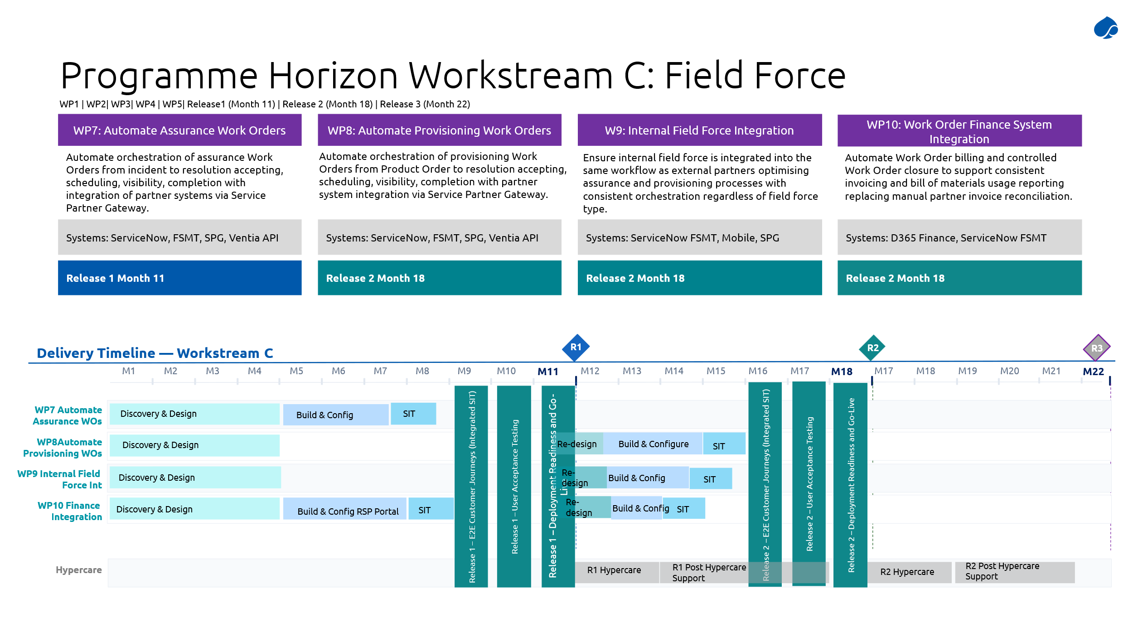
    - Work Package 7: Automate Assurance Work Orders
Work Package 7 delivers the end‑to‑end automation of assurance workflows, from fault detection through to resolution. Business Objective 7 requires:
- Automated orchestration of assurance Work Orders
- Integration with partner systems (e.g. Ventia)
- Real-time status visibility and lifecycle control

Solution Details
ServiceNow FSMT is implemented as the central Work Order Management platform, responsible for Work Order lifecycle orchestration, field task coordination, and integration with partners via the Service Partner Gateway (SPG). It sits between demand systems (SOMT, netw event systems) and execution systems (Ventia and internal field teams). Key to this model is FSMT owning the Work Orders with partners (Ventia and internal field teams) owning Tasks within those Work Orders.

In the context of WP7, it focuses specifically on “Assurance” work orders, but it also lays the foundation for supporting “Provisioning” work orders (WP8) and internal work assignment (WP9) by implementing some of the core, underpinning capabilities.

The end-to-end assurance work order lifecycle automation will be implemented as follows:
- Fault Detection and Demand Trigger
  - Assurance workflows are initiated from Incident Tickets in ServiceNow ITSM, once support personnel have validated the fault and determined if field intervention is required. Incidents may be created:
    - Automatically from network events (alarms and outages from OSS), via ServiceNow ITOM
    - Manually, directly in ServiceNow ITSM by TFF personnel
    - From customer reports, although this is not a defined use-case for the RSP portal, so would likely revert to manual creation once TFF are informed.
  - Changes to the current state of ServiceNow ITSM/ITOM or OSS is not required for the solution and therefore is out of scope.
- Work Order Creation
  - Once field work is required, FSMT will generate a Work Order from the Incident ticket. During discovery and design, we will evaluate if there are appropriate triggers to do this automatically based on attributes of the source ticket.
  - Each work order includes:
    - Fault context (affected services, severity)
    - Linked network and service inventory
    - Place ID (for traceability from order to fulfilment)
    - SLA requirements
    - Required work type (repair, inspection, maintenance)
This ensures standardized, structured, and complete field instructions for the work that needs to be performed.
- Task Decomposition and Assignment
  - FSMT decomposes the Work Orders into Tasks, with tasks representing executable steps (e.g. Fibre repair, splice check, etc).
  - Tasks can be routed internally (with this capability expanded in WP9), or externally to service partners (Ventia) via the Service Partner Gateway (SPG)
  - Each task will be standardised and have an associated billing code, to facilitate automation of financial reconciliation and billing.
This architecture, with Work Orders being the orchestration construct and Tasks being the execution units, allows effective assignment of responsibilities whilst retaining full visibility of work progress.
- Routing via Service Partner Gateway (SPG)
  - Tuatahi’s preferred architecture model requires routing all work, both internal and external, via the SPG. The outbound work routing capability will be implemented as part of this work package, but the internal work consumption capability (for internal field force) will be implemented as part of WP9.
  - The SPG isn’t currently in production use at Tuatahi but exists from an earlier work-routing integration from Maximo to external service partners. It provides a standardized interface for controlled data exchange and validation, decoupling internal and partner systems. It is based on a pub-sub model for outbound work assignment, and a REST API for inbound status updates. Tuatahi are responsible for reinstating (and uplifting) the SPG so it can be utilized in the implementation of this work package.
  - When work is dispatched via the SPG, it will include details such as:
    - Job specifications
    - Location and network details
    - SLA timelines
    - Required materials/work types
The delegated service partner is notified of the work through the pub-sub mechanism of the SPG.
  - When the service partner performs work for a given task, certain updates will be sent back via the REST API mechanism of the SPG. The exact updates required will be determined through the discovery and design process, but it is anticipated that the following updates will be required:
    - Accepted – The service partner has accepted the work that has been assigned to them and will perform the required work.
    - Scheduled – The service partner has scheduled the work for action. This update would typically include the planned date/time and would be triggered again if the work is rescheduled.
    - In Progress – The work is underway.
    - Completed – The work has been completed. This update could include attachments such as photographs of completion, checklists, diagnostic reports, etc.
When updates come back into FSMT via the SPG, the state changes will be validated to ensure only allowed state transitions are permitted. This ensures correct sequencing of activities and better governance of exception states (e.g. Paused, Blocked, etc).
- Work Order Lifecycle Management and Control
  - As tasks are updated via the SPG (or otherwise), they can drive the status of the parent Work Order. This is governed by the workflow for assurance Work Orders to ensure that the Work Order status is updated accordingly based on the associated tasks, particularly if multiple tasks are required.
  - FMST acts as the authoritative system for Work Order status. It will provide visibility of this to other systems (including RSPs) via the Experience APIs.
- SLA Monitoring
  - FSMT measures time across lifecycle stages to track SLA performance, triggering alerts for delays, breach risk, and SLA violations. This enables more proactive operational management and helps improve compliance.
- PNI changes
  - Some assurance work orders will require physical changes to the network, which will be recorded in 3-GIS/ArcGIS as the master system for PNI. Rather increase complexity by passing GIS updates through Ventia systems, SPG and ServiceNow, such updates will be done directly in 3-GIS/ArcGIS via their application.
- Reporting and Analytics
  - FSMT captures fault types, resolution times and root cause indicators. It also ensures full linkage between the originating incident, the work order and tasks, and the field execution outcomes. This can be fed into process for performance analytics and continuous improvement of network operations.
- Bill of Materials (BoM) and Labour
  - Currently the BoM and Labour components are tracked in the field using Survey123, which will continue with this solution. However, that data will be pulled into ServiceNow FSMT and fed through to D365 for financial reconciliation (via WP10).
- Integration with Billing (D365)
  - When a work order is completed by an external service partner, with BoM and Labour captured, it will trigger a financial update event for D365 to record the BoM and Labour against the service partner, linked to the work order to support financial reconciliation and billing.
  - Since the provisioning tasks will be standardised with pre-defined billing codes, ServiceNow will propagate the billing codes for the completed tasks to D365 in the update event, and D365 will apply the correct rate.

Once implemented for WP7, ServiceNow FSMT will be the central assurance Work Order orchestration platform, enabling:
- Automated creation of Work Orders from faults and incidents
- Structured decomposition into executable Tasks
- Seamless routing to Ventia via the Service Partner Gateway
- Bi-directional, real-time status synchronisation
- SLA-controlled lifecycle management and exception handling
This delivers Business Objective 7 by providing a fully automated, transparent, and partner-integrated assurance workflow, ensuring consistent, efficient, and reliable fault resolution across the network.

Exception handling
For WP7, exception handling must be embedded within a controlled Work Order and task lifecycle framework. The solution defines explicit task states and enforces strict transition rules to prevent out-of-sequence updates or invalid states, but there are situations when exception may still arise. Such situations, such as incomplete tasks, failed assurances, external partner delays, etc, will be captured as governed exception states (for example “On hold”), with clear rules for how and when tasks can return to active progress. This will ensure lifecycle integrity while supporting real-world operational variability.
Exception handling will also support end-to-end visibility and auditability across internal and partner ecosystems. All exception events should be logged, categorised, and linked to the originating demand ticket, the Place ID and the associated network or service context. We expect that the Service Partner Gateway will support the synchronisation of exceptions raised by service partners, with consistent status definitions and ownership boundaries (Tuatahi owns work orders; partners manage tasks). SLA monitoring is tied to task progression, so exceptions will be clearly reflected in SLA calculations and performance reporting. This will ensure that service assurance remains transparent, measurable, and resilient despite operational disruptions.

Data Migration and Consolidation
No specific data migration is required for Work Package 7.

Delivery approach
As WP7 shares a lot in common with WP8 and WP9, we propose to deliver WP7 in Release 1. This will allow us to deliver not just the automation workflows required for assurance work orders, but also the common components, such as the core FSMT configuration, the SPG integration and the business logic for routing work orders externally vs internally.
Release 2 will then build upon this work to deliver the functionality for WP8 and WP9, with no rework anticipated for WP7.

Activities and Dependencies
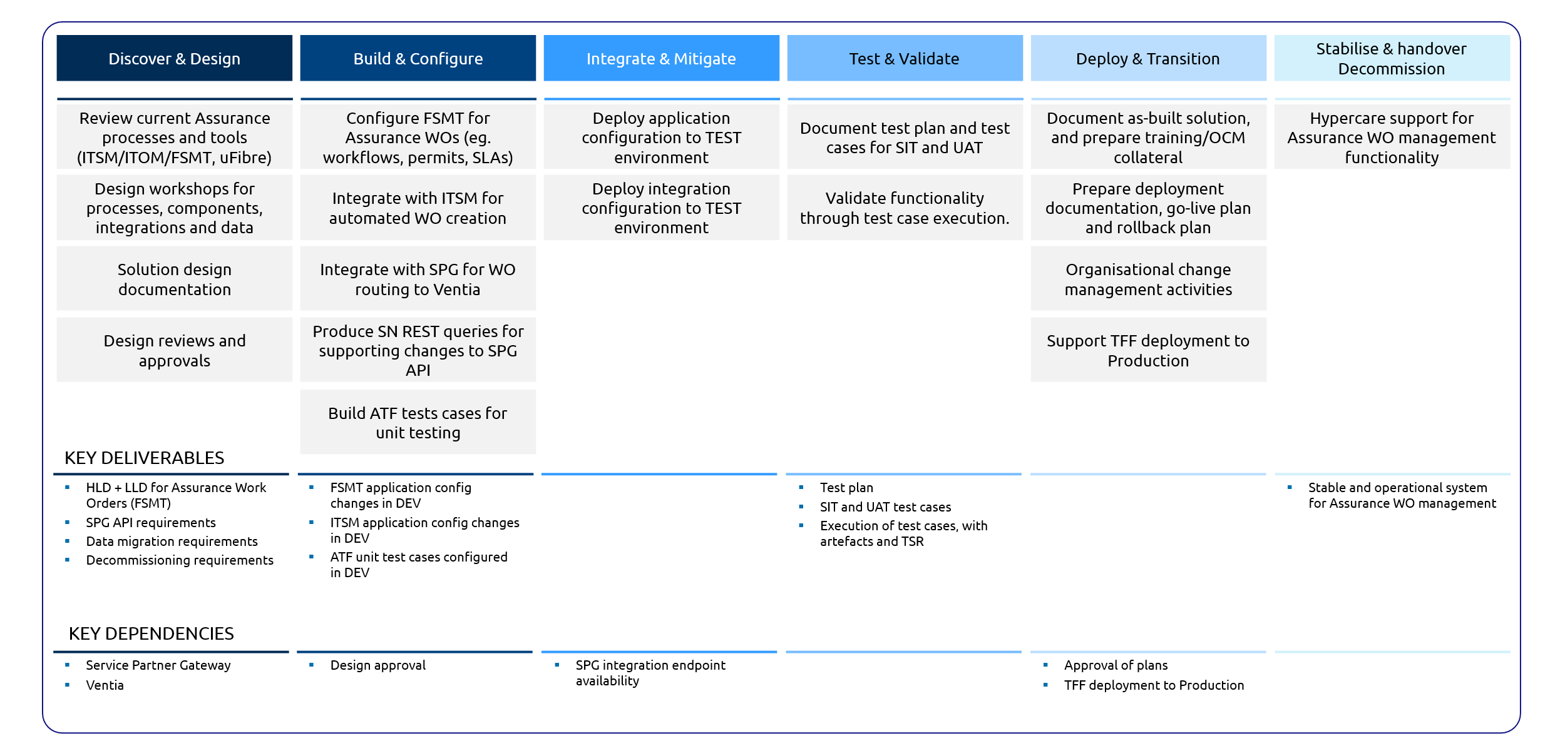

Detailed Dependencies
- A key requirement of Objective 7 is transparent assurance work order status tracking, thus FSMT needs to provide real-time order status and visibility across field service and associated SLA positions. This will be exposed through the Experience APIs.
- Tuatahi will implement required changes to the Experience APIs, but Capgemini will provide detailed ServiceNow API details for underpinning these changes, based primarily on the Table API capabilities of ServiceNow. These details will include endpoints and connectivity, and queries to execute to retrieve the required data.
- As a result, the uplifted Experience APIs will consume FSMT work order information as the source of truth for assurance work orders. This may not necessarily be exposed externally to RSP, at least initially, but at a minimum will provide internal visibility. It will also underpin future capability to expose work order scheduling to RSP end customers.

Out of scope
The following areas are considered out of scope from the proposed solution:
- Service Partner Gateway, including any implementation, modification, or deployment activities.
- Experience APIs, including any implementation, modification or deployment activities.
- Definition of standardised work order tasks and associated billing codes, which will be the responsibility of TFF.

    - Work Package 8: Automate Provisioning Work Orders
Work Package 8 delivers the end-to-end orchestration of provisioning (network build) work, including new fibre deployment, capacity augmentation, and network extensions and remediation builds.

Solution Details
Business Objective 8 requires:
- Planned, scalable, and efficient delivery of network build work
- Strong control of delivery partners (Ventia)
- End-to-end visibility and governance of build programmes

ServiceNow FSMT is extended from WP7 to become the central planning, orchestration, and execution control platform for provisioning Work Orders.

The end-to-end provisioning work order lifecycle automation will be implemented as follows:
- Building on WP7 and extending the FSMT pattern
  - WP8 reuses and extends the WP7 assurance work order architecture, rather than creating a separate model. It primarily differs in how work orders are initiated. Rather than originating from network faults, they originate from orders placed via SOMT.
- Work Order Creation
  - Once field work is required, a Work Order will be generated in FSMT from the Sales Order ticket in SOMT. Not all orders in SOMT will require work orders, only those will require specific tasks in the field, typically related to network provisioning activities.
  - The decision point for field work is determined in WP2 as part of the SOMT processes. This boundary for this work package is the point at which that determination is made.
  - Each work order includes:
    - Build scope (e.g. area, route, assets)
    - Linked locations and network elements
    - Place ID (for traceability from order to fulfilment)
    - SLA requirements
Work Order Templates will be used to automatically populate work orders and associated tasks based on the nature of the work to be complete. This ensures standardized, structured, and complete field instructions for the work that needs to be performed.
- Task Decomposition and Assignment
  - Per WP7, FSMT decomposes the Work Orders into Tasks, with tasks representing executable steps. During discovery and design, this process will be investigated in more depth, as potentially complex field work can be planned out in FSMT. However, the expectation is to realise the greatest benefit from automation by templating as much as possible to auto-generate suitable tasks based on the nature of the work order. This will need to be able to accommodate inter-task dependencies.
  - Tasks can be routed internally (with this capability expanded in WP9), or externally to service partners (Ventia) via the Service Partner Gateway (SPG)
  - As per WP7, provisioning tasks will also be standardised with associated billing codes, to facilitate automation of financial reconciliation and billing.
- Routing via Service Partner Gateway (SPG)
  - This will re-use the capability delivered for WP7.
- Work Order Lifecycle Management and Control
  - This will re-use the capability delivered for WP7, as all Work Orders share the same state model.
- SLA Monitoring
  - This will re-use the capability delivered for WP7, although provisioning-specific SLAs will be defined and configured.
- PNI changes
  - This will re-use the capability delivered for WP7.
- Reporting and Analytics
  - This will re-use the capability delivered for WP7, although the nature of the reporting will be provisioning-focused rather than fault-focused, and specific dashboards and reports may be required.
- Bill of Materials (BoM) and Labour
  - This will re-use the capability delivered for WP7.
- Integration with Billing (D365)
  - This will re-use the capability delivered for WP7.

Once implemented for WP8, ServiceNow FSMT extends the WP7 assurance model into a structured provisioning orchestration platform, enabling:
- Creation of planned, multi-stage provisioning Work Orders
- Decomposition into hierarchical tasks for execution
- Seamless routing to Ventia via the existing SPG integration
- Lifecycle and milestone-based control of build delivery
- Real-time progress visibility and performance management

This delivers Business Objective 8 by providing a controlled, scalable, and transparent network build capability, built on the same FSMT and SPG foundations established in Work Package 7.

Exception handling
This will re-use the capability delivered for WP7, but with additional considerations that has the potential to increase the complexity. Specifically, in WP8, exception handling must address the complex, multi-activity nature of provisioning workflows, particularly where parent–child Work Order relationships exist. Exceptions such as failed installations, scheduling conflicts, or incomplete dependencies will need to be isolated at the appropriate Work Order or task level while maintaining the overall integrity of the orchestration. The system will propagate exception states across related Work Orders to ensure dependencies are visible and managed (e.g. delaying downstream tasks until upstream issues are resolved), without breaking the broader provisioning lifecycle.
Additionally, exception handling is expected to be needed to support customer-facing transparency and coordinated recovery, such that RSPs are able to see accurate status updates, including delays, risks, and required actions, while internal teams and partners are provided with structured remediation workflows (e.g. rescheduling, reassignment, or escalation). SLA and scheduling commitments will need to dynamically adjust based on exception states, and deviations should be captured with reason codes and audit trails. The intent is to ensure that provisioning exceptions are managed predictably, minimising customer impact and operational disruption.

Data Migration and Consolidation
No specific data migration is required for Work Package 8.

Delivery approach
No functionality specifically for WP8 is planned for Release 1, although the core components delivered in this release for WP7 will underpin WP8.
Release 2 will then build upon WP7 to introduce automation workflows for provisioning work orders. It will leverage the core FSMT foundation, SPG gateway, and external vs internal routing logic that will already be in place. It is anticipated that there may be some minor enhancements required for the SPG integration, in the event that provisioning work orders carry additional details that weren’t identified in WP7.

Activities and Dependencies
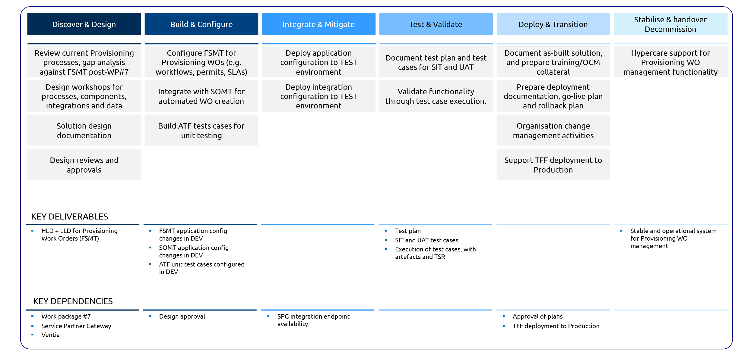

Out of scope
The following areas are considered out of scope from the proposed solution:
- Service Partner Gateway, including any implementation, modification, or deployment activities.
- Experience APIs, including any implementation, modification or deployment activities.
- Definition of standardised work order tasks and associated billing codes, which will be the responsibility of TFF.

    - Work Package 9: Internal Field Force Integration
Work Package 9 extends the FSMT operating model to support internal delivery teams, applying the same integration and orchestration principles used for external partners (Ventia).

Solution Details
Business Objective 9 focuses on:
- A consistent, unified operating model for all work execution (internal and external)
- Standardised routing and lifecycle control
- Full visibility and traceability regardless of executor

FSMT is implemented for WP9 to treat internal teams as service partners, leveraging the same SPG integration model used for external vendors. It does not introduce a new paradigm—it extends the existing architecture:
- WP7: Established FSMT + SPG for external assurance (fault repair)
- WP8: Extended FSMT + SPG for provisioning (network build)
- WP9: Applies the same SPG-based interaction model to internal execution teams

All work, whether delivered by Ventia or internal teams, is routed via SPG using a consistent interaction pattern, ensuring uniform control, simplified integration, and consistent lifecycle governance.

In WP9, FSMT plays a dual role:
- Primary Work Order Orchestrator (as in WP7/8)
- Execution host via SPG Client for internally assigned work

This introduces a key architectural extension, in that FSMT must consume its own SPG messages for internal work execution. To do so, an SPG Client capability will be implemented within FSMT, enabling it to receive tasks routed via SPG (as if it were an external partner), to interpret and process incoming task requests, and to create execution artefacts internally. It introduces a "controlled duplication" model:
- Primary Work Order - End-to-end orchestration (created from demand and managed centrally)
- Execution Work Order - Created internally to manage SPG-assigned tasks

The process flow is as follows:
- Primary Work Order Created (FSMT)
  - Triggered from SOMT or incident (as per WP7/8)
  - Represents overall scope and lifecycle
- Task Routed via SPG
  - Task designated as “internal execution”
  - Sent through SPG (same as Ventia routing)
- SPG Client Receives Task (FSMT)
  - FSMT consumes the SPG message
  - Interprets it as a partner-issued task
- Execution Work Order Created
  - FSMT creates a secondary (duplicate) Work Order
  - Acts as the parent container for execution tasks
- Task Created Under Execution WO
  - Task assigned to internal resources/crews
  - Managed through FSMT scheduling and dispatch
- Status Updates Propagate Back
  - Execution WO updates
  - Task updates sent via SPG back to:
    - Primary Work Order
    - Overall orchestration flow

This is necessary to ensure consistent work order workflows and handling, and re-use of business logic from WP7 and WP8. Without it, internal and external processes would diverge and governance and traceability would degrade. It guarantees a single version of truth regardless of who is executing the field work and provides consistent lifecycle behaviour.

Some key differences do arise in how the internal field force executes the work:
- SLAs can be defined against the Execution Work Orders to measure internal field force operations using specific KPIs tailored to drive internal operational efficiency. These do not replace SLAs at the Primary Work Order level, which are still required for consistency, but they do complement those SLAs.
- Internal field technicians will use the ServiceNow NowAgent mobile application to update Tasks in the field. However, they will still require the use of 3-GIS/ArcGIS to update PNI.

Once implemented for WP9, ServiceNow FSMT extends the WP7 and WP8 architecture to support internal execution by:
- Introducing an SPG Client capability within FSMT
- Routing internal work via the same SPG framework used for external partners
- Implementing a dual Work Order model:
  - Primary WO for orchestration
  - Execution WO for internal delivery
- Ensuring bi-directional synchronisation and traceability across both

This delivers Business Objective 9 by creating a fully unified, SPG-driven execution model, where internal and external work are managed consistently, transparently, and efficiently within FSMT.

Exception handling
As the architecture treats the internal field force as another “service partner”, with the same, standardised work management process, we can re-use the exception handling capability delivered for WP8, but with an uplift in capability that will also be applicable for WP8. This additional capability is to address the need for WP9 to support seamless reassignment and cross-team recovery in exception scenarios. Where internal teams cannot complete work (e.g. capacity constraints or specialised requirements), Work Orders must be transferable to external partners (and vice versa) without loss of context, status, or audit history. Exception handling should therefore include mechanisms for reassignment, escalation, and prioritisation, all while maintaining end-to-end traceability and consistent SLA treatment. This unified approach will ensure operational resilience, optimise resource utilisation, and prevent fragmentation in field service execution.

Data Migration and Consolidation
No specific data migration is required for Work Package 9.

Delivery approach
No functionality specifically for WP9 is planned for Release 1, although the core components delivered in this release for WP7 will underpin WP9.
Release 2 will then build upon WP7 to introduce workflows for fulfilment of work orders by the internal field force, following the same pattern established for external service partners. It will leverage the core FSMT foundation, SPG gateway, and external vs internal routing logic that will already be in place, but it will also require the implementation of an SPG Client for receiving internally assigned work orders, and the adoption of the NowAgent mobile application for field updates to tasks.

Activities and Dependencies

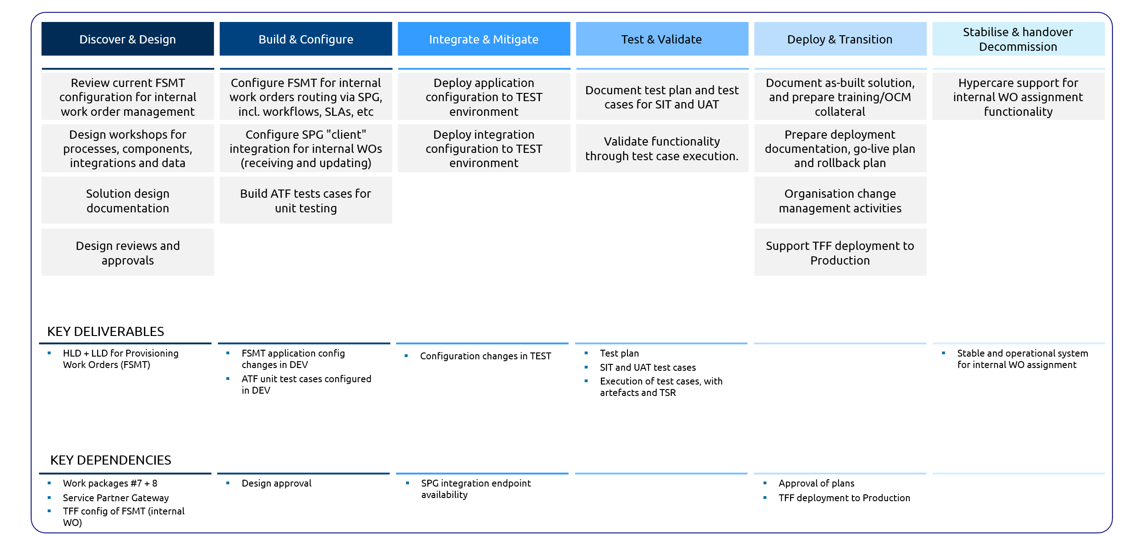

Out of scope
The following areas are considered out of scope from the proposed solution:
- Service Partner Gateway, including any implementation, modification, or deployment activities.
- Experience APIs, including any implementation, modification or deployment activities.
- Definition of standardised work order tasks and associated billing codes, which will be the responsibility of TFF.

    - Work Package 10: Work Order Finance System Integration
The solution provided will automate the Work Order billing and enabling controlled Work Order closure. It will establish a seamless, event-driven integration between ServiceNow (FSMT) and Dynamics 365 Finance.

Solution Details
The solution will ensure an automated invoice generation based on validated work completion, accurate cost allocation (materials and labour), strong auditability and reconciliation across systems with reduced manual intervention currently performed by the assurance team.
The end-to-end implementation for work order billing will be as follows:
- When a work order is completed in FSMT, a notification is automatically sent to Dynamics 365 through middleware to trigger the financial process.
- This event will update various fields in D365
  - Work Order ID
  - Billing code(s)
  - Completion status
  - Labour costs
- ServiceNow FSMT will trigger data for Work orders in D365 on work order completion event and create Purchase Orders with the relevant details.
- Inventory movements will be recorded via journals (inventory movement journals - manual)
- After posting the Purchase invoice, system will allocate the amounts to the correct accounts ensuring the work order details preserved.
- Middleware will take care of the data transformation, validation, error handling and status communication. Success or failure messages will be tracked.

Activities and Dependencies
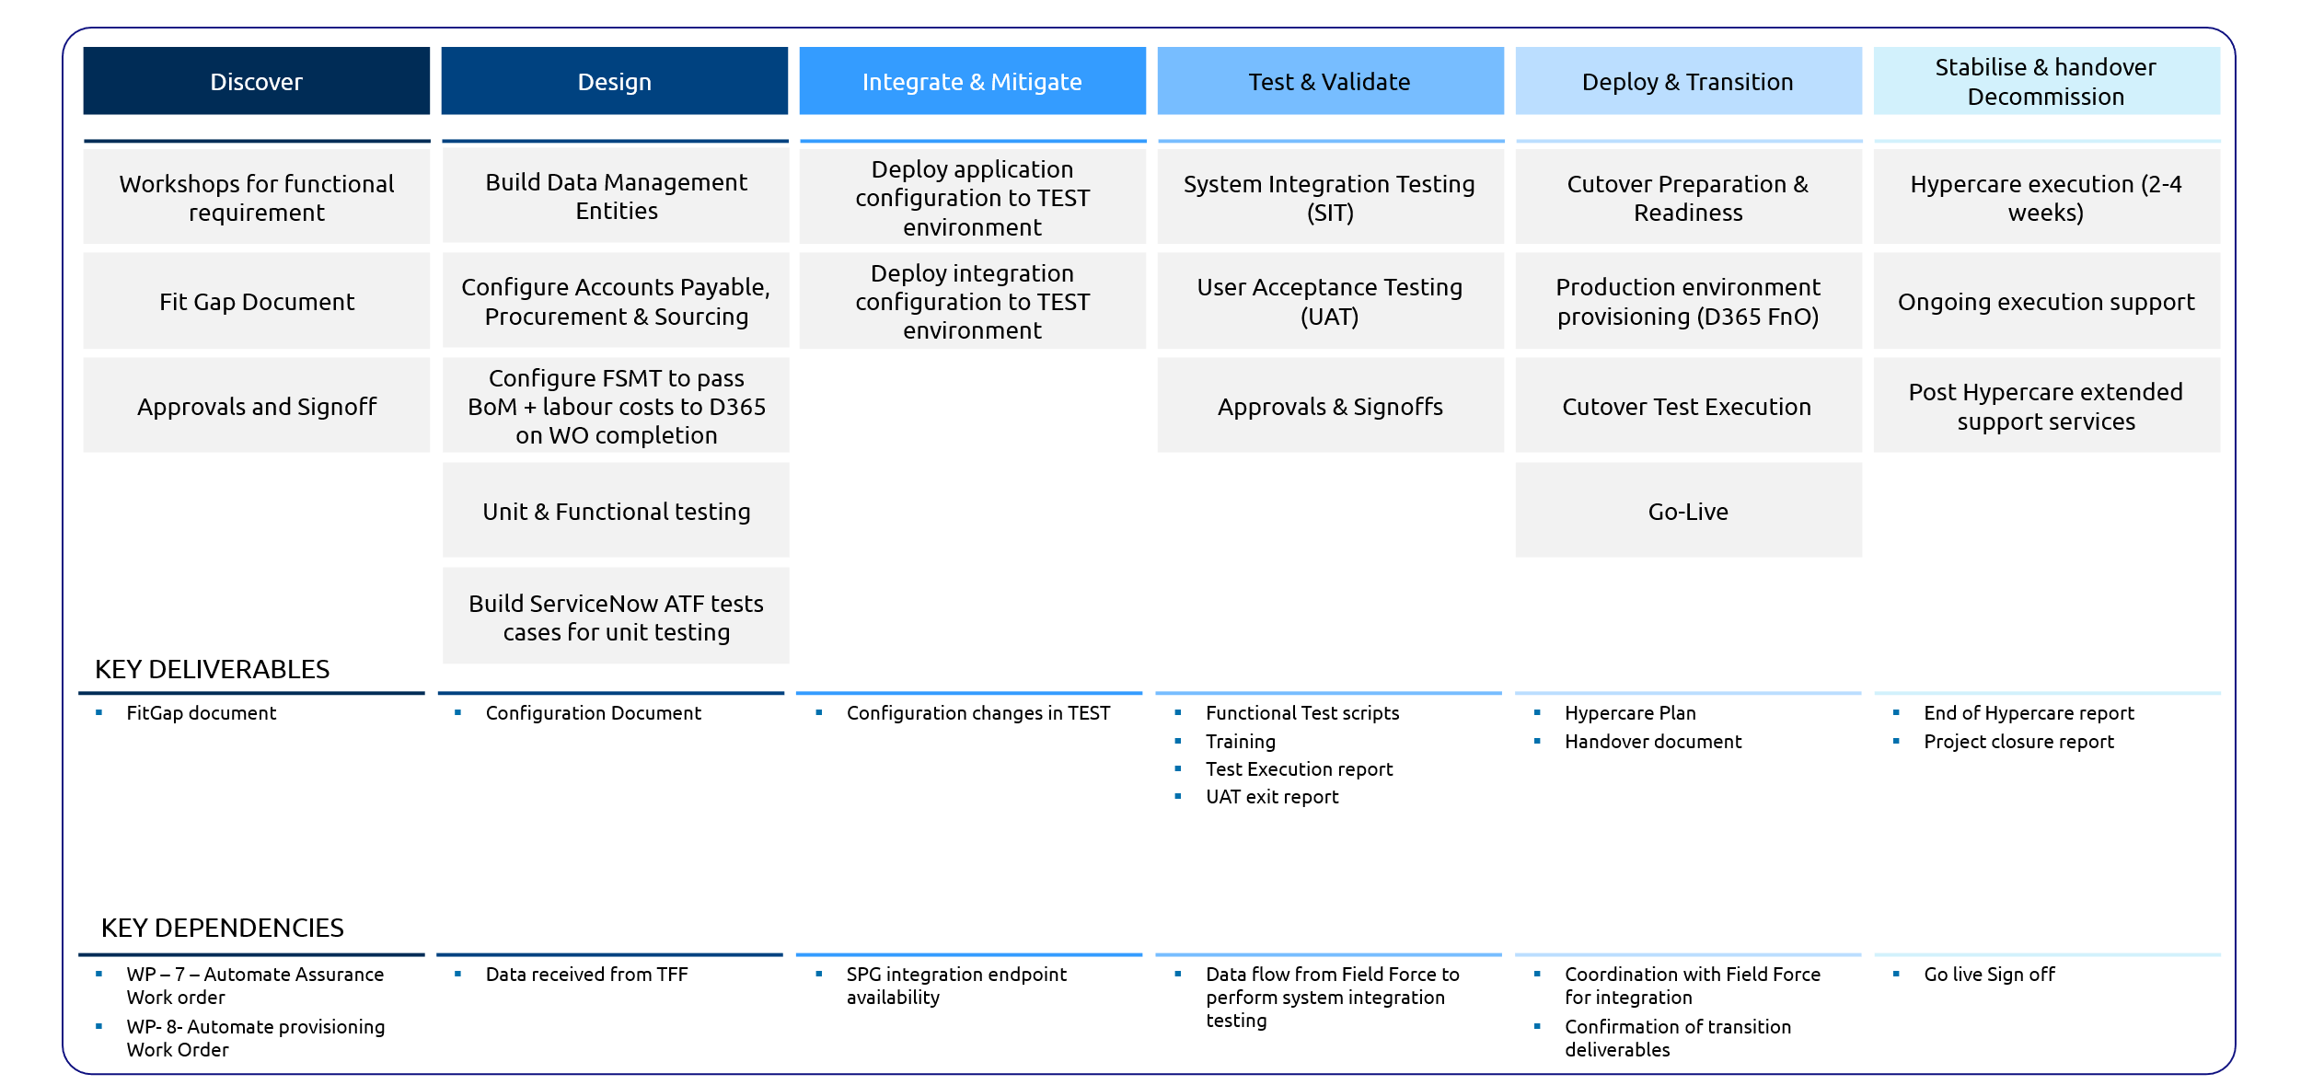

Assumptions
The following assumptions apply to the proposed solution:
- Middleware availability
- Master data alignment
- FSMT data quality

Out of Scope

The following areas are considered out of scope from the proposed solution:

- Vendor onboarding process
- Inventory management process
- Handling of Vendor payments
- Bank integration

Integration
Based on the requirements, we recognise multiple integration patterns and supporting platforms needed to enable seamless communication across systems.
Patterns are classified into 2 major categories:
- API’s that will integrate into existing platform of “Experience APIs”
- APIs that are new and will be required for internal communications that will be added into a new integrations platform called “Internal API Platform”

Capgemini will implement a governed integration resilience framework to ensure reliable, consistent, and fault-tolerant communication across all systems in the Tuatahi ecosystem
This approach aligns with:
- Tuatahi’s requirement for retry-resilience in integration gateways
- Expectations for integration backlog recovery, throttling, and error monitoring
- Programme focus on exception tracking and quality control

    - Solution Details
- We understand that Experience API layer is an integration platform that exposes Business APIs to external RSP as well as to the internal systems
- We propose adding a new internal integration platform following the same tech stack as that of experience API, the choice of technology so that:
  - It ensures easy maintenance of the platform as requested by TFF since this will follow same technical stack and framework it will be easier for TFF to maintain after go-live/hypercare period
  - It avoids any vendor lock-in
  - Built on open source and so additional license requirements
  - In the overall architecture, the “Internal integration platform” will be found in the middle to highlight the integrations between internal systems like ServiceNow and Dynamics365 etc
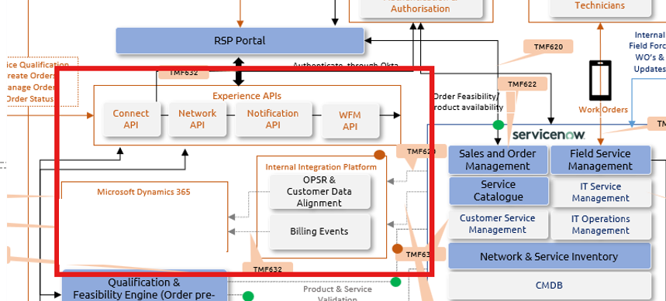

- Various Integrations categories are explained below:
Platforms | Details | Existing Platform or New
Experience API | - API interactions will be routed through the Experience API layer.  - Each underlying system will be responsible for exposing its respective APIs.  - The TFF team is responsible for enhancements and configurations within the Experience API layer to ensure required functionalities are exposed and accessible. | Existing (new integrations to added/adjusted)
Internal API Gateway | - A new API Gateway will facilitate both internal system-to-system communication and Event-driven integrations | New
P2P | - Integration with SPG handled directly by ServiceNow team and TFF | New
Direct | - These integrations will involve secure, direct API calls from the respective consuming systems. for e.g. Cribl, Okta | New

A detailed integration register (Excel document) has been prepared and added under addendum section titled as “Addendum 1 - Programme Horizon Integration Register.xlsx”. This workbook captures: Source and target systems, Integration types, Key interaction details, and boundaries

- During the design phase, this Integration Register will be
  - Validated and refined based on technical feasibility and business alignment
  - Finalised through mutual agreement on scope and implementation approach
- A summary of the count of integrations is as below:
Responsibility | Direct | Experience API | Internal API Gateway | P2P | Grand Total
CG | 2 | - | 24 | - | 26
TFF | - | 23 | - | 2 | 25
Grand Total | 2 | 23 | 24 | 2 | 51

  - Go-live of the integrations are planned along with the work package go-lives where the integrations are required; and their hypercare period will follow
  - Integrations that are owned by TFF, i.e. the “Experience APIs” are not considered in the estimations while it is assumed that source and target systems will enable the integration endpoints for the “Experience APIs” to consume
  - Hypercare solutioned for (1 month) and post hypercare (3 months)

Deployment Architecture
With the known details around the “Experience APIs” platform, an architecture has been put for the internal integration platform as shown below:
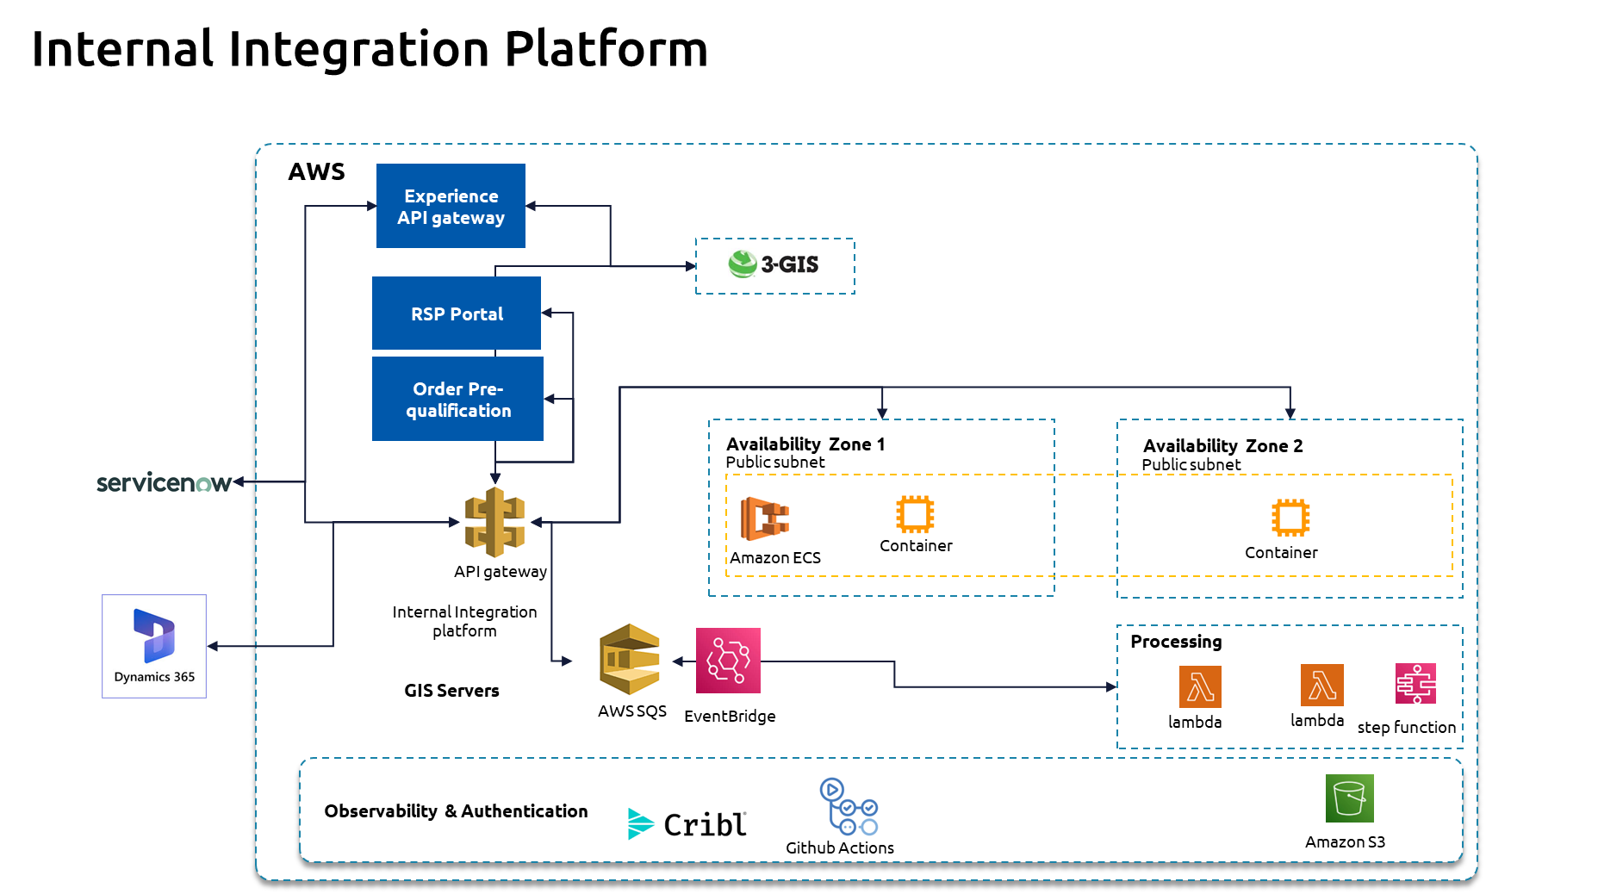
  - Considerations
    - Inline with Experience API architecture, the internal integration platform is also design – this will enable TFF to easily maintain the platform after hypercare support
    - Event processing is required for few integrations and already SQS is being used in the landscape from Experience API scope, during discovery the need for AWS Kinesis or EventBridge will be evaluated and approval taken from TFF.
    - Following services from AWS has been planned:
      - ECS on EC2/Fargate- Custom integration components will be deployed as docker containers using AWS Elastic Container Services.
      - Lambda functions/Step Functions- To handle a few data transformation scenarios, the solution includes a limited number of optional AWS Lambda utilities or step functions.
      - Static Portal Assets – Amazon S3- For any storage requirements for intermediate storage for data manipulation
      - API gateway – to act as a gateway and to provide a security and scalability for all integrations
      - For event processing choice will be made between SQS or Event bridge or Kinesis after discovery phase
      - AWS API gateway in front gives a scalability as well as security functionality. Capgemini will enforce API rate limiting and input validation through a centralised API Gateway and policy-driven security framework, ensuring controlled access, protection against abuse, and consistent data validation aligned with Tuatahi’s security standards and Experience API governance model.
    - An API first approach has been selected for the internal integration platform too. With the given details here is the integration pattern that is suggested:

Integration Pattern | Count
API | 18
Event | 6
Grand Total | 24

    - Activities and Key Dependencies:
Activities and dependencies are detailed below:

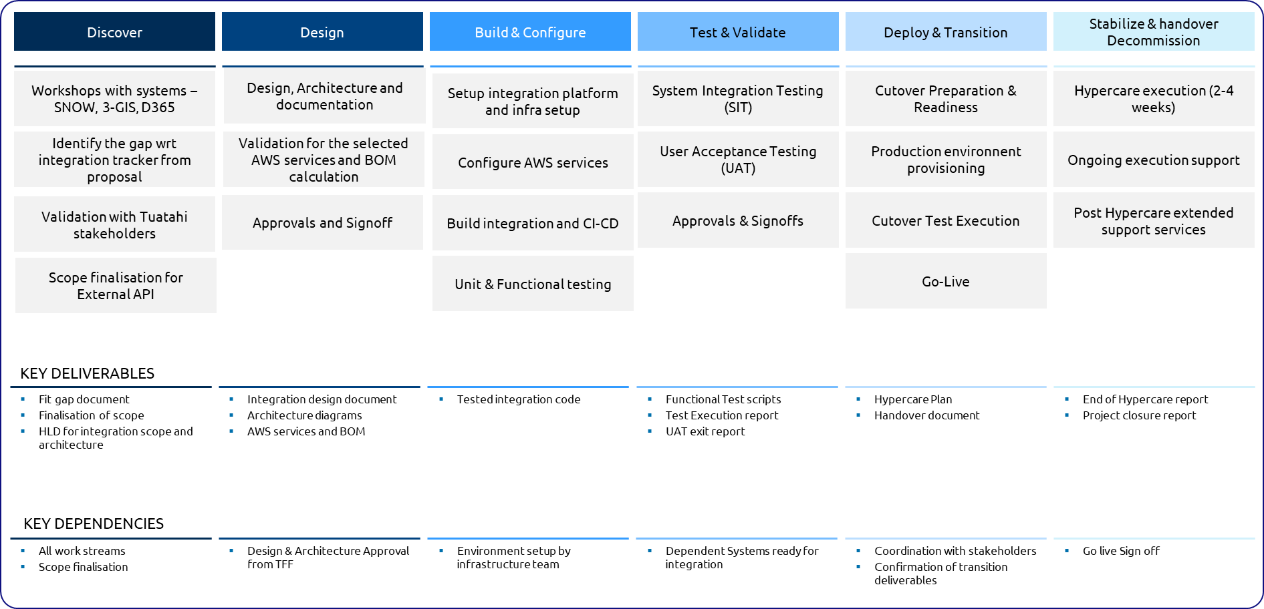

Detailed Dependencies
  - A dedicated Tuatahi portal product owner will be available throughout the project to provide direction and resolve blockers.
  - Access to required stakeholders and SMEs will be ensured, with availability supporting timely engagement, a single round of feedback per deliverable, and approvals and feedback provided by Tuatahi within 3 business days of submission
  - Required services in AWS provisioning will be handled by TFF infrastructure team along with any requirement around network, DNS etc
  - AWS services used for the solution will be deployed in TFF AWS environment and cost incurred will be calculated after finalisation of architecture.
  - Performance and penetration testing execution will be TFF responsibility and support will be provided by Capgemini team
  - Licenses for Github copilot for the development phase will be provided by TFF

RACI
Integration governance distinguishes between internal platform integration and external ecosystems interfaces. Capgemini leads design and delivery of “Internal integration platform”. Tuatahi retains ownership of “Experience API” platform and external stakeholder relationships.
(R) | Responsible | Carries out the process or activity
(A) | Accountable | Owns the process or activity being completed
(C) | Consulted | Stakeholder or subject matter who is consulted to provide input
(I) | Informed | Receive the output of activity

Activity | Scope | TFF Architecture / TDA/ ARB | TFF Programme Lead | Capgemini Integration Lead | Capgemini Workstream / Testing Lead
Integration architecture principles and target state design | Int | A | C | R | C
API alignment and pattern definition | Int | A | C | R | C
AWS alignment for API and integration components | Int | A | C | R/C | C
API contract definition Capgemini delivered outcomes | Int | A | C | R | R/C
Technical decision logging and design governance | Int | A | C | R | I
Internal Integration Platform
Integration: ServiceNow, D365, GIS/3GIS and portal | Int | C | C | R | R
Integration with downstream retained systems | Int | A | R/C | R/C | R/C
Integration dependency identification tracking | Int | C | A | R | R/C
Integration test strategy, defect triage and remediation | Int | C | C | C | A/R
Experience API Platform
RSP Facing interface requirements | Ext | C | A, R | C | C
RSP facing API and portal technical collateral | Ext | A | R | C | C
RSP relationship management for interface changes | Ext | I | A, R | C | C
RSP testing coordination | Ext | C | A/R | C | C
Go-live, Cutover and Post Go-live
Cutover planning for integration components | Both | C | A | R | R/C
Go-live readiness for integration scope | Both | A | A | R/C | R/C
Post go-live support for external facing integration | Ext | C | A/R | C | C

6.4.1.4 Out of Scope
- Scope is limited to the list and complexity of integrations shown in the addendum for integration register; any changes to that will result in impact to timeline and efforts

Data Migration (Non-GIS Data)
Tuatahi has embarked on the modernization journey with their Horizon programme that requires carefully planned data management activities such as Data Migration and Data Cleansing to the new solution for cutover and archiving legacy data from legacy applications allowing decommissioning activities. From the technical approach, toolset, applications and planning considerations these activities are grouped as GIS Data related data activities and Non-GIS related data activities.

    - Solution Details

GIS data is related to Network inventory (including Geospatial data) and is sourced mostly from ODN and Place source systems and 3 GIS as target system. Data Migration, cleansing and data archival of this data will be handled as part of Workstream B and Work package 6. It is described in detail in section 6.2Workstream B: Network.

Non-GIS data handles customer, asset, OPSR and billing data and is sourced from Telflow and Inomial source systems and Service Now (CSMT, SOMT) and Dynamics 365 F&O (Billing) as target system. Data Migration, cleansing and data archival of this data will be handled as part of Workstream A and Work package 1,2 and 3. It is described in detail in this section.

    - Scope
Below is the detailed description of in scope/out scope activities, systems and sizing pertaining to Non-GIS Data Migration, cleansing and data archival:

In Scope:
Sr. | Description
1 | Telflow (up to 21 tables and approximately 2500 attributes) and Inomial (up to 14 tables and 76 attributes) are considered as Source system for ServiceNow (CSMT, SOMT) and D365 F&O (Billing module) as Target systems for non-GIS data processing.
2 | Data Migration of Recurring Billing Contracts from Inomial source system to Dynamics 365 F&O - Subscription Billing Suite for up to 4 entities and up to 150 attributes. Refer table for source and target entities and complexity details.
3 | Data Migration of Customer and Asset data from Telflow source system to ServiceNow Customer Service Manager for Telecommunications (CSMT) for up to 6 entities and up to 75 attributes. Refer to the Data Migration Register from Addendum 2 for complexity and entity details.
4 | Data Migration of Order, Product, Service, and Resource structural specifications (OPSR Templates) alongside transactional logs (Sales data) from the Telflow source system to ServiceNow Sales and Order Manager for Telecommunications (SOMT) for up to 7 entities and up to 85 attributes. Refer to the Data Migration Register from Addendum 2 for complexity and entity details.
5 | Active and historical data migration to ServiceNow and D365 for 70-80 RSP & 5000K Retail and 2500 Business Customers with ~ 5000K Retail contracts, 2500 Business Contracts, 1 mil inventory records and 1.7 mil orders.
6 | Migration of bulk data load in two release cycles to D365 and ServiceNow.
7 | Data migration to archive data from Inomial and Telflow sources to archival data storage (e.g. Azure Data Lake) to support continual reporting and allow decommissioning of such sources by TFF.
8 | Technical reconciliation of the migrated data based on the system, row, total counts. Create standard data migration reconciliation report - row count, subtotal count, fallout reports for migration run.
9 | Technical source data profiling for Inomial and Telflow source systems (File/DB copy provided by TFF) to inform correctness of data mapping and any data quality (fitment) issues.
10 | Technical data cleaning is performed in the migration system with up to 20 simple, 8 medium and 3 complex data cleansing rules applied as per agreed mapping design based on data profiling outcome or load requirement.
11 | Scope Include up to 4x2 End-to-end data migration runs to support System Testing, SIT, End-to-end User Testing and UAT for both releases i.e. 3 Work Packages (WP1, WP2, WP3).
12 | AS-IS document migration from Telflow system to ServiceNow (CSMT, SOMT) for up to 700 GB or up to 600K documents.

Out Scope:
Sr. No | I&D Out-scope
1 | Data migration and archival of non-GIS data from source and target systems/modules other than those specified in-scope section.
2 | No data extraction and transformation is required for existing ServiceNow and D365 F&O systems data. These are target systems for data load.
3 | Data Migration and archival of geospatial data (ArcGIS system) is managed by specialised team for Geospatial data handling. Hence ODN and Place is out of scope for non-GIS data migration.
4 | Data Migration of Physical/network inventory to ServiceNow SOMT and/or TNI modules from Layer2 system is managed by TFF and hence Layer2 system is out of scope.
5 | Data migration environment provisioning and maintenance. Setting up baseline infrastructure such as network, security, firewall, RBAC
6 | No data masking or obfuscation is required for data migration.
7 | Data cleansing at the Source System is to be handled by TFF.
8 | Source data cleansing by pseudo (Fuzzy) match & survivorship rules (MDM-style match & merge) for data deduplication is not required for ServiceNow (CSMT, SOMT) and D365 F&O data migration. Iterative data cleaning by Business is to be managed by change control.
9 | Address, email and, phone cleansing using external data sources during migration/ transformation is not required.
10 | Creation of Power BI or other reports including any customised report for remediation or reconciliation.
11 | Actual decommissioning of the source systems (Telflow, Innomial).
12 | Multilingual data (other language than English language data)
13 | Business validation of migrated data in target system

    - Non-GIS Data Processing Architecture

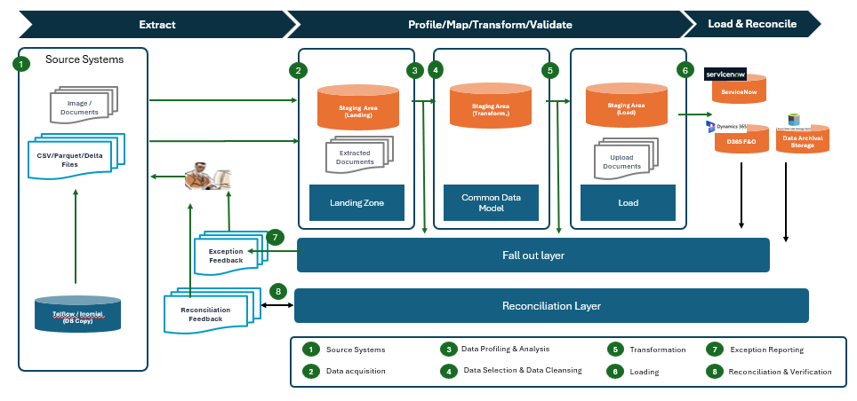

Below are the main considerations for non-GIS data processing:
1. Data Extraction & Source Systems
- Multi-Format Ingestion: Ingests flat files, structural documents, and tabular data (CSV, Parquet, and Delta formats) from diverse operational source systems.
- Storage Layer: Raw file assets are securely landed inside Azure-based file storage (such as Azure Data Lake Storage Gen2) to act as the primary ingestion point.
2. Data Acquisition & Landing
- Orchestrated Pipelines: Azure Data Factory (ADF) utilizes high-performance Copy Activities to parse incoming files and move them into the database environment.
- Relational Staging: The data lands in an Azure SQL Database landing zone, which hosts the staging environment for subsequent data transformations, auditing, and structural preparation.
3. Data Profiling & Mapping Insights
- Technical Evaluation: The ingested files undergo technical data profiling to understand data health, schema structures, and null distributions.
- Hybrid Tooling Approach:
  - Azure ADF Data Flows: Used for lightweight, design-time interactive profiling and immediate data mapping assessments.
  - Microsoft Purview: Used for advanced, enterprise-grade data profiling, deep data quality metrics, and automated structural classifications.
4. Data Selection & Cleansing
- Quality Filtering: ADF pipeline criteria filter out corrupt or structurally invalid data from the primary stream.
- Exception Isolation: Destructive structural anomalies—such as orphaned records or missing mandatory values—are targeted, isolated, and prevented from moving forward.
5. Data Flow Transformation
- Schema Alignment: Azure ADF Mapping Data Flows execute structural transformations and apply business rules to normalize the data into a Common Data Model (CDM) structure.
- Load-Ready Formatting: The data is aggregated, cleansed, and verified against final schema constraints to ensure it is in a target-ready format prior to final handoff.
6. Target Loading Orchestration
- Hybrid ETL Pipeline: Target system loading is built inside Visual Studio using the KingswaySoft SSIS Integration Toolkit (Ultimate Edition).
- Optimized Connectors: SSIS packages leverage built-in KingswaySoft optimizations (such as automatic column mapping and UI-driven performance tuning) to push data into Dynamics 365 F&O and ServiceNow via native REST APIs. We will not be accessing target database and load data using queries.
- Cloud Execution: The SSIS packages are deployed to and executed on an Azure-SSIS Integration Runtime (IR), controlled globally by the master ADF pipeline.
7. Exception Reporting & Fallout Layer
- Error Isolation: Any API or database-level insertion errors during the load phase are trapped natively by KingswaySoft handlers.
- Audit Trails: Error rows are routed into dedicated staging tables within Azure SQL, allowing developers and analysts to troubleshoot issues using tools like SSMS (SQL Server Management Studio).
8. Reconciliation & Verification Layer
- End-to-End Auditing: Automated run logs capture row counts, timestamps, error logs and processing execution statuses across every stage of the ADF pipeline lifecycle.
- Balanced Ledger View: The architecture matches source file ingestion tallies against successful target loads and fallout logs to eliminate data loss.
- Business Reporting: Audit tables feed into downstream Excel or Power BI dashboards to provide stakeholders with clear data lineage and business reconciliation reports.

    - Non-GIS Data Processing Approach & Activities

Our proposed approach is based on Capgemini’s Data Migration Methodology (DMM) that underpins our internal delivery framework “Deliver”. DMM describes different stages and the different activities that span across the project stages for data migration/Archival including cleansing.
The below diagram identifies the DMM phases (Initiate & Analyse, Design, Development, Test and Acceptance, Execution and Post Migration Support) and how they relate to the data processing streams:
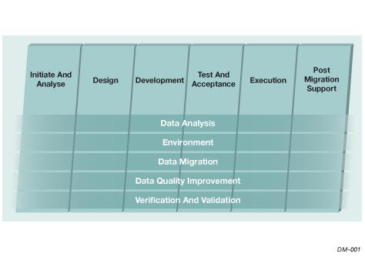

Discovery Phase (Includes Initiate & Analyse and Mapping Design)
The objective of this phase is to define the data migration detailed strategy in which the scope of the data migration and responsibilities during the data migration are made transparent for all involved. The design part includes high level design of important aspects of the data migration. This is one off process conducted at the beginning of the project.
Additionally, a detailed source to target data mapping is carried out including transformation and cleansing rules. Selection criteria for migration and archival determine the volume of the source data being loaded to Target vs getting archived. TFF will be involved to infer source details, agree on cleansing approach and business/transformation rules to support data load to targets.
Some of the key activities include:
- Define scope of data migration.
- Develop data migration plan.
- Conduct Data Profiling to proactively identify data cleansing requirements
- Environment planning and availability.
- Build high level functional design documents
- Data mapping including transformation, business, archival, reconciliation and cleansing rules.
- Define data load strategy.
- Plan test phase, including data migration rehearsals.
- Design manual & automatic migration processes.

Build Phase (include Technical Design and Development)
The build phase supports the iterative design of ETL pipelines (low level design) and build of the data migration solution. The objective of this phase is to build, configure and to an extent, test (unit/system), the different routines for data analysis, data quality improvement and data conversion.
Some of the key activities for data migration during this phase include:
- Extraction process technical design and build.
- Transformation process technical design and build
- Load process technical design and build.
- Create reconciliation routines.
- Develop manual routines to support verification, extraction, etc.
- Data migration unit testing and dry runs (system testing).
- Perform Data cleansing based on a review of the data profiling results.
- Data test planning.

Test & Acceptance
The objective of this phase is to prove the correctness of the developed migration products through data migration rehearsals and obtain the approval to execute the production data migration.
The migrated data is loaded for System Integration Testing, User acceptance Testing.

Execution and Post Migration Support
During this phase, the new business processes and organization are implemented. A migration dress rehearsal is conducted into E2E Testing environment (Pre Prod) to check the readiness and correctness of runbook and finalise business testing.
The fully developed system is moved into production, and data is migrated into the production system as per cut over planning.
Hypercare support is provided post one time migration activities after production cutover.

The main activities carried out in these stages are listed in below picture. Please note that Build, Testing and Go Live/Hypercare activities happens twice, once for each release.
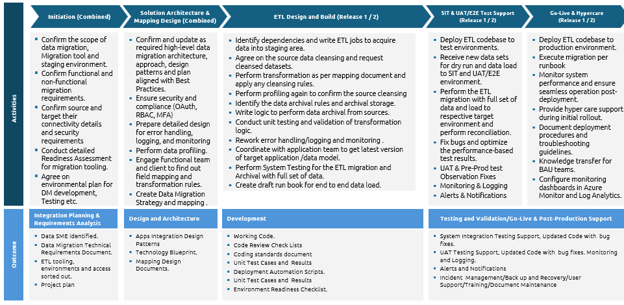

Below are the main deliverables applicable to this data team

Deliverable Name | Deliverable Description
Data Migration and Data Archival Strategy | Document defines the data migration scope, approach, activities, migration infrastructure, environments and high-level migration/ archival plan.  Format: Microsoft Word
Data Migration Mapping Design | Document captures source to target mapping including business and transformation rules, cleansing rules, reconciliation rules.  Format: Microsoft Excel
Migrated data / Archived data | Data in ServiceNow, D365 F&O or Archival system as migrated from the TFF’s Legacy Systems in accordance with the Data Migration/Archival Plan for Release 1 and 2.  Format: Data (System delivery)

    - Assumption and Dependencies
Below are assumptions and dependencies for handling non-GIS data through migration, archival and cleansing:

# | Description | Category
A01 | TFF will procure, provision, configure access and maintain platform infrastructure including but not limited to hardware, software, services, network, subscription and licences required for the Data Migration (DM), Data Archival and Profiling. Azure platform is assumed for data profiling, ETL and Data Archival. | Migration Infrastructure
A02 | Azure ADF is assumed as ETL tool with KingswaySoft Azure-SSIS IR (Licenses - Ultimate edition) for target connectivity and productivity. Azure Purview is considered for detailed profiling. | Migration Tooling
A03 | TFF will ensure the data quality in source data extracts from TFF source systems will be of good quality and fit for migration purpose. If data quality is not fit for purpose, TFF will help define cleansing rules to be applied during staged data processing in ETL job or agree on cleansing steps that will be applied at source before/after extraction. | Data Quality
A04 | TFF will be responsible for applying data cleansing of source data in TFF source systems including but not limited to data enrichment of missing data, standardisation, de-duplication and resolving integrity issues (e.g. create missing mandatory records). | Data Quality
A05 | TFF and Capgemini DM Team will agree and sign-off file specifications of source data extracts from TFF sources systems | Source Extracts
A06 | TFF will make full volume cleansed (as agreed during cleansing design) source data extracts available to the Capgemini DM team at an agreed location | Source Extracts
A07 | TFF will provide business, cleansing and transformation rules required for migration | Data Mapping
A08 | TFF will provide signed off for Source to Target mapping including business and technical transformation rules | Data Mapping
A09 | TFF will provide updated mapping, business, cleansing and transformation rules to address non-conforming data identified during DM Testing | Data Mapping
A10 | TFF and Capgemini DM Team will agree and sign-off technical validation/reconciliation rules between Sources and Targets in scope of migration | Audit and Reconciliation
A11 | Data Masking, if required, will be done by TFF team. Data security will be addressed by encryption provided by platform infrastructure and ETL toolset used. | Data Security
A12 | Documents are to be migrated as-is. No data content extraction from the digitalised document is required. Latest version of documents will be migrated without migrating version history/audit trail of changes. | Document Migration
A13 | Data for ServiceNow TNI will be required to be migrated by CG team as it will be handled by integrations with 3GIS application or migrated by TFF team (Layer2 data) | Data Load

    - RACI
Below are the RACI for handling non-GIS data through migration, archival and cleansing:
(R) | Responsible | Carries out the process or activity
(A) | Accountable | Owns the process or activity being completed
(C) | Consulted | Stakeholder or subject matter who is consulted to provide input
(I) | Informed | Receive the output of activity

Activity/Work Package | TFF Stakeholder  (Business) | TFF Stakeholder (IT/DBA) | CG Data Migration Team | CG Application Team | CG Testing Team
Define the Scope | A/R | I | I | I | I
Design Target Entities | A/C | C | I | R | I
Data Profiling | C | C | R | C | I
Data Mapping | A/R | C | R | R | I
Define Cleansing and Transformation Rules | A/R | C | C | R | I
Source Data Extract & Source Cleansing | A | R | C | C | I
DM/Archival Solution Implementation | I | C | R | A/R | R
Test and reconcile | A/R | R | R | R | R

R: Responsible || A: Accountable || C: Consult || I: Inform

Organisation Change Management (OCM)
    - Tuatahi-led, Capgemini-enabled
This transformation represents a significant shift in how Tuatahi operates across its network and customer domains. Enabled by a modern Wholesale BSS architecture, RSP Portal, catalogue-driven service design and OPSR framework, the programme will require targeted change and training interventions to embed new ways of working, strengthen data ownership, support automation adoption, and build confidence in end-to-end traceability across orders, services, resources, billing and assurance.
Organisational Change Management (OCM) will be embedded within the PMO and overall delivery governance model, rather than operating as a standalone activity. Change impacts, stakeholder actions, readiness activities, communications, training and adoption risks will be fully integrated into workstream planning, RAID management, governance forums, release planning and go-live decision points. This ensures that change remains aligned to delivery progress and business priorities throughout the programme.
OCM services are proposed as an optional layer of support and can be flexed based on Tuatahi’s needs. The additional cost for those services can be provided upon request.
The key structural shifts to be managed include:
- Moving towards greater automation and straight-through processing,
- Improving data quality, auditability and ownership across operational and financial processes,
- Adopting a more modular data model and OPSR framework,
- Simplifying complexity for RSPs and customers through stable products, APIs and catalogues,
- Enabling teams to operate effectively in a more integrated, scalable and digitally enabled environment.

    - Change Management Delivery Model
Tuatahi will retain full ownership, responsibility and accountability for the delivery of all change management activities, deliverables and outcomes.
Capgemini’s role with regards to change management will be to provide targeted contribution, input, artefacts and subject matter expertise to support Tuatahi’s change delivery.
These OCM support services remain optional and can be engaged as required, with cost visibility available on request.
This may include support across:
- Change impact assessments,
- Stakeholder engagement,
- Communications content and templates,
- Business readiness planning,
- Transition and hypercare support,
with Capgemini remaining available to support where appropriate and add capacity as needed.
    - Integrated Training Approach

Training scope
Capgemini will own, be responsible and accountable for the end-to-end training approach.
Training will be provided for relevant internal technical and non-technical business users impacted by new systems, processes and ways of working.
External user education and training is out of scope. Capgemini will not be required to provide education or training sessions for external user groups.
As part of the approach, the Capgemini Training Lead will be engaged during the final two weeks of the Design phase to review Tuatahi’s overall change management plan and provide feedback on its completeness and RACI, prior to commencement of the Build phase.

Training, documentation and knowledge transfer deliverables
The training approach will include the development and delivery of relevant training, documentation and knowledge transfer materials, including:
- Training needs analysis and curriculum design,
- End-user training materials,
- Delivered train-the-trainer sessions and attendance records,
- Operational runbooks and support documentation,
- Knowledge transfer sessions and formal handover sign-off,
- Runbooks for operational procedures and BAU support.

Train-The-Trainer Model
Training will be delivered through a Train-the-Trainer model, designed to build internal capability and enable scalable, business-led adoption.
The focus will be on equipping nominated trainers, key users, and change champions to deliver and reinforce learning within their respective business areas.

A structured Train-the-Trainer approach will be used to ensure internal trainers are confident, capable, and aligned in how training is delivered.
This will include:
- Trainer enablement sessions covering:
  - Solution overview and key process changes,
  - Role-based impacts and “what changes”,
  - Expected business outcomes and adoption priorities.
- Facilitation guidance, including:
  - How to deliver training sessions (virtual and in-person),
  - How to manage questions and resistance.
- Standardised training materials, such as:
  - Slide decks and system walkthroughs,
  - Facilitator guides and session plans,
  - Scenario-based exercises and discussion prompts.

Role-Based Training Delivery
Trained business trainers will deliver role-based training tailored to local needs, focusing on:
- Key tasks and activities in the future state,
- End-to-end process understanding where relevant,
- Practical, scenario-based application aligned to real workflows.

This approach ensures training is contextualised, credible, and directly relevant to each team’s operational environment.

Reinforcement and Performance Support
To support adoption beyond training, trainers will be equipped with a suite of reinforcement and performance support materials, including:
- Job aids and quick reference guides,
- FAQs and common scenarios,
- Exception handling guidance,
- Short “how-to” resources for key tasks.

Trainers and key users will act as first-line support, reinforcing learning during transition and hypercare.

Governance and Quality Assurance
To maintain consistency and quality across delivery:
- Trainers will participate in alignment sessions and dry runs,
- Feedback loops will be established to continuously improve materials and delivery

Training Strategy Components
The training strategy will be structured around the following core components:
- Training Needs Analysis: identify impacted roles, skill gaps and training requirements by work package and user group, with an iterative approach allowing refinement as additional detail becomes available.
- Curriculum Design: define learning journeys, modules and delivery formats,
- Standardised Materials: develop reusable training assets, job aids, runbooks and support materials,
- Train-the-Trainer Preparation and Delivery: prepare internal trainers and ambassadors to support rollout,
- Feedback and Effectiveness Mechanisms: capture user feedback, confidence levels and adoption indicators to refine training content and support.

6.6.1.8 Business Readiness and Adoption
Business readiness and adoption measurement will be embedded throughout the change and training approach. This will help Tuatahi assess whether impacted teams are ready to transition, whether training has been effective, and whether new ways of working are being adopted in practice. Business readiness will be tracked progressively against delivery milestones, with clearly defined readiness criteria aligned to each release or work package. Assessments will consider multiple dimensions including people capability, processes, training completion, communications effectiveness and operational procedures, ensuring a holistic view of readiness. This structured approach will enable Tuatahi to make informed go/no-go decisions based on evidence, ensuring that solution delivery and adoption are appropriately aligned and risks are proactively managed.
    - Training Needs Overview
The table below outlines the training requirements across each work package, reflecting the scale of process change, system interaction complexity and operational risk introduced by the transformation. Training impact levels have been assessed based on the degree of change to day-to-day activities, the criticality of decision-making points and the level of user confidence required at go-live to avoid operational disruption.

Training Impact Legend:

- High training requirement: Significant change to core processes, roles, and decision points. Users must understand new workflows, system interactions, and exception handling. Errors carry a high operational and financial risk, requiring hands-on, scenario-based training rather than simple awareness.
- Medium-High training requirement: Impacts multiple teams and handoffs, with role-specific variations. Users need clarity on responsibilities, workflow routing, and escalation paths. Targeted hands-on training is required for some groups, depending on system and process changes.
- Medium / Role-based training requirement: Changes are focused on specific user groups or system interactions. Training can be tailored by role, with emphasis on navigation, data inputs/outputs, and reporting responsibilities. Lower operational risk than core transaction processes.
- Low – Medium / specialist training requirement: Impacts a smaller, specialist user group. Training is technical and focused on tool usage, data updates, and governance. Lower user volume, but accuracy remains important. Can be delivered through SME-led sessions or targeted walkthroughs.

# | Work Package | High-Level Training Needs Assessment | Training Key Focus
1 | Centralised catalogues and party manager | High | - Catalogue navigation and usage  - Product and service selection rules  - New ordering logic, terminology and “parlance”  - How catalogue changes impact order creation and downstream teams
2 | Fibre ordering automation and fulfilment | High | - End-to-end automated order lifecycle  - Workflow changes across order capture, fulfilment and completion  - Exception handling and SLA monitoring  - Interaction with automation tools and system-triggered workflows
3 | RSP billing automation | High / Specialist | - Overview of the recurring billing setup  - Creation/update/Termination of recurring billing contract  - Validation of billing details  - Generation of invoice  - Validate the accounting transactions  - Validate Customer invoice  - Validate customer account statement  - Updating Billing status to service now (RSP Portal)
4 | New RSP portal | Medium / Role-based | - Portal navigation and role-based access  - Data inputs and outputs  - Reporting and visibility features  - User responsibilities for maintaining accurate information  - How portal activity interacts with internal workflows
5 | Order pre-qualification | High | - Automated eligibility and pre-qualification logic  - Manual override process  - Decision-making checkpoints  - Impacts on order acceptance, rejection and rework  - Escalation pathways for exceptions
6 | Consolidated physical network inventory | Low–Medium / Specialist | - GIS tool usage and data management  - Inventory data governance and update processes  - Network data accuracy expectations  - Integration touchpoints with downstream systems  - Roles and responsibilities for maintaining physical network data
7 | Automated assurance work orders | High | - Assurance work order lifecycle  - Fault resolution workflow orchestration  - Scheduling and partner coordination  - Visibility tools and status tracking  - Exception handling and escalation
8 | Automated provisioning work orders | High | - Provisioning work order lifecycle Service activation and fulfilment workflows Partner and system interactions Exception handling and escalation Handover points between order management, provisioning and field teams
9 | Internal field force for integration | Medium–High | - New field force versus partner coordination model Workflow routing logic Dispatch and scheduling changes Mobile/tool usage, where applicable Role clarity across internal teams, partners and operations
10 | Work order finance system integration | Medium–High | - Creation of PO/Vendor invoice for the work order costs on event trigger from Service Now FSMT  - Validating the key fields on the PO  - Validating the accounting transactions  - Updating status of the invoice creation back to ServiceNow FSMT

Work Package Enablement Packaging
Our assumption is that there will be training delivery synergies across work packages that can be leveraged to create efficiencies where possible, while minimising training fatigue and improving user comprehension. Where relevant and feasible, learning will be grouped into end-to-end user experience and role-based learning journeys, rather than delivered separately for each work package. This will help teams understand the end-to-end process impacts across the future operating model.
A key dependency for this approach will be the completion of the change impact assessment by Tuatahi, which will provide the necessary view of impacted user groups, process changes and cross-work package overlaps to inform how training journeys are designed and delivered.
    - High-Level OCM & Training RACI
The table below outlines the proposed high-level RACI for OCM and Training deliverables. Additional Capgemini expertise will be available on request, where required.

Organisational Change Management RACI (OCM) RACI
Programme Horizon affects both internal operating teams and external ecosystem stakeholders. The table below combines internal and external facing OCM activities. The scope column indicates whether each activity applies internally (Int), externally to RSPs and Partners (Ext) or both (both).
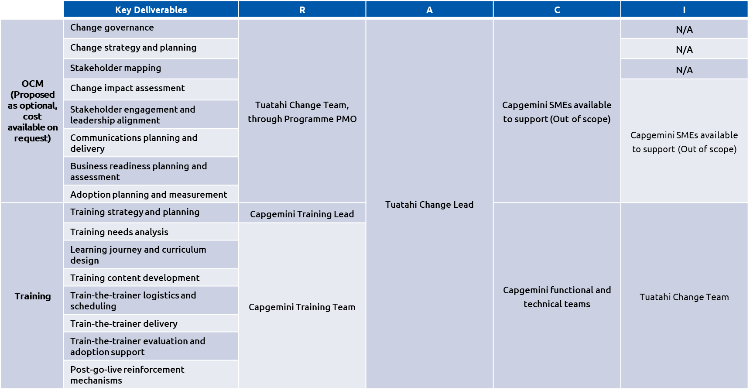

Testing Solution
The overall testing approach for this programme is designed to ensure seamless validation of business processes across a complex, multi-system ecosystem consisting of ServiceNow, ArcGIS/3-GIS, Dynamics 365, Okta, Microsoft data platforms, and associated integration layers. Across the three workstreams Portal & Customer, Network, and Field Force the strategy adopts a phased validation model that progressively tests individual system to ensure that work packages are working as expected in integrated environment
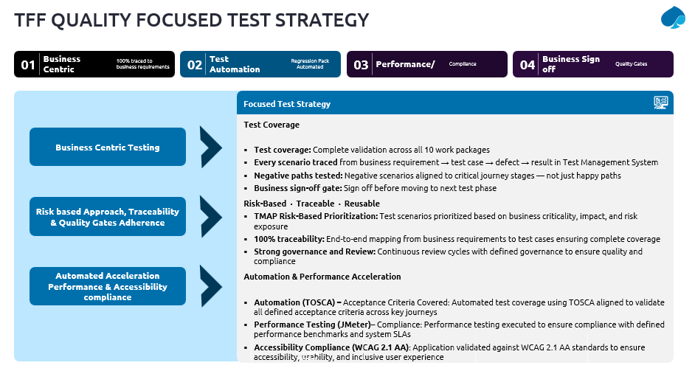
Testing will be executed across multiple levels, starting with System Testing (ST), followed by System Integration Testing (SIT), and User Acceptance Testing (UAT). The approach emphasizes validating not just functionality but also data consistency, integration reliability, and business process integrity across all ten work packages. Attention is given to critical flows such as order lifecycle management, provisioning, assurance work orders, billing automation, and network inventory updates, all of which span multiple systems.

To ensure the quality Capgemini will establish and mutually agree upon clear entry and exit criteria for all key milestones, including System Integration Testing (SIT), End to end testing, User Acceptance Testing (UAT), and Go-Live. These criteria will be formally documented within the Test Strategy document and consistently adhered to throughout the project lifecycle. Capgemini will follow a structured test methodology supported by well-defined quality gates, incorporating acceptance standards and entry/exit criteria at each phase. Upon completion of the test phase, Capgemini will deliver a comprehensive Test Summary Report. This report will provide a detailed overview of all testing activities performed, key results, and outcomes, along with an assessment of the tested components against the predefined exit criteria, ensuring transparency and alignment with quality expectations.

Capgemini invests in specialised Centre’s of Excellence to develop testing-specific tools and accelerators to facilitate process implementation, foster adherence to standards and guidelines, accelerate test planning, and execute and report testing activities. Capgemini will bring in the best suitable methodologies and IP’s applicable.

For the testing solution, the following are included:

- It is assumed that an integrated test environment will be made available during the testing phase to support testing activities.
- The test team will require collaboration and support from the respective system owners of integrating applications to validate outcomes and, where necessary, provide confirmation of results from their systems.
The following items are included as part of SIT, E2E and UAT testing:
Release 1
- SIT: 190 test cases
- End-to-End (E2E) Customer Journeys: 60 test cases
- User Acceptance Testing (UAT): 60 test cases
Release 2
- SIT: 190 test cases
- End-to-End (E2E) Customer Journeys: 120 test cases
- User Acceptance Testing (UAT): 120 test cases
- While defining the test cases for Network functionality, Capgemini will refer ‘Network - Test Criteria and Use cases.xlsx document.
- A total of 50 automation scripts will be developed to support regression testing, leveraging the TOSCA automation tool for automating functional test cases.
- For performance validation, 25 critical end-to-end business scenarios will be identified and executed using Jmeter.
- Accessibility testing will cover 17 unique screens, executed across two combinations of devices and browsers, using BrowserStack to ensure coverage and consistency.
- Testing activities will be conducted using desktop environments.
- It is assumed that TFF will provide the necessary tool licenses and infrastructure required to support automation, performance, accessibility, and overall test management activities.
- End to End test cases will serve as the baseline for UAT, with further refinement and extension to align with business validation needs.

Details on the individual test phases are provided in the following sections

    - System Integration Testing (SIT) Approach (Release 1 & Release 2)

System Integration Testing (SIT) will be executed at the individual work package level, with each work package validated independently while consuming inputs from its dependent work packages. The approach focuses on validating how each work package consumes, processes, and passes data across systems such as ServiceNow, Dynamics 365, ArcGIS/3-GIS, and Microsoft data platforms.
Each work package will be validated against its core objective, covering catalogue management, fibre ordering and fulfilment, billing automation, RSP portal capabilities, and pre-qualification. Testing will validate network inventory, updates, orchestration of assurance and provisioning of work orders, partner integration, and work order life cycle controls.
    - Release 1 and 2 – E2E Customer Journeys (Integrated SIT)

The primary objective of strategy is to ensure that E2E Customer Journeys function seamlessly across integrated systems in scope of release (1 & 2) provide a consistent and reliable user experience and meet both business and technical requirements before production deployment.
Customer journey will be validated from the perspective of its respective persona groups and will incorporate different customer triggers and journey stages. The testing scope ensures that variations of user interaction including standard flows, validation failures, and alternate execution paths are covered.
The systems involved in customer journeys include customer portals, APIs, product catalogues, order management systems, inventory systems, network orchestration layers, and billing platforms The overall testing approach is designed to validate business journeys in an end-to-end manner rather than focusing on isolated components. Each test case will represent a complete logical flow that begins with a customer trigger and ends with a clearly defined business outcome.
At the end of this phase, Capgemini will publish the test summary report and assess readiness to proceed to the next phase.

    - Release 1 and 2– User Acceptance Testing

User Acceptance Testing (UAT) will be conducted at the release level, focusing on validating end-to-end user journeys rather than individual work packages. The objective is to ensure that integrated business processes function seamlessly and meet overall business objectives for the defined release scope.
The testing will emphasise critical user journeys such as ordering, provisioning, billing, network inventory, and work order management, validating their behaviour across interconnected systems.
Capgemini will support test case creation, execution, and managing UAT scenarios, while TFF business users will provide inputs, validate outcomes. This collaborative approach ensures comprehensive validation of end-to-end processes and readiness for business use at the release level.
At the end of the UAT phase, Capgemini will publish the test summary report along with testing evidence and TFF business users will validate outcomes and provide formal acceptance sign-off.

    - Accessibility Testing
Accessibility testing will ensure that user-facing interfaces are usable by individuals with diverse abilities. This is particularly important for customer-facing applications such as portals and web interfaces.
The testing will be aligned with recognized accessibility standards WCAG 2.1 AA. It will evaluate whether users can navigate the application using assistive technologies such as screen readers and whether the interface supports keyboard navigation, proper contrast ratios, and meaningful error messages. Accessibility validation will not only ensure compliance but also enhance the overall user experience by making the system inclusive and easy to use for a wider audience.

    - Performance Testing Approach

We have reviewed the non-functional requirements outlined in Section 3.2.4 and will ensure that these requirements are comprehensively addressed through a well-defined performance test plan. This will be followed by design and execution of performance testing to validate compliance with the defined NFRs and ensure that the system meets expected performance standards
Performance testing will be conducted to ensure that the integrated system can handle expected transaction volumes and user loads while maintaining acceptable response times and system stability. Given the distributed architecture and multiple integration points, performance validation will focus on both individual system performance and end-to-end transaction performance across the ecosystem.
Key performance scenarios will include peak order volumes, concurrent portal users, bulk work order processing, and large-scale data synchronization between systems. Special emphasis will be placed on API performance, middleware throughput, and latency in communication between systems such as Dynamics 365, ServiceNow, and GIS platforms.
Performance testing will also evaluate system behaviour under stress conditions, including high load and resource constraints, to identify bottlenecks and ensure resilience. The results will be used to fine-tune system configurations and ensure readiness for production-scale usage.

    - Test Automation Approach
Automation will be implemented using TOSCA, focusing on high-value and repeatable scenarios such as order processing, service activation, qualification flows, and lifecycle changes. The automation framework will be modular, allowing reuse of components such as address validation, order submission, and inventory checks. Data-driven testing will be used to execute the same workflows with different inputs, improving coverage and reducing effort.
Automation will be progressively developed and expanded to cover multiple work packages aligned with end-to-end user journeys. The automation strategy will focus on building a modular, scalable, and reusable test suite that evolves alongside user journey coverage. This will enable efficient regression cycles, minimize manual intervention, and enhance overall test coverage, reliability, and execution consistency across work packages.
Test automation will play a critical role in ensuring efficiency, repeatability, and coverage across the testing lifecycle. Automation will primarily focus on regression testing, integration validation, and critical business workflows that span multiple systems.

    - Defect Management and Reporting

A structured defect management process will be followed to track, prioritize, and resolve issues identified during testing. Defects will be categorised based on severity and impact, with critical issues addressed on priority.

Regular status reporting will be maintained, including test execution progress, defect trends, and overall quality metrics. This will ensure transparency and enable timely decision-making.

Delivery Model

Capgemini has an established record of working seamlessly with clients’ in house teams to deliver high quality outcomes as a single, integrated delivery organisation. Our approach focuses on shared purpose, aligned ways of working, transparent communication, and joint accountability ensuring that Tuatahi and Capgemini function as “one team” from the outset.

Ways of Working

On-site engagement, delivery model and partner disclosure
Capgemini’s delivery model for Programme Horizon is designed to provide Tuatahi First Fibre with strong local engagement, effective programme oversight, and access to specialist capability across New Zealand, Australia, India and Capgemini’s global delivery network. Our model combines on-site presence in Hamilton, nearshore leadership support, and offshore delivery capacity in a way that is intended to maintain close collaboration with Tuatahi while enabling efficient, scalable and specialist delivery.
On-site engagement model
Capgemini recognises Tuatahi’s expectation that Key Personnel, as defined in the MSA, will spend sufficient time on-site in Hamilton, New Zealand to provide effective programme oversight, particularly during critical phases of the Programme. We will align the on-site presence of Key Personnel and relevant workstream leads to the needs of each phase, with higher on-site engagement expected during:
- Discovery and detailed design
- Solution build and configuration checkpoints
- Testing and quality assurance
- Cutover and go-live readiness
- Hypercare and stabilisation
- Training, documentation and knowledge transfer
Our proposed model assumes that senior programme leadership, solution architecture, delivery governance and relevant functional or technical leads will be on-site for key workshops, governance forums, decision points, readiness reviews and transition activities. Between these periods, the team will operate through a structured hybrid delivery model, using agreed governance forums, collaborative tooling, daily/weekly cadence, and clear escalation paths to maintain continuity and decision velocity.
Onshore/ Right shore Engagement Model
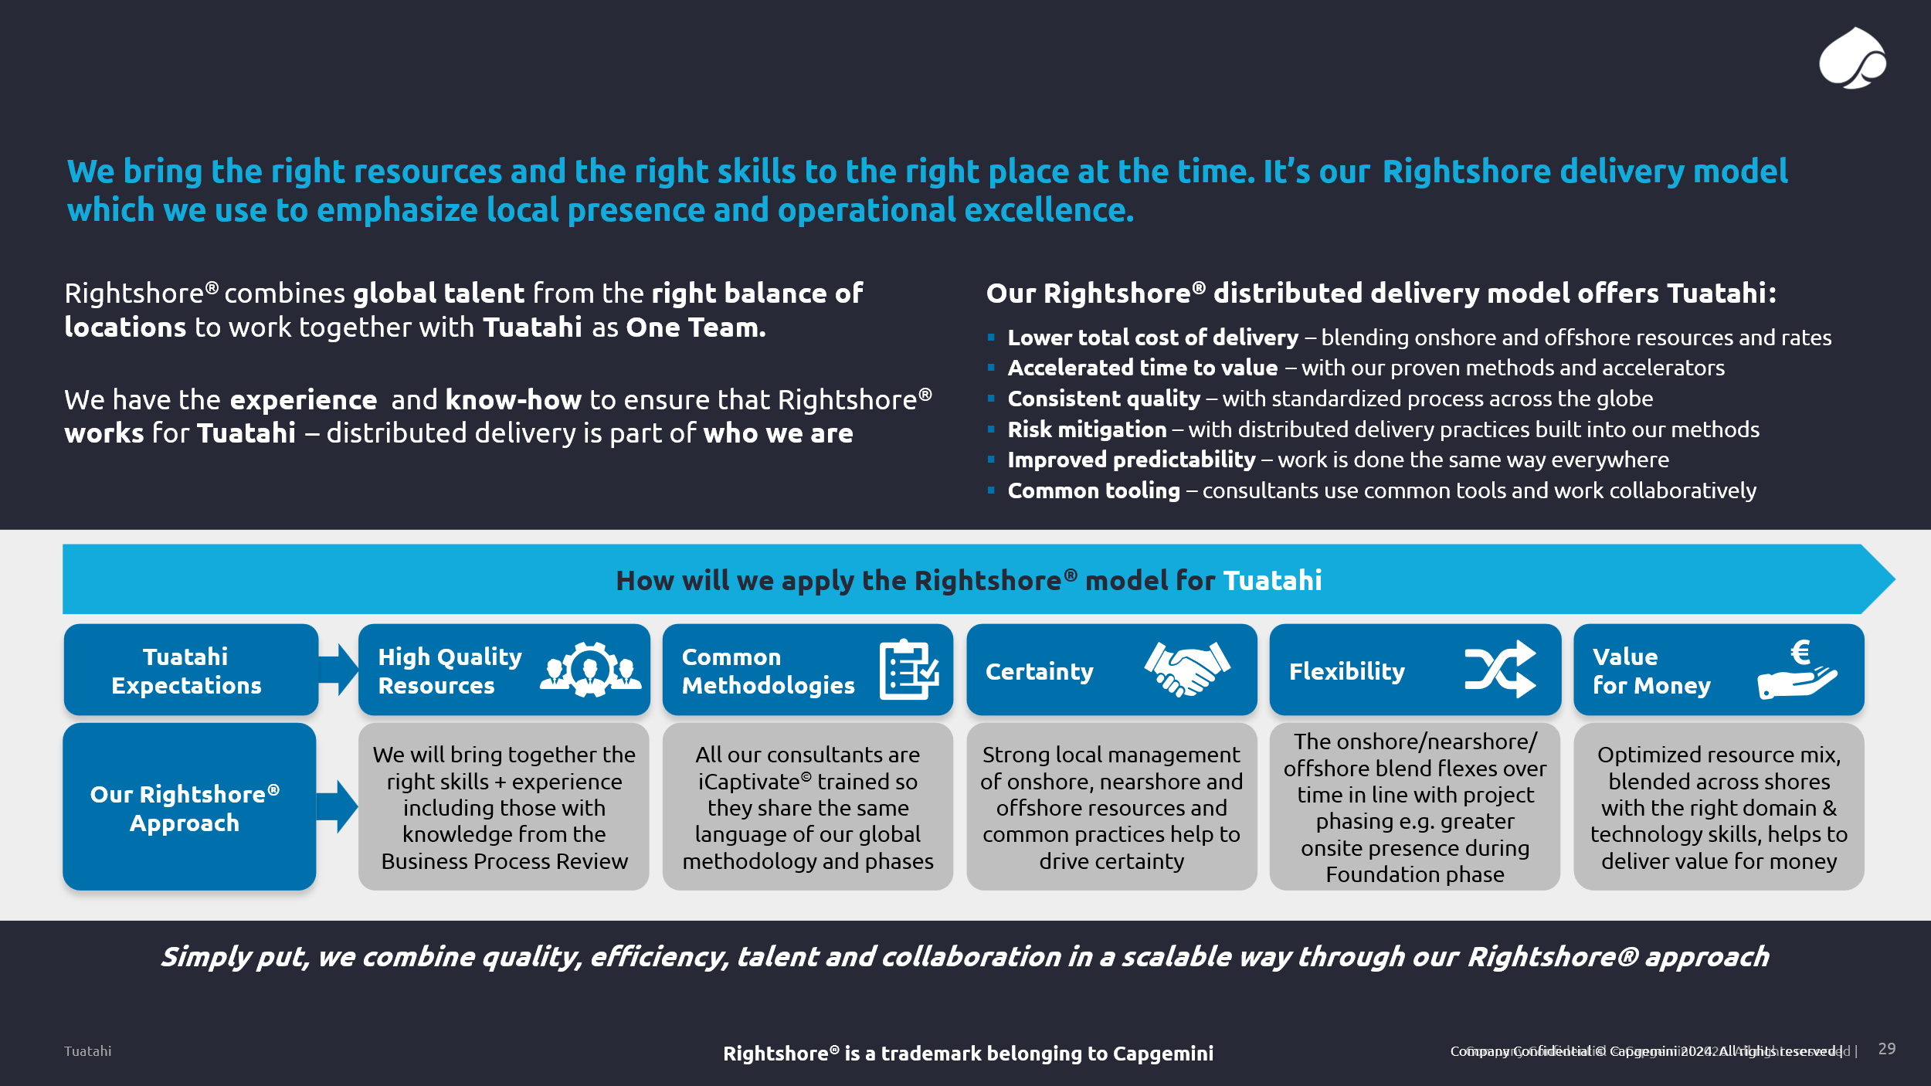

Collaboration, decision-making cadence and governance alignment
Capgemini will operate an integrated delivery model with Tuatahi, structured around clear workstreams, common delivery ceremonies, and transparent programme controls. The model will support effective collaboration and decision-making through:
- Joint governance and oversight — regular programme governance forums, including executive steering, programme delivery governance, workstream reviews, risk and dependency management, and release readiness forums.
- Clear decision cadence — time-bound decision forums, agreed escalation routes, and an active decision log to avoid delivery delay and maintain alignment across Tuatahi, Capgemini and relevant partners.
- Iterative delivery approach — work packages will be planned, elaborated, configured, tested and reviewed iteratively, enabling progressive validation of scope, design assumptions and business outcomes.
- Continuous integration discipline — solution build, configuration, integration and testing activities will be managed through controlled release, environment, defect, integration and readiness processes.
- Integrated programme controls — RAID, dependency, milestone, financial, quality and change controls will be managed through the Programme Control Office / PMO, with appropriate reporting into Tuatahi governance forums.
This approach is intended to ensure that collaboration is not dependent solely on physical location. Instead, on-site presence is targeted to the moments where it creates the highest value, while day-to-day delivery remains connected through structured governance, integrated tooling, defined accountabilities and regular engagement with Tuatahi stakeholders.
Subcontractors, partner organisations and non-owned facilities
Capgemini may use a combination of Capgemini-owned delivery capability, affiliated Capgemini entities, and specialist partner or subcontractor capability where this is required to deliver specific components of Programme Horizon. Where subcontractors, partner organisations or non-owned facilities are used, Capgemini will disclose the relevant organisation, location, role and scope of work, and will remain responsible for managing their contribution within the overall delivery model, governance framework and quality expectations.

The anticipated categories of support may include:
Delivery component | Potential delivery source | Scope of work
Programme leadership, governance and client engagement | Capgemini New Zealand / Australia | Programme oversight, executive engagement, governance, delivery management, commercial management and local stakeholder alignment
Solution architecture and functional leadership | Capgemini Australia / global SME network | Architecture assurance, design leadership, platform alignment, integration oversight and quality review
Configuration, build, testing and technical delivery | Capgemini delivery centres, including India where appropriate | Platform configuration, development support, testing, defect resolution, integration support and documentation
GIS / PNI specialist components | Specialist partner and/or Capgemini global GIS capability, where applicable | GIS/PNI-specific solution input, integration support, specialist configuration or advisory support
Non-owned facilities, if used | Capgemini-approved partner or delivery locations | Delivery activities performed under Capgemini governance, security, quality and confidentiality controls
Capgemini will ensure that any partner or subcontractor contribution is governed through the same delivery controls, security expectations, quality standards, reporting cadence and escalation model as the core Capgemini team.

Travel, on-site assumptions and pricing transparency
Our commercial model will transparently reflect the travel and on-site engagement assumptions used to support the proposed delivery model. The Pricing Workbook will identify the cost assumptions associated with planned travel, on-site engagement and related expenses, including the expected role categories, phase-based travel needs, and the assumed frequency or duration of on-site attendance.
Our current assumptions are:
- On-site attendance will be prioritised for Key Personnel and workstream leads during high-value engagement points, including discovery, design, testing, cutover, go-live, hypercare and knowledge transfer.
- Routine delivery activity will be performed through a hybrid model, combining on-site engagement, New Zealand/Australia-based participation, and remote delivery support.
- Travel costs will be estimated based on the proposed delivery plan, expected role participation, and agreed on-site requirements by phase.
- Any material change to the required on-site presence, travel frequency, programme duration or stakeholder engagement model may require adjustment to the associated travel and expense assumptions.
- Travel and on-site costs will be separately identifiable in the Pricing Workbook to provide Tuatahi with transparency over the assumptions included in Capgemini’s proposal.
Capgemini’s intent is to provide Tuatahi with a delivery model that balances proximity, governance confidence and specialist capability. The model is designed to enable effective collaboration and decision-making with Tuatahi in Hamilton, while also drawing on Capgemini’s wider capability base to support quality, scalability and delivery efficiency across the Programme.

Subcontractors/Partners and Responsibilities
3-GIS
Founded in 2006, 3-GIS is a leading provider of GIS-based network management solutions for the telecommunications and utility sectors. As part of SSP Innovations, a Platinum Esri Partner, 3-GIS delivers enterprise-scale geospatial solutions built on Esri technology and deployed globally across critical network infrastructure environments. 3-GIS operates internationally with delivery and support presence across North America, Europe, the Middle East, Africa, and Asia, enabling execution of large-scale transformation programs for Tier 1 operators. The organization combines product engineering, implementation, and data migration expertise to support end-to-end delivery of network inventory and planning systems. The company’s core field of activity is the design, development, and deployment of Physical Network Inventory (PNI) systems that support the full lifecycle of telecommunications networks, including planning, design, construction, operations, and maintenance. 3-GIS solution positioning;
Though 3-GIS, LLC is 19 years old, the core team has been together for over 30 years and has delivered software solutions to over one hundred different electric, gas, and telecom customers. The founding team of 3-GIS sought to continue their history of success in GIS applications and services as they had seen during their 10 years at MESA Solutions and 10 years prior at Intergraph Corporation. Mesa and the Network Engineer technology was sold to Telcordia, now with Ericsson. Under the core team’s leadership, 3-GIS has recruited a highly experienced group of employees from different backgrounds, each using their various talents and experiences to add unique value to how 3-GIS connects with customers around the globe. Many team members bring knowledge and experience from working with telecommunication and geospatial giants such as Verizon, British Telecom, AT&T, Esri, Intergraph (Hexagon), Telcordia, and others. The 3-GIS Product Development group consists of high-impact technology specialists who solve complex problems in the market. Team members hold advanced degrees in statistics, mathematics, and computer science and have backgrounds in various fields, including data science, marketing analytics, and academia. The 3-GIS Services and Support teams include experienced data analysts, GIS experts across multiple platforms, systems engineers, subject-matter experts from the telecommunication field, and certified Project Managers. The combined 3-GIS teams have successfully implemented both the SaaS and on-premise deployments of 3-GIS Network Solutions for numerous clients from around the world.
3-GIS specialises in:
- GIS-based Physical Network Inventory systems for telecom operators
- Fixed network planning and design, including fibre and hybrid networks
- Integration with OSS/BSS ecosystems
- Large-scale data migration from legacy systems (including ENE-type environments)
- Enterprise deployment in on-premises and hybrid architectures
- Mobility enablement and field operations support
The 3-GIS platform is purpose-built to support complex telecommunications environments and is aligned with industry-standard GIS architectures and integration practices.
Experience in Telecommunications Operator Systems
3-GIS has extensive experience delivering solutions for telecommunications operators, including Tier 1 carriers managing national-scale fibre networks. The platform is used as a system of record for network infrastructure, supporting organizations with networks ranging from dense urban deployments to large-scale regional and national footprints.
The company has delivered multiple implementations involving:
- Fixed network planning and design systems
- Fiber network inventory management at strand-level detail
- Integration with enterprise OSS environments
- Migration from legacy GIS and network inventory platforms
Representative customers include organizations such as Verizon, Lumen, CityFibre, Oman Broadband, and Orange Jordan. These implementations demonstrate 3-GIS’s capability to support high-volume, high-complexity network environments with strong requirements for data integrity and operational continuity.

Area | Demonstrated Capability
Fixed Network Planning | Delivered GIS-based planning and design solutions for national fibre networks
Telecom Operator Systems | Deployments with Tier-1 operators (Verizon, Lumen, etc.)
Legacy Migration | Experience migrating from legacy GIS/network systems including ENE-type environments

3-GIS Growth and Market Position
3-GIS has experienced sustained growth driven by increasing demand for modernization of legacy network inventory systems and expansion of fiber networks globally. The company’s focus on telecommunications and utilities, combined with its alignment to Esri technology, has enabled consistent adoption across operators seeking scalable and future-ready solutions.
The company maintains a single, continuously developed platform, avoiding fragmentation across multiple product lines and enabling consistent product evolution aligned with industry requirements.
Case Studies
- National Operator – North America - https://info.3-gis.com/national-network-customer-spotlight
- Fingrid – Finland - https://info.3-gis.com/fingrid-customer-spotlight
- DANC – USA - https://info.3-gis.com/danc-customer-spotlight
- Gasline – Germany - https://info.3-gis.com/gasline-customer-spotlight
- OBB – Oman - https://info.3-gis.com/oman-broadband-customer-spotlight
- TDC – Denmark - https://blog.3-gis.com/blog/futureproofing-denmarks-telecom-infrastructure-why-tdc-net-chose-3-gis
Within the Programme Horizon GIS workstream, 3-GIS acts as a specialist product partner, providing deep expertise on the 3-GIS platform and telecommunications Physical Network Inventory (PNI).
3-GIS operates as a subcontractor under Capgemini governance, contributing to product-specific activities, while Capgemini retains full accountability for end-to-end delivery, including architecture, integration, data migration, and programme management.
    - Scope of services delivered by 3-GIS

Data migration
3-GIS delivers a structured data migration service focused on migrating Tuatahi’s network data into the 3-GIS data model and system.
Key principles of the approach:
- Migration of both:
  - Network features
  - Connectivity relationships
from the existing source systems into the 3-GIS model
- Execution structured around:
  - A Data Model Workshop, including detailed evaluation of input data
  - Production of a Field Mapping document, owned by 3-GIS and used as the reference for migration
- Consolidation activities during the workshop, including:
  - Equipment subtypes
  - Domain values
  - Alignment across source data sets
- Iterative migration approach:
  - Execution of multiple migration iterations
  - client validation cycles after each iteration
  - Incorporation of feedback into subsequent iterations
- Data validation and control:
  - Internal quality control (QC) process conducted by 3-GIS
  - Validation checks on migrated data
  - Reconciliation between source and target
- Final step:
  - Final data cutover into the 3-GIS production environment
This approach ensures progressive, controlled migration aligned with the target data model and business requirements.
Implementation and configuration
3-GIS provides implementation services for the deployment of the 3-GIS platform, including:
- Project oversight through a dedicated 3-GIS project manager
- Delivery team composed of:
  - Implementation engineers
  - Trainer
  - Additional specialists where required
- Delivery model including:
  - Regular project status meetings
  - Close collaboration with client teams
The implementation approach follows a structured sequence:
- Standard deployment of the 3-GIS platform
- Testing and training phases
- Configuration in collaboration with the customer, to align the platform with business objectives and workflows
Configuration activities may include:
- definition of customer-specific BOM structures
- QA/QC rules
- adjustments to feature class subtypes
This ensures alignment between the platform capabilities and Tuatahi’s operational processes.
Partner Training and Enablement
3-GIS provides a structured, remote instructor-led training programme designed to enable selected trainees to support, implement and troubleshoot the 3-GIS application.
This programme includes:
- LMS Training
All trainees are given access to 3-GIS LMS courses as a prerequisite, ensuring baseline knowledge before instructor-led sessions
- Live Remote Training
Classroom-based remote sessions led by a certified 3-GIS instructor, covering:
  - Platform functionality
  - Administration
  - Mobile operations
  - Key modules (Web, Admin, Server, Mobile)
Upon successful completion, trainees are certified in implementing, supporting and troubleshooting the 3-GIS platform, with demonstrated capability across configuration, deployment and diagnostics.
Customer training during implementation
3-GIS provides training, combining:
- e-Learning modules
  - Self-paced training
  - Continuous availability
  - Introduction to system usage
- Instructor-led sessions
  - Hands-on training post-installation
  - Remote delivery
  - Focused on real operational use cases
This ensures effective adoption and operational readiness of the solution.
2.5 Hypercare support
3-GIS provides Hypercare Support during the post go-live stabilisation phase, to support transition into production.
This includes:
- Support to address high-priority issues and user questions after go-live
- Focus on:
  - System stability
  - User effectiveness
  - Integration behaviour
  - Continuity of operations
- Close collaboration with:
  - Partner teams
  - Designated system administrators
- Support activities:
  - Triage and resolution of post-go-live issues
  - Support on accepted functionality and workflows
Hypercare is delivered as:
- An ad hoc support service focused on stabilisation and operational readiness
- Excluding:
  - New functionality
  - Changes to previously accepted requirements (handled through separate change requests)
Integration and data quality support
3-GIS also contributes to:
- Data profiling and cleansing support
- Validation of data rules aligned with the 3-GIS model
- Technical support for data exposure and API usage
However:
- integration design and implementation remain under Capgemini responsibility
- end-to-end data quality strategy and execution are led by Capgemini
3‑GIS will deliver its scope of activities from its United States–based teams, where its core product engineering, implementation, and support capabilities are located.
Scope boundaries and responsibilities
3-GIS responsibilities
- 3-GIS product installation and configuration
- Telecom PNI data model expertise
- Migration methodology, tooling and execution support
- Training and certification
- Hypercare support
Capgemini responsibilities
- End-to-end solution architecture
- Integration design and development
- Data migration governance (E2E)
- Data quality strategy and execution
- Testing, cutover and overall delivery governance
This model ensures clear accountability, aligned with Capgemini’s role as Prime System Integrator.

Critical Roles & Named Profiles

Below are the key roles identified for the programme along with tentative profiles:
Name | Role or Service Area | Personnel details including relevant qualifications, skills and experience, and security clearance level
Bruce Koefoed | Client Partner | Bruce is an experienced technology leader with 20+ years in the New Zealand market, specializing in digital solutions including SaaS, ERP, CRM, cloud infrastructure, and digital transformation. He has a strong track record of driving revenue growth, building customer value, and leading high-performing teams through a collaborative leadership style. His expertise spans strategic sales, financial management, and operations, supported by a background in finance, marketing, and operations. Bruce has spent nearly six years at Capgemini and holds a Graduate Diploma in Business from the University of Auckland, along with executive education from INSEAD.
Paul Russo | ServiceNow Lead | Paul Russo is an experienced ServiceNow Architect specializing in designing scalable, extensible, and best-practice solutions. He leverages broad industry experience to address complex business challenges with a pragmatic, outcome-focused approach. Known for strong collaboration and expertise in software design and development, Paul holds degrees in Mechatronics Engineering and Computer Science. He is highly certified in ServiceNow (CSA, CAD, CIS ITSM, CIS CSM, CIS Risk & Compliance), ITIL Foundation certified, and holds AGSVA NV1 security clearance.
Jordan Le Goff | 3-GIS Solution Architect | Jordan is a GIS and geomatics specialist with over 15 years of experience supporting transformation initiatives across utilities, telecom, transport, and local government sectors. He excels in defining and implementing geomatics roadmaps, aligning business, technical, and strategic objectives within complex environments. He brings a strong mix of functional and technical expertise, including GIS technologies (ArcGIS, FME, open-source tools), data management, and IT best practices. Jordan is experienced in project and engagement management, leading cross-functional teams, and driving client-focused outcomes. He holds a Master’s degree in Geomatics applied to urban studies and risk management and is a Certified Engagement Manager (Level 1).
Kamaruddin Sayyed | Data Migration Lead | Kamaruddin is an Associate Director with over 20 years of IT experience, specializing in Data Management, including data migration, master data, and cloud data solutions. He has strong expertise in solution architecture, development, testing, and project management, delivering successful projects across financial and non-financial sectors globally. He is a skilled Data Management Architect with hands-on experience in data integration, modelling, strategy, and reporting. Kamaruddin holds Informatica (MDM, IICS) certifications, is a Capgemini Certified Architect (Level 1), and has completed certifications in data modelling and warehousing. He earned a Master of Technology from IIT Madras and is currently pursuing Azure and Fabric certifications.
Zohaib Rais | Finance Lead (Dynamics 365 F&O) | Zohaib is an experienced IT professional with 13+ years in the field, including over a decade specializing in Microsoft Dynamics 365 F&O/AX as a Functional Consultant and Certified Trainer. He has worked across multiple industries and geographies, including India, Europe, and New Zealand. He possesses strong domain expertise supported by an MBA in Finance, Chartered Accountant (ICAI) qualification, and a Master’s in Economics. Zohaib is also Microsoft certified in Finance (MB-310) and Dynamics 365 Finance & Operations (MB-300).
David Shorter | Integration Lead | David Shorter is a technology professional focused on helping organizations modernize and transform their business, leading initiatives from strategy through to execution. He specializes in application modernization, digital transformation, cloud-native architecture (Azure), integration and event-driven systems, DevOps, and AI-enabled solutions. David combines strong technical expertise with business insight, delivering well-architected solutions aligned to organizational goals, managing risk, and ensuring successful project delivery. He also has experience in customer journey and solution design. He holds a Bachelor of Computer Information Technology from Auckland University of Technology.
Rob Weaver | UI/UX Lead | Rob Weaver is a seasoned digital leader with 20+ years of experience shaping and delivering complex digital initiatives across customer, business, and technology domains. He excels at defining problems, aligning stakeholders, and translating ambiguity into actionable strategies and delivery plans. With a strong background in service design and human-centered design within enterprise environments, Rob has led multidisciplinary teams across strategy, design, and technology. He has held senior roles at organizations such as Capgemini Invent (frog), Empired, VERSA, Movember, and Isobar. His core strengths include stakeholder alignment, requirements definition, and driving alignment between business, user, and technology needs to enable successful programme delivery.
Tina Swinburne | PMO lead | Tina is a senior transformation leader with extensive experience in programme delivery, PMO leadership, and organizational change. She specializes in leading complex business and technology transformations, combining strong governance, risk management, and structured execution with a focus on people and change outcomes. She is skilled in aligning cross-functional teams across multi-stream programs, ensuring effective stakeholder engagement and successful delivery in complex environments. Her experience spans government, education, financial services, and enterprise sectors. Tina holds a Bachelor of Economics and a postgraduate qualification in Organizational Change and Strategic Communications and is also a Certified Trainer.
Warren Pinto | Change Management Lead | Warren is a Learning Partner with over 10 years of international experience across the full learning lifecycle, including discovery, design, delivery, and outcome analysis. He specializes in aligning learning strategies with technology and organizational transformation initiatives. An experienced change management professional, Warren excels in driving cultural transformation, building high-performing teams, and optimizing processes in complex environments. His key strengths include stakeholder and vendor management, workshop facilitation, learning strategy and pathway development, international team leadership, and post-merger organizational integration.
Himanshu Gupta | Domain Lead - Telcom SME | Himanshu is a seasoned management consultant with over 20 years of experience, having worked with leading firms such as EY, IBM, PwC, Nokia, and Tech Mahindra. He brings deep expertise in the Telecom and Media ecosystem, including BSS (CRM, billing), OSS, and networks, along with strong capabilities in financial modelling, ROI analysis, and due diligence. He has cross-industry experience spanning dairy, insurance, and energy sectors, and specializes in business and IT consulting, operating model design, business transformation, and modernization. Himanshu is also a Lean Six Sigma Black Belt with strong project management skills. He holds an MBA in Operations and Marketing from IIT Bombay and a Bachelor’s degree in Electronics and Telecom Engineering.
Ram Ramanan | Test Manager | Ram Ramanan is a highly experienced test management professional with over 25 years of expertise across multiple domains. He has led large-scale, business-critical testing programs, including SAP S/4HANA greenfield and brownfield implementations, with full ownership of SDLC and STLC processes. He specializes in end-to-end testing solutions, covering SIT (manual and automation), UAT, non-functional testing, and security. Ram is skilled in building automation frameworks, managing release schedules, and engaging with executive stakeholders. He holds an MBA in Information Systems and multiple certifications, including ISTQB, IBM Rational Quality Manager, TOSCA automation credentials, and Capgemini Level 1 Software Engineer.

Relevant Experience and References

Key referenceable case studies

Case Study 1 Geospatial Platform Application Management & Development – Equinor Norway
Objective Addressed:
This case study addresses the following Programme Horizon Business Objectives
- Objective 6 - Consolidate Physical Network Inventory (geospatial/network asset data consolidation single authoritative source of truth, real time data integrity)

Engagement Overview
Client | Equinor ASA (formally Statoil)
Engagement Type | Application Management (AM) & Application Development (AD) End to End Run, Maintain and Modernise
Duration | May 2019 – 2027
Scope | E2E GIS platform operations, application modernisation (40+ apps), cloud migration (M2C to Azure), data modernisation via MS Fabric, enterprise architecture, and test management
Technologies | ArcGIS / ESRI, ArcGIS Online (AGOL), Azure Cloud, MS Fabric Lakehouse, FME, Low-Code / Custom Solutions

The Challenge
Equinor operated legacy geospatial systems with significant on-premises infrastructure. Core challenges included:
- Data integrity risk: geospatial data sourced from multiple vendors required near real-time synchronisation.
- Legacy application estate: 40+ GIS applications required modernisation to a cloud platform (ArcGIS Online) to reduce licensing costs and eliminate on-premises dependencies.
- Costly on-premises infrastructure: application servers and databases were driving high operational costs and limiting agility.
- SLA compliance: business users required timely resolution of incidents and requests within defined SLA windows across a globally distributed operations model.

Our Approach
Capgemini delivered an integrated AM & AD service across five capability streams:
- Run & Maintain GIS Systems: 1st Line Business Support, infrastructure management, scope/change control, GIS system upgrades, third-party vendor product management, managed services through Level 2 and Level 3 application support, daily health checks, incident queue monitoring, data refresh, and vulnerability scanning.
- Solution & Enterprise Architecture: ESRI enterprise design, Azure infrastructure design, and detailed solution design ensuring all modernisation was architecturally governed and aligned to a target-state platform.
- Application Modernisation: Migrated 40+ legacy on-premises GIS applications to ArcGIS Online (AGOL), delivering low-code applications and custom solutions reducing operational cost by 2M NOK.
- Cloud Migration (M2C): Moved on-premises application servers and databases to Azure Cloud (10M NOK savings). Implemented MS Fabric Lakehouse for real-time data subscription and synchronisation enabling 1TB of operational geospatial data to be hosted on ArcGIS Online.
- Data Modernisation: Migrated and hosted geospatial data on AGOL; implemented real-time synchronisation via Microsoft Fabric directly addressing near real-time data integrity requirements analogous to Tuatahi's PNI inventory.
- Test Management: Full testing lifecycle Systems Testing, SIT, Release Acceptance Testing, OAT, Performance Testing, and Vulnerability Testing with formal Test Closure Reporting.

Measurable outcomes
10M NOK | 2M NOK | 40+ | 1TB
Cloud (M2C) Cost Savings | App Modernisation Savings | Applications Modernised | Data on ArcGIS Online
- One-click ArcGIS system upgrades including customisations and third-party integrations, eliminating manual upgrade risk.
- AMS for 40+ products achieving maximum OTACE (Operational Target Achievement and Customer Experience) scores.
- Successful ArcGIS BCP implementation on non-vendor-supported TGX infrastructure.
- FME jobs fully migrated to MS Fabric Lakehouse, eliminating FME licence costs.

Relevance to Programme Horizon
- Geospatial data consolidation and single authoritative source of truth directly maps to Objective 6.2 (Single System for PNI) and Objective 6.3 (End-to-end Traceability) the same consolidation of disparate data sources into one authoritative, near real-time system.
- ArcGIS as the platform of record maps precisely to Objective 6.4 (Integrated Place Management) Tuatahi requires ArcGIS to become the authoritative source for Place data and management. Our deep ESRI/ArcGIS expertise is directly applicable.
- User adoption across all targeted operational teams maps to Objective 6.1 (Ease of Use).
- Legacy application decommissioning (40+ apps migrated and retired) satisfies RFP criteria (E) demonstrated consolidation and decommissioning of legacy systems.
- Real-time data synchronisation via MS Fabric mirrors Tuatahi's near real-time PNI data requirements under Objective 6.
- Stable engagement since May 2019 through multiple platform upgrades satisfying RFP criteria (G) and (H).

Referee Details
Project Name | Application Management (AM) & Application Development (AD) End to End Run, Maintain and Modernise
Organisation Name | Equinor
Contact Person | Magnus Leikvoll
Contact Email / Phone | MLEIK@equinor.com
Engagement Duration | May 2019 – 2027

Case Study 2: BuyICT Marketplace Portal – Digital Transformation Agency Australian Government

Objectives Addressed:
This case study addresses the following Programme Horizon Business Objectives:
- Objective 1 Centralised Catalogues and Party Manager (multiple catalogues consolidated into a single platform; catalogue-driven buyer/seller access control)
- Objective 3 RSP Billing Automation (automated contract and billing workflows; 82% boost in contract value through automation; note: this is procurement contract automation, not wholesale billing automation, but demonstrates the same underlying capability)
- Objective 4 New RSP / Customer Portal (single self-service portal for buyers and sellers, role-based access, order/quote/contract management, status visibility)

Engagement Overview
Client | Digital Transformation Agency (DTA), Australian Government
Engagement Type | Design, Implementation, and Ongoing Enhancement BuyICT Marketplace Portal
Duration | Ongoing
Scope | Transformation of multiple legacy procurement portals to a single ServiceNow-based BuyICT marketplace; migration and onboarding of existing panels; multiple catalogue support; buyer/seller self-service portal; automated procurement and contract workflows; compliance automation

The Challenge
Government ICT procurement was a largely manual process. Panel requests for quotes were published and submitted via email, contracts required handwritten signatures, and physical records had to be stored on-site for seven years. The manual, email-based process meant response times were slow, complex quote requests could take weeks and there was a constant risk of missed communications. The DTA needed a single, consolidated, compliant, and transparent procurement platform to manage billions of dollars of public ICT spending annually.

Our Approach
- Capgemini designed and implemented the BuyICT marketplace portal on ServiceNow Customer Service Management, including:
- Consolidation of multiple legacy portal systems into a single marketplace portal.
- Migration and onboarding of existing procurement panels, plus addition of new panels (Hardware, Software, Telecommunications, Cloud Marketplaces).
- Catalogue configuration supporting multiple procurement categories with role-based access, buyers and sellers see only what they are authorised to access.
- Automated procurement workflows covering quote requests, contract management (including individual terms and conditions, PDF export), and compliance step-by-step guidance.
- Dashboards enabling buyers and sellers to manage requests, quotes, and contracts end-to-end.
- ServiceNow Agent Workspace integration to speed up Level 1 support resolution and improve reporting.
- Ongoing platform enhancements and customisations to meet evolving DTA requirements, long-term partnership continuing to 2026.

Measurable outcomes
82% | 95% | 40 mins | 5,000
Boost in Contract Value via Automation (AUD700M → AUD3.9B) | Cases Resolved at Level 1 Support | Average Level 1 Resolution Time | Transactions Facilitated in One Year

Relevance to Programme Horizon
- Objective 4 (New RSP Portal): BuyICT is a directly comparable self-service portal built for a regulated multi-party environment. It supports qualification (catalogue browsing and eligibility), order management (quote/contract lifecycle), and status information (dashboards, event-driven notifications), mirroring Objectives 4.1–4.4 in structure and function.
- Objective 1 (Centralised Catalogues): Multiple procurement catalogues (Hardware, Software, Telecoms, Cloud) consolidated into a single platform with catalogue-driven access control and configuration, directly analogous to Tuatahi's requirement for a unified product/service/resource catalogue.
- Objective 3 (RSP Billing Automation: Automated contract generation, pricing application, and workflow-driven contract closure demonstrates the same underlying automation capability. The 82% boost in contract value through automation is a quantified outcome.

Referee Details
Project Name | BuyICT Marketplace Portal
Organisation Name | Digital Transformation Agency (DTA), Australian Government
Contact Person | Matt Mason
Contact Email / Phone | matt.mason@dta.gov.au
Engagement Duration | Ongoing

Case study 3: Customer Experience Programme – No Reason to Call – Leading Nordic Telco

Objectives addressed
- Objective 4 New RSP / Customer Portal (multi-channel self-service capability, digital deflection, RSP-facing portal adoption and customer onboarding)
- Objective 3 RSP Billing Automation (automated billing exception identification, billing accuracy improvement and operational cost reduction through process automation)
- Objective 9 Internal Field Force Integration (cross-functional ways of working, process change management across operational teams, sustained adoption across delivery and field teams)
- Programme governance and change management (sustained multi-year programme control across 300+ improvement initiatives, embedded OCM and stakeholder management at executive level)

Engagement Overview
Client | Telia (Nordic Telecommunications Provider)
Engagement Type | Customer Experience Transformation Programme — No Reason to Call
Duration | 2021 – ongoing
Scope | End-to-end programme to identify, prioritise and eliminate root causes of inbound B2C customer calls across all service lines. Delivery across four improvement levers: Avoidance (eliminate root cause), Deflection (improve self-service), Efficiency (improve AHT and FCR), and Engagement (communicate proactively).

The Challenge
The client faced persistently high volumes of inbound customer calls across B2C services, driving significant operational costs and signalling widespread customer pain points. The volume of calls was symptomatic of systemic gaps across billing accuracy, self-service capability, proactive communication, and operational efficiency. The client required a strategic partner to move beyond call reduction tactics and address root causes systematically across the business.

Our Approach
Capgemini applied an insight-driven delivery programme, combining qualitative and quantitative data analysis to quantify the root causes of inbound contacts and prioritise improvement initiatives by business impact.

Delivery was structured across four parallel improvement levers:
- Avoidance: Eliminating the root cause of contact (billing accuracy, product/service issues, fulfilment errors)
- Deflection: Improving digital self-service capability and customer portal adoption to reduce the need to call
- Efficiency: Improving Average Handling Time (AHT) and First Contact Resolution (FCR) through process improvement and knowledge management
- Engagement: Proactive outbound communication to pre-empt inbound contacts before they arise

Programme governance was embedded from day one. A structured programme management office, stakeholder steering model, continuous backlog of prioritised improvements, and a benefits realisation framework tracking outcomes at initiative level. Over 300 customer pain points were identified, designed, built and delivered across the four-year programme.

Change management and adoption were treated as delivery disciplines, not afterthoughts ensuring that improvements to self-service, billing and communications were actually adopted by customers and internal teams rather than simply deployed.

Measurable outcomes
10–20% | 300+ | 4 years | Multi-lever
Year-on-year call volume reduction | Customer pain points resolved (2021–2025) | Continuous programme delivery with sustained OPEX benefit | Digital self-service, billing accuracy, proactive comms & efficiency
Additional outcomes include a measurable shift towards digital self-service and Omnichannel enablement, improved cross-functional collaboration and data-driven decision making across the client organisation. The programme is considered a sustained success within the client, with executive sponsorship maintained throughout.

Relevance to Programme Horizon

- Directly supports Objective 4 (New RSP Portal): the programme delivered digital deflection and self-service adoption at scale, mirroring the RSP portal's objective of enabling RSPs to self-serve for qualification, ordering and status enquiry without requiring direct contact. Portal adoption strategy, UX design, and change management for new digital channels are all demonstrated.
- Directly supports Objective 3 (RSP Billing Automation): billing accuracy improvement and automated exception identification were core workstreams. Eliminating billing root causes as a call driver required the same automation and reconciliation logic that underpins Tuatahi's billing automation objective.
- Supports Objective 9 (Internal Field Force Integration): cross-functional process change across operational teams, including field force and back-office, was central to the Efficiency lever. The programme embedded consistent ways of working across functions regardless of team type, directly analogous to TFF's requirement to integrate internal field force into the same workflow as external partners.
- Programme governance at scale: 300+ improvement initiatives across 4 years, maintained under a structured PMO and benefits realisation framework, directly demonstrates Capgemini's programme control capability for a complex, multi-workstream transformation like Programme Horizon.
- Change management and adoption: the programme explicitly addressed adoption as a delivery outcome, ensuring changes to billing, self-service and communications were embedded in behaviour, not just deployed as technology. This directly supports TFF's OCM requirements across all 10 Work Packages.

Referee Details
Project Name | Customer Experience Transformation Programme — No Reason to Call
Organisation Name | Telia
Contact Person | Head of Customer Care – Telia Norway
Contact Email / Phone | Referee details to be provided upon request
Engagement Duration | Ongoing

Capgemini Capabilities and experiences
This capabilities table summarises how Capgemini’s delivery experience and accelerators directly support Tuatahi First Fibre’s transformation objectives. It demonstrates a strong alignment between our proven telco and digital transformation credentials and the key outcomes sought spanning automation uplift, order-to-activation reduction, service quality, and platform modernisation. Through a combination of targeted case studies and broader industry experience, the table highlights our ability to deliver scalable, API-first architectures while improving operational stability, simplifying legacy landscapes, and embedding efficient, SLA-driven delivery models.

Engagement  Overview | Automation Uplift | SLA Improvement | Order-to-Activation Reduction | Billing / Order Quality | Legacy / System Consolidation | API-first / TMF Integration | Scalable Architecture / Platform Maturity | Operational Stability / Managed Delivery
Programme Horizon Referenced Case Studies
Equinor Norway Geospatial Platform Application Management  ArcGIS/ESRI consolidation, 40+ app modernisation, real-time MS Fabric data sync. 10M NOK cloud savings.  Objective: 6 (Consolidate Physical Network Inventory / 3-GIS) | ✓ | ✓ |  |  | ✓ |  | ✓ | ✓
Digital Transformation Agency (DTA) BuyICT Marketplace Portal  ServiceNow self-service portal: multi-catalogue, automated contract workflows. 82% boost in contract value (AUD700M → AUD3.9B).  Objectives: 1 (Catalogues)  Objective: 3 (Billing Automation)  Objective: 4 (RSP Portal) | ✓ | ✓ |  | ✓ | ✓ |  | ✓ | ✓
Telia (Nordic Telecommunications Provider)  Objective 4 New RSP / Customer Portal  Objective 3 RSP Billing Automation  Objective 9 Internal Field Force Integration | ✓ | ✓ |  | ✓ |  |  |  | ✓
Additional Telco and Technology Credentials
Vodafone UK BSS Transformation  ServiceNow work order automation for field service assurance and provisioning (UK).  Objective: 7 (Automate Assurance WOs)  Objective: 8 (Automate Provisioning WOs) | ✓ | ✓ | ✓ |  | ✓ |  | ✓ | ✓
Deutsche Telekom Greenfield FTTH Digital Platform  MACH microservices BSS/OSS for national fibre rollout: ordering, inventory, multi-tenant RSP portal, 450 microservices.  Objective: 1 (Catalogues)  Objective: 2 (Fibre Ordering)  Objective: 4 (RSP Portal)  Objective: 5 (Pre-qualification) | ✓ |  | ✓ | ✓ |  | ✓ | ✓
PLDT Digital Transformation / B2B CRM and Order Management  Large-scale telco B2B transformation using Salesforce, Velocity EPC / CPQ / CLM / COM and MuleSoft to automate quote, order and provisioning workflows. | ✓ |  | ✓ |  |  | ✓ | ✓
PLDT EPC-Centric BSS / Product Catalogue  Product catalogue-led BSS transformation focused on centralised product management, product specification, lifecycle control and improved order quality. | ✓ |  |  | ✓ |  | ✓ | ✓
PLDT Intelligent CPQ & CLM  Sales and contract lifecycle transformation using standardised proposal, contract and service agreement templates to reduce cycle time and improve visibility. | ✓ | ✓ | ✓
Leading German Telekom Fibre Rollout Platform  Fibre rollout platform supporting transition from copper to fibre, TMF-standard interfaces, cloud-based microservices and partner integration at scale. | ✓ |  | ✓ |  |  | ✓ | ✓
Leading German Fixed-Line Operator – OSS / ServiceNow / GIS / MuleSoft Transformation  OSS rationalisation and network transformation involving ServiceNow, GIS, MuleSoft-led integration, TMF-aligned APIs and unified network inventory. |  |  |  |  | ✓ | ✓ | ✓
Tier 1 UK Operator OSS Tools Transformation and Consolidation  Major OSS simplification programme reducing tool complexity, consolidating suppliers and improving defect prevention and OPEX performance. |  | ✓ |  |  | ✓ |  | ✓ | ✓
Telia B2B Sales Transformation / Lead-to-Order  B2B sales and lead-to-order transformation streamlining quotation, proposal and contract processes with reduced manual intervention. | ✓ |  | ✓ |  |  |  | ✓
T-Mobile Digital Billing  API and microservices-based billing transformation reducing manual billing steps and supporting system-of-record-agnostic billing architecture. | ✓ |  |  | ✓ |  | ✓ | ✓
French Telecommunications Provider ServiceNow ITSM / CSM / Store Operations  ServiceNow transformation across ITSM / CSM, automated service requests, customer portal, knowledge base and operational service management. | ✓ | ✓ |  |  |  |  | ✓
Cox Network Design Orchestration & Construction Automation  Network design and construction automation using a single platform to reduce swivel-chair activity and improve design-to-build orchestration. | ✓ | ✓ |  |  | ✓ | ✓

Addendums

Number | Description
Addendum 1 | Integration Register referenced in Section 6.4
Addendum 2 | Data Migration Register (Non GIS data) as referenced in Section 6.5
Addendum 3 | 3-GIS Detailed Solution as referenced in Section 7 Delivery Model Subcontractors
Addendum 4 | ISO 27001 certificate and Data Protection
Addendum 5 | Key Resources’ Profiles
Addendum 6 | Capgemini ESG Policy
Addendum 7 | Modern Slavery

Declaration
Name of authorised officer of the Respondent | Alexander Taxis
Signature of the authorised officer of the Respondent | 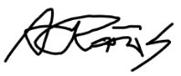
Date | 02-June-2026

